1 The accompanying diagram shows the starting position of the spinner on a board game.

How does this spinner appear after a 270° counterclockwise rotation about point P?
1)
2)
3)
4) | 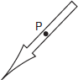

2 Which point shown in the graph below is the image of point P after a counterclockwise rotation of 90° about the origin?
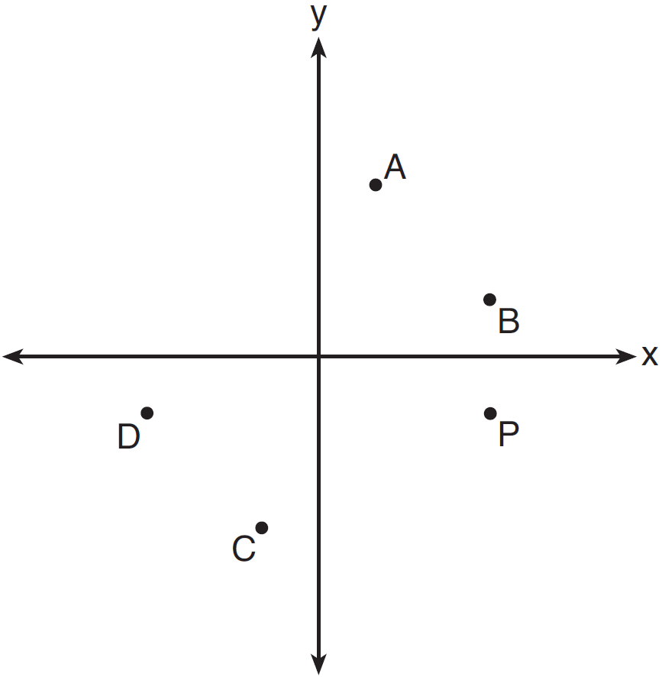
1) | A
2) | B
3) | C
4) | D

3 The coordinates of the vertices of are , , and . State the coordinates of , the image of after a rotation of 90º about the origin. [The use of the set of axes below is optional.]

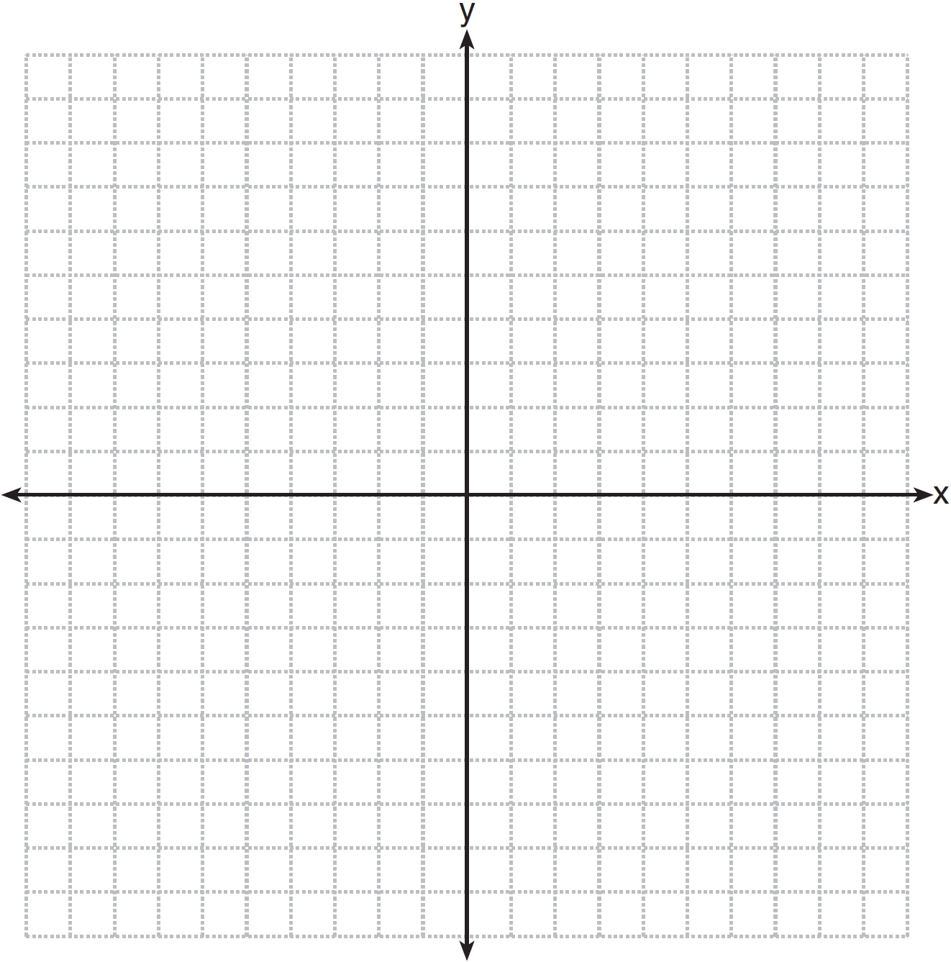

4 The coordinates of the vertices of are , , and . Triangle is the image of after a rotation of 90° about the origin. State the coordinates of the vertices of . [The use of the set of axes below is optional.]

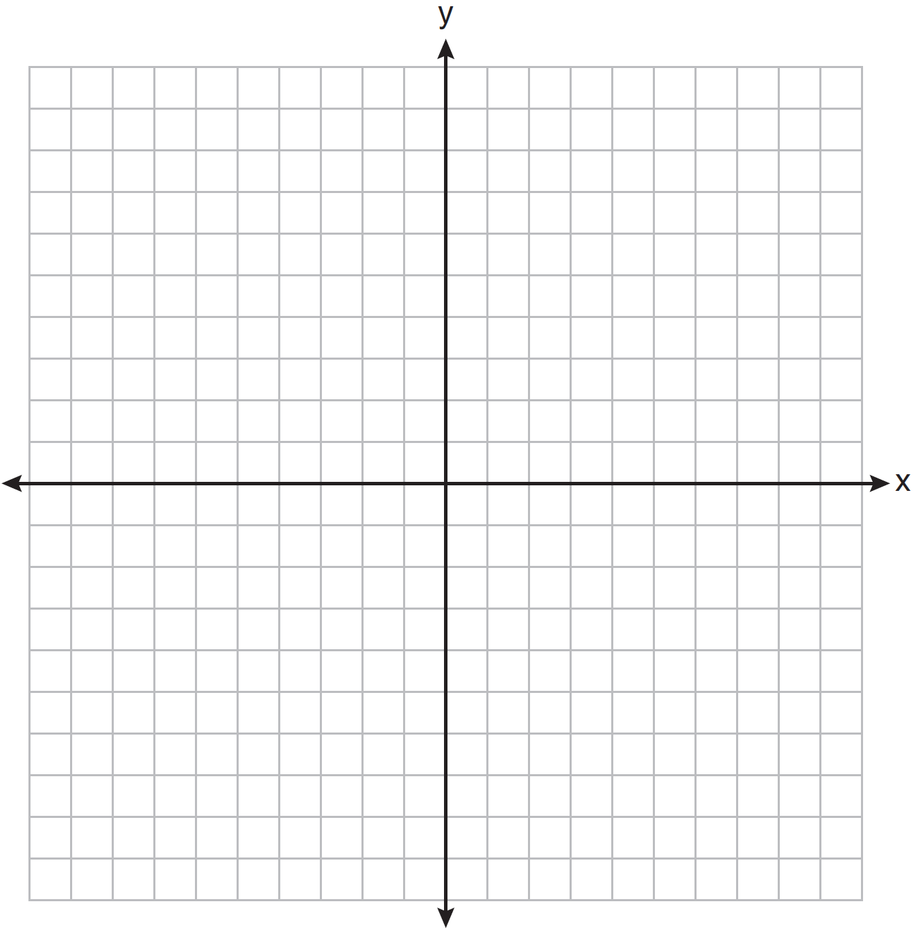

5 The grid below shows and .

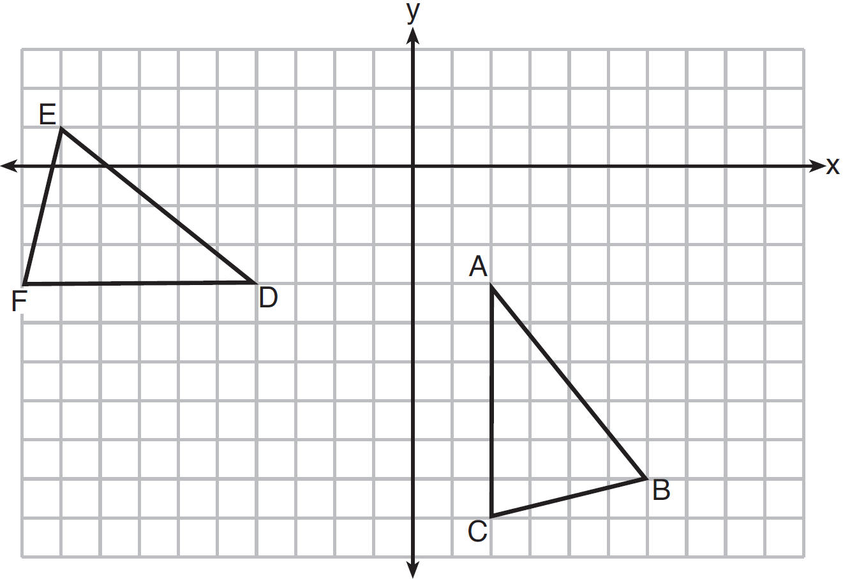

Let be the image of after a rotation about point A. Determine and state the location of B' if the location of point C' is . Explain your answer. Is congruent to ? Explain your answer.
1 ANS: 3 REF: 080721a

2 ANS: 1 REF: 081605geo

3 ANS:
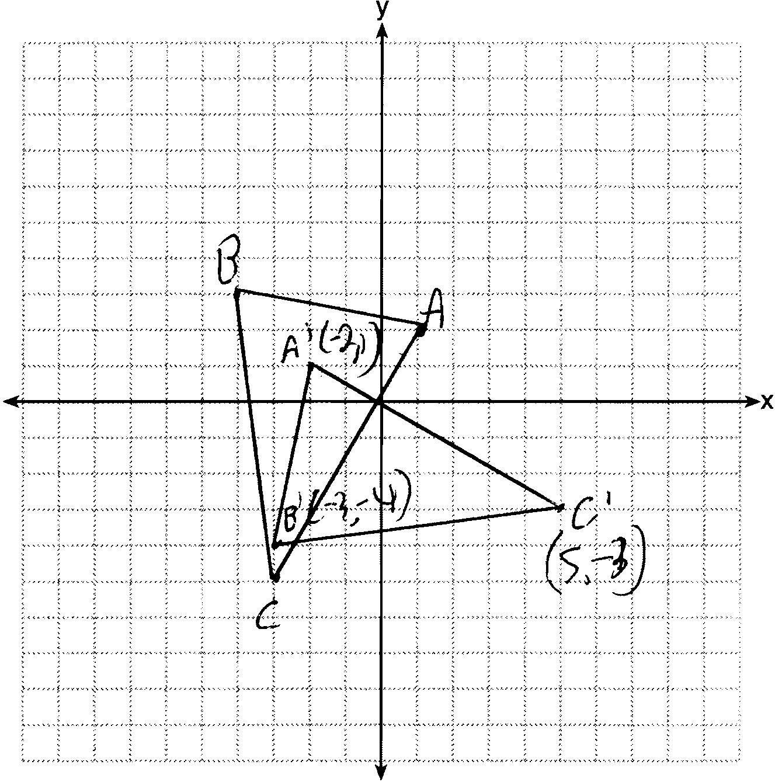 , , and

REF: 081230ge

4 ANS:
, , and .

REF: 011232ge

5 ANS:
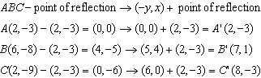 because is a reflection of and reflections preserve distance.

REF: 081633geo

