1 The coordinates of the endpoints of are and . Graph and state the coordinates of and , the images of A and B after is reflected in the x-axis.

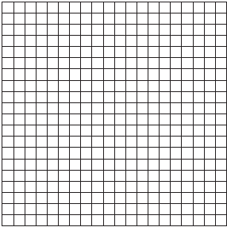

2 Triangle ABC has vertices , , and . Find the coordinates of the vertices of , the image of after the transformation . [The use of the grid is optional.]

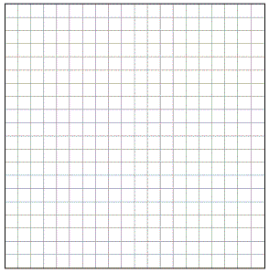

3 Triangle SUN has coordinates S(0,6), U(3,5), and N(3,0). On the accompanying grid, draw and label . Then, graph and state the coordinates of , the image of after a reflection in the y-axis.

4 Triangle ABC has coordinates , , and . On the accompanying set of axes, graph, label, and state the coordinates of , the reflection of in the y-axis.

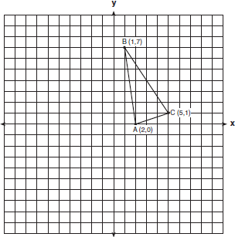

5 On the accompanying grid, draw and label quadrilateral ABCD with points , , , and . On the same set of axes, plot and label quadrilateral , the reflection of quadrilateral ABCD in the y-axis. Determine the area, in square units, of quadrilateral .

6 Carson is a decorator. He often sketches his room designs on the coordinate plane. He has graphed a square table on his grid so that its corners are at the coordinates , , , and . To graph a second identical table, he reflects ABCD over the y-axis. On the accompanying set of coordinate axes, sketch and label ABCD and its image A'B'C'D', which show the locations of the two tables. Then find the number of square units in the area of ABCD.

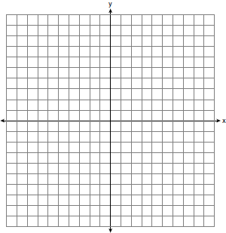

7 On the accompanying set of axes, draw the reflection of ABCD in the y-axis. Label and state the coordinates of the reflected figure.

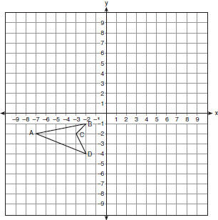

8 Triangle ABC has vertices , , and . The image of after the transformation is . State and label the coordinates of . [The use of the set of axes below is optional.]

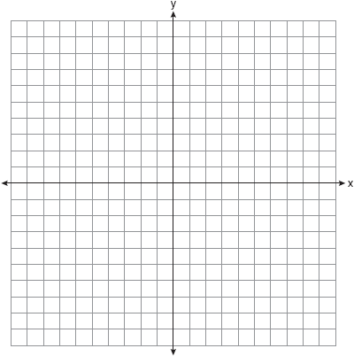

9 The image of after a reflection through the origin is . If the coordinates of the endpoints of are and , state and label the coordinates of R' and S'. [The use of the set of axes below is optional.]

10 Triangle XYZ, shown in the diagram below, is reflected over the line . State the coordinates of , the image of .

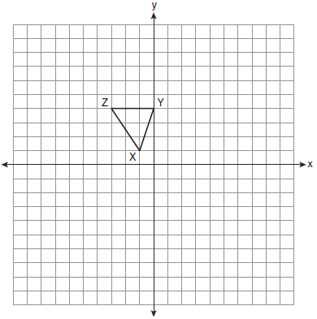

11 Triangle ABC is graphed on the set of axes below. Graph and label , the image of after a reflection over the line .

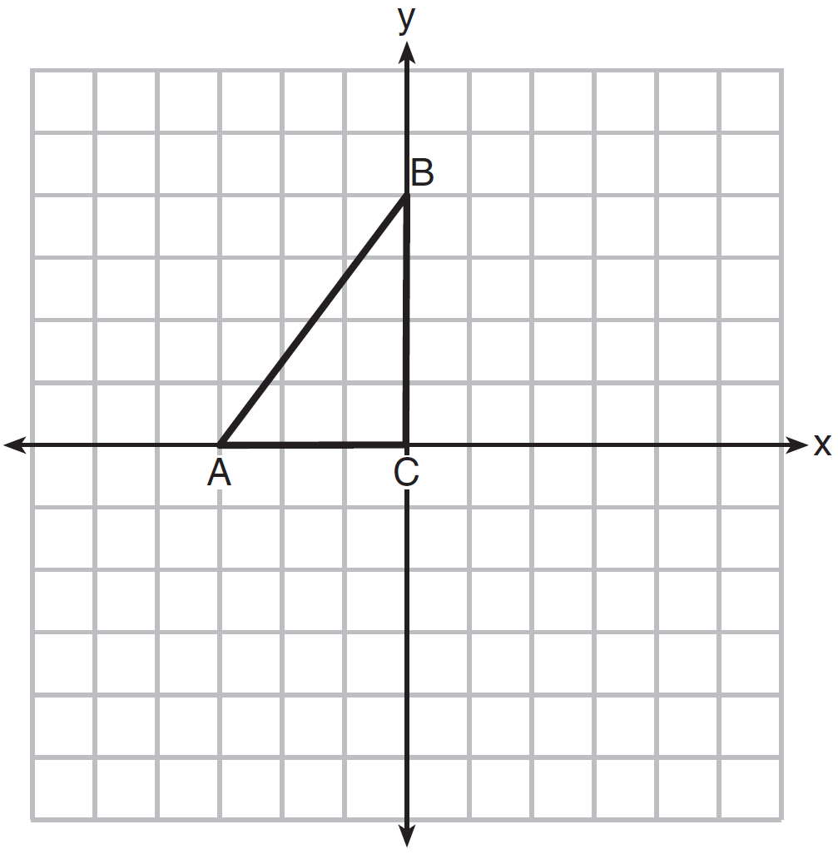
1 ANS:
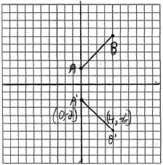

REF: 010124a

2 ANS:
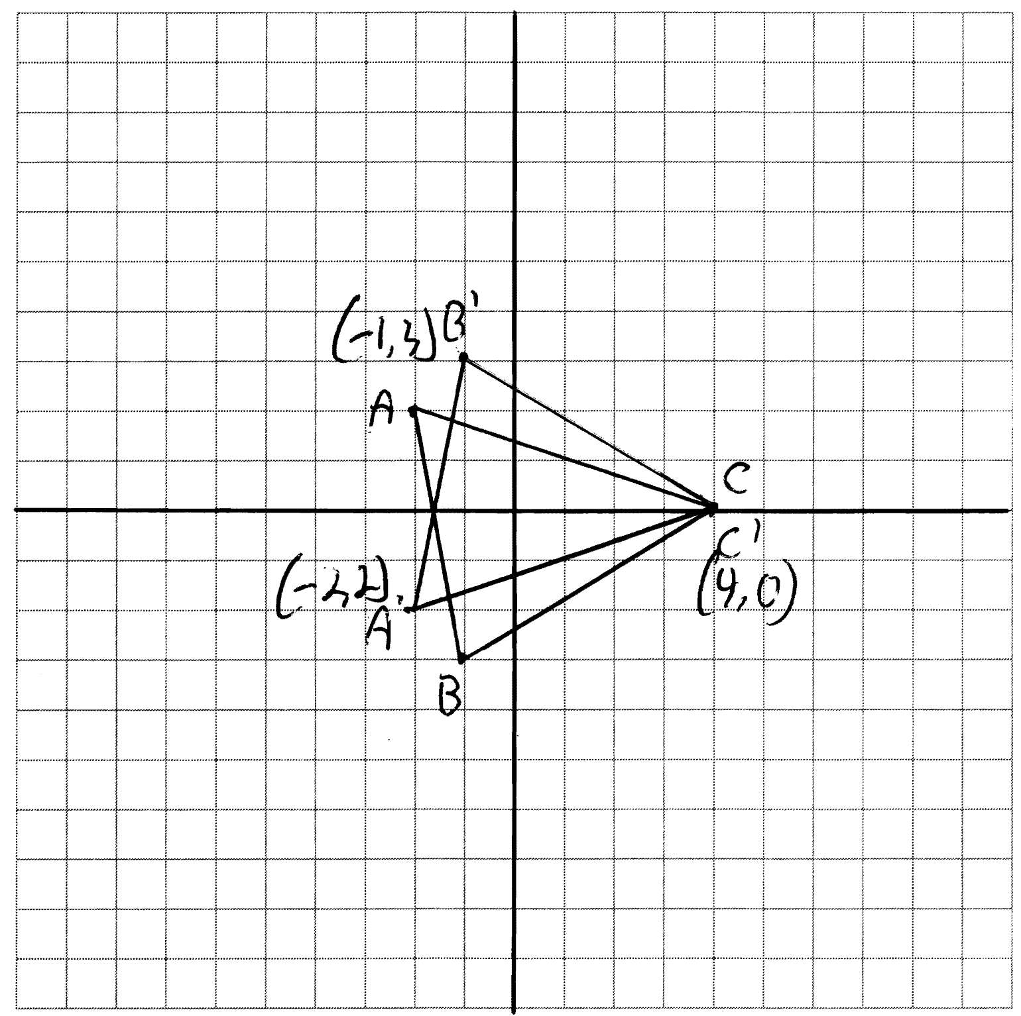

REF: 011130ge

3 ANS:
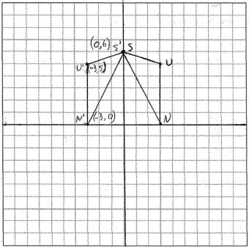

REF: 060135a

4 ANS:
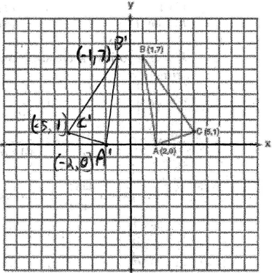

REF: 080637a

5 ANS:
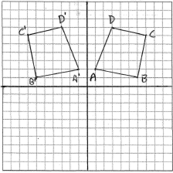 24.

REF: 010333a

6 ANS:
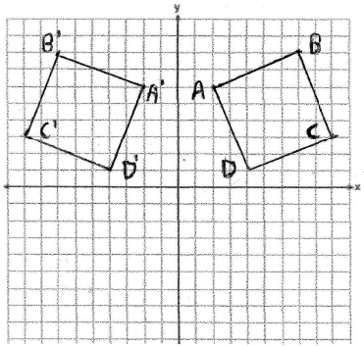 29. 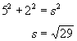

REF: 060739a

7 ANS:
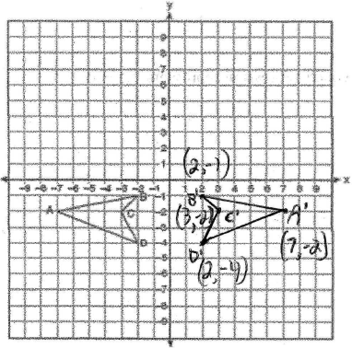

REF: 060537a

8 ANS:
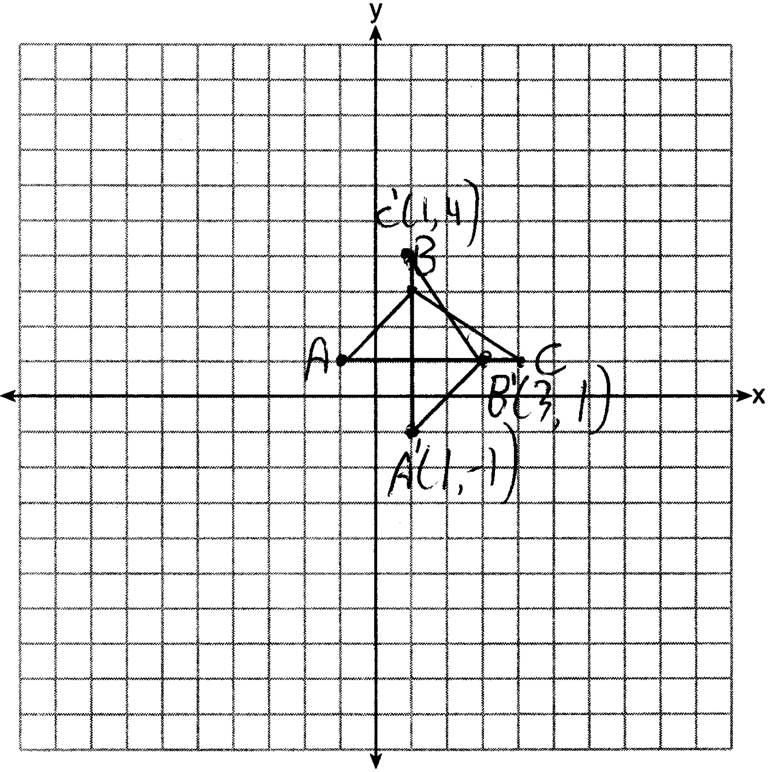

REF: 061530ge

9 ANS:
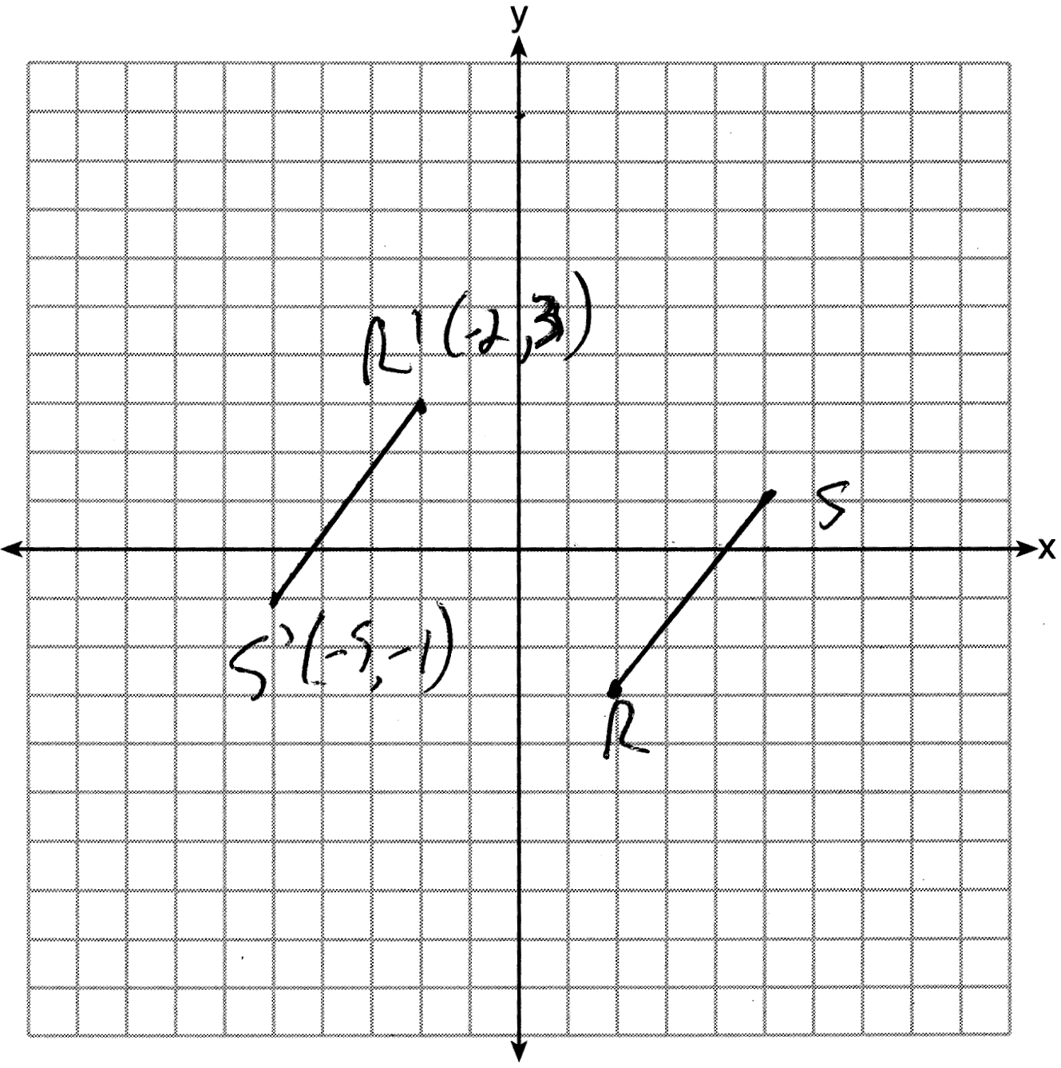

REF: 081529ge

10 ANS:
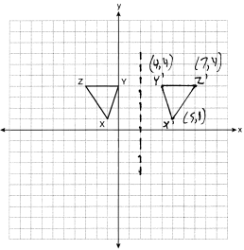

REF: 061032ge

11 ANS:
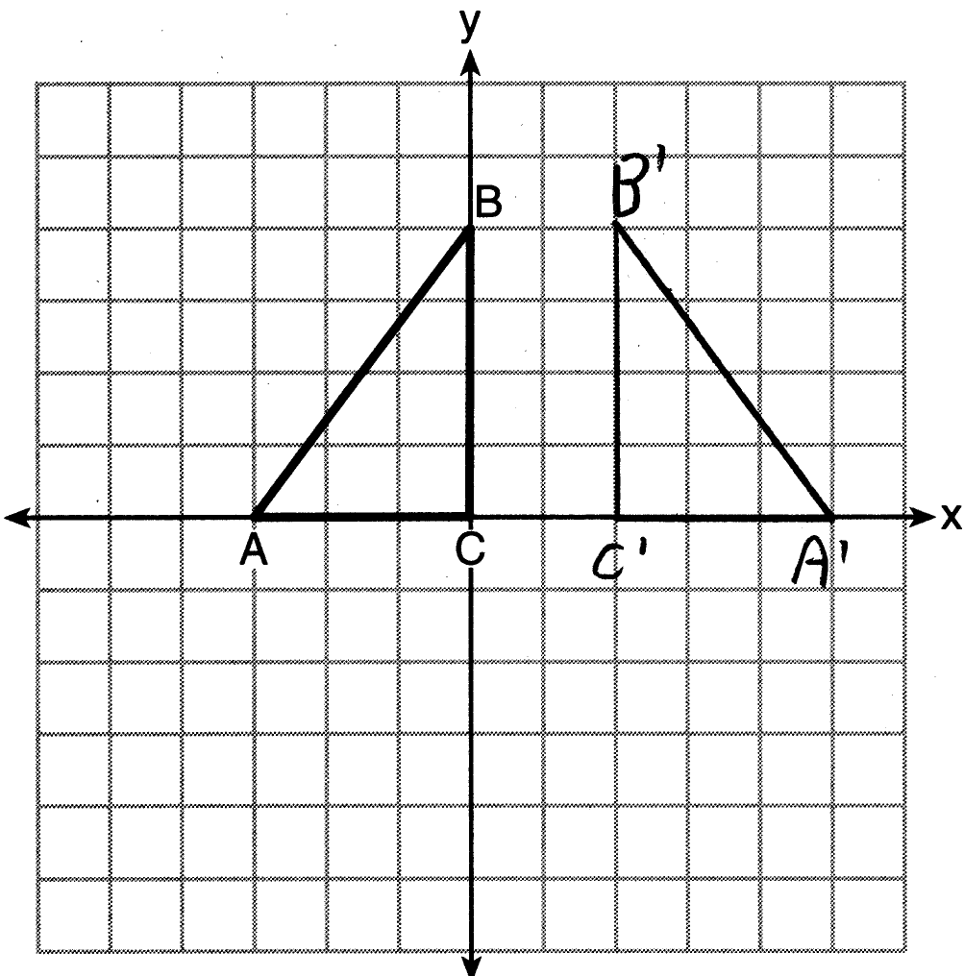

REF: 011625geo

