1 If the coordinates of point P are , then is
1)
2)
3)
4)

2 Which transformation is equivalent to the composite line reflections ?
1) | a rotation
2) | a dilation
3) | a translation
4) | a glide reflection

3 Write a single translation that is equivalent to followed by .

4 Find the coordinates of if the coordinates of A are .

5 Find the coordinates of the image of under the transformation .

6 What is the image that results from this composition of transformations?

7 Find the coordinates of point under the composite .

8 If the coordinates of A are , what are the coordinates of , the image of A after ?

9 If the coordinates of B are , what are the coordinates of B’, the image of B after ?

10 Find the image of point under the composition of translations .

11 Given with points , , and . On the grid below, sketch . On the same set of axes, graph and state the coordinates of , the image of after a reflection in the line . On the same set of axes, graph and state the coordinates of , the image of after the translation .

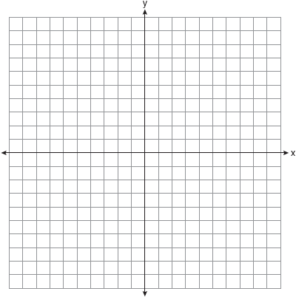

12 Triangle ABC has coordinates , , and .
a On the grid below, draw and label .
b Graph and state the coordinates of , the image of after the composition .
c Write a transformation equivalent to .

13 On the graph below, draw and label , whose vertices are , , and . On the same set of axes, graph and state the coordinates of
a , the image of after .
b , the image of after .
c , the image of after .
Based upon these graphs, write a single transformation that shows the composition .

14 Given triangle ABC with coordinates , , and .
a On the graph below, draw and label .
b Graph and label , the image of after translation .
c Graph and label , the image of after a reflection in the origin.
d Graph and label , the image of after a reflection in the line .

15 Given: with coordinates , , and .
a On the graph below, draw and label .
b Graph and state the coordinates of , the image of after the translation .
c Graph and state the coordinates of , the image of after a reflection in the x-axis.
d Graph and state the coordinates of , the image of after a reflection in the origin.

16 Triangle ABC has coordinates , , and .
a On the graph below, graph and label .
b Graph and state the coordinates of , the image of after a point reflection in the origin.
c Graph and state the coordinates of , the image of reflected in the line .
d Graph and state the coordinates of , the image of after translation .

17 Triangle ABC has coordinates , , and .
a On the graph below, draw and label .
b Graph and state the coordinates of , the image of after a reflection in the line .
c Graph and state the coordinates of , the image of following .
d Graph and state the coordinates of , the image of after a translation that maps onto .

1 ANS: 4 REF: 010028siii

2 ANS: 1 REF: 018634siii

3 ANS:

REF: 019816siii

4 ANS:

REF: 088611siii

5 ANS:

REF: 089340siii

6 ANS:

REF: 069514siii

7 ANS:

REF: 019613siii

8 ANS:

REF: 089714siii

9 ANS:

REF: 010112siii

10 ANS:

REF: 060307siii

11 ANS:
;

REF: 080141siii

12 ANS:
;

REF: 019541siii

13 ANS:
; ; ;

REF: 089938siii

14 ANS:
; ;

REF: 018541siii

15 ANS:
; ;

REF: 018739siii

16 ANS:
; ;

REF: 088741siii

17 ANS:
; ;

REF: 018936siii

