1 What is the image of point after the composition of transformations defined by ?
1)
2)
3)
4)

2 What is the image of point under ?
1)
2)
3)
4)

3 What are the coordinates of point , the image of point after the composite transformation where the origin is the center of rotation?
1)
2)
3)
4)

4 Given point . State the coordinates of the image of A under the composition . [The use of the accompanying grid is optional.]



5 The accompanying graph represents the figure _{I}.

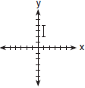

Which graph represents _{I} after a transformation defined by ?
1) | 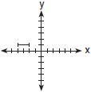
2) | 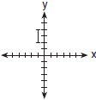
3) | 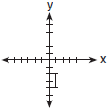
4) | 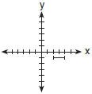

6 On the accompanying grid, graph and label , where A is and B is . Under the transformation , A maps to , and B maps to . Graph and label . What single transformation would map to ?

7 In the diagram below, is a transformation of , and is a transformation of .

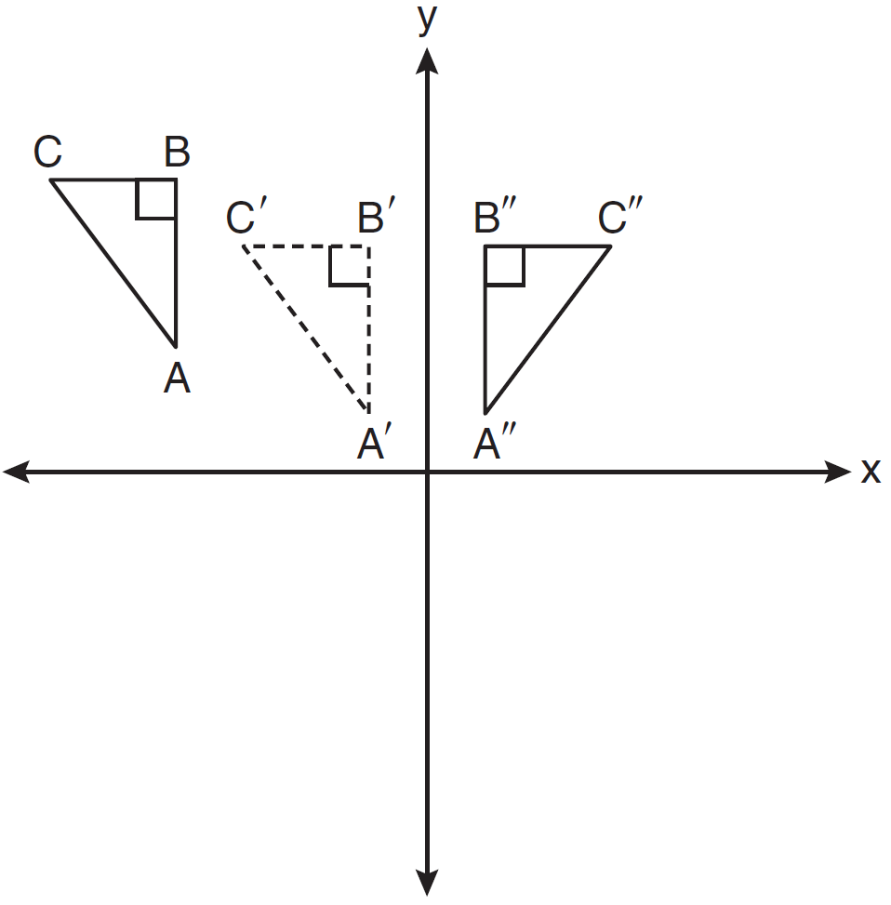

The composite transformation of to is an example of a
1) | reflection followed by a rotation
2) | reflection followed by a translation
3) | translation followed by a rotation
4) | translation followed by a reflection

8 The coordinates of are , , and . What are the coordinates of the vertices of its image after the transformation ?
1)
2)
3)
4)

9 The graph below shows , the image of after it was reflected over the y-axis. Graph and label , the pre-image of . Graph and label , the image of after it is reflected through the origin. State a single transformation that will map onto .

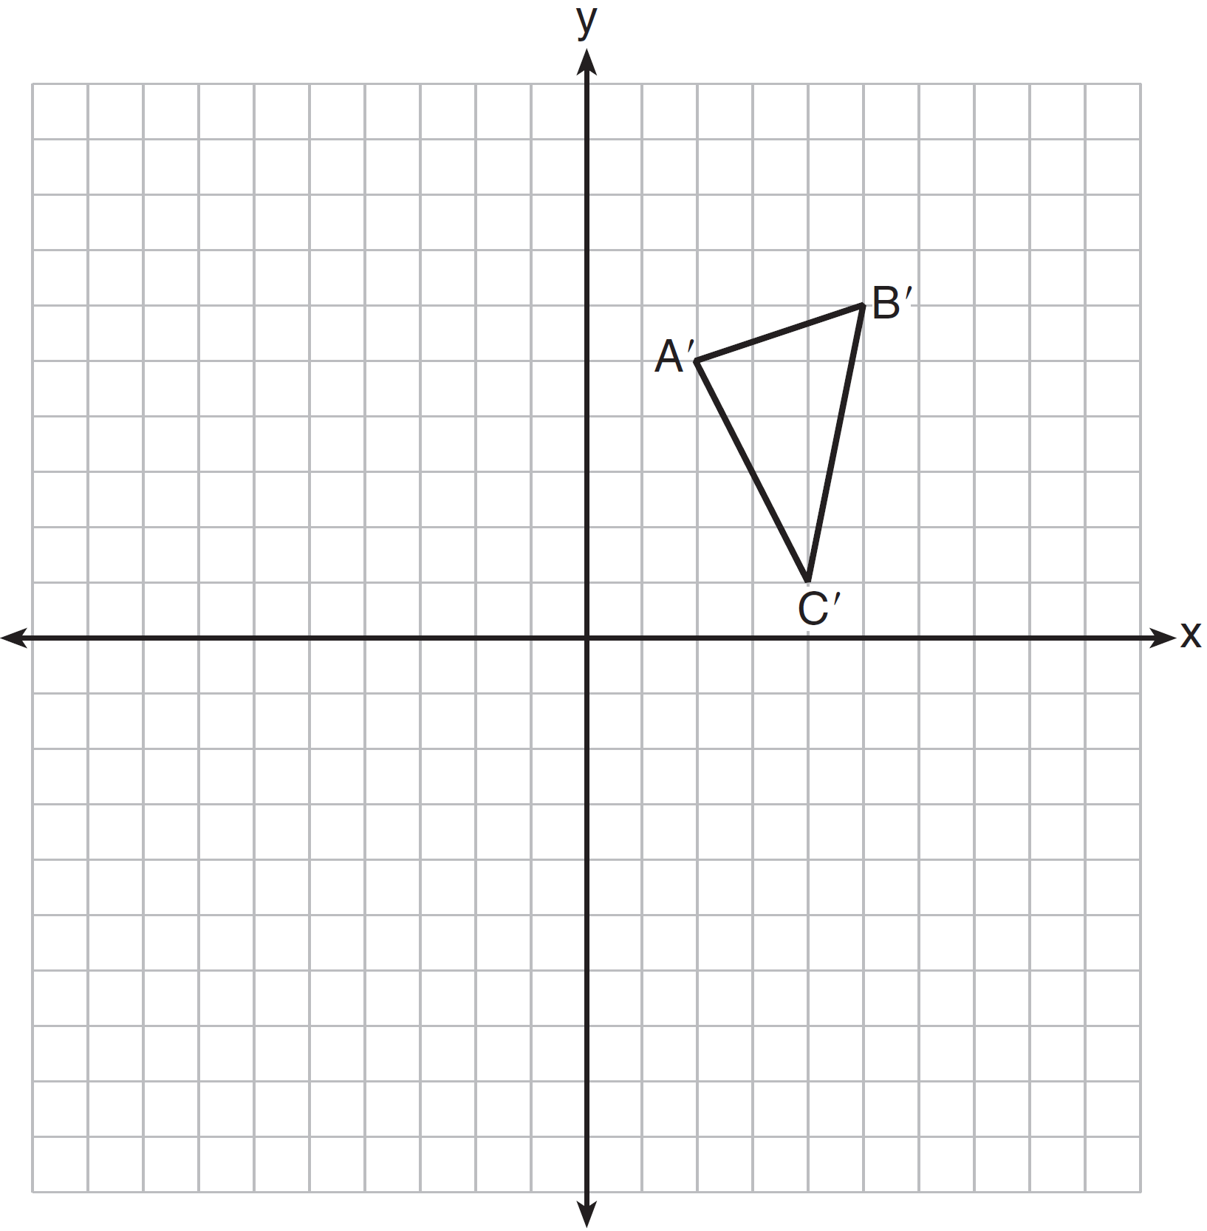

10 The coordinates of , shown on the graph below, are , , and . Graph and label , the image of after it is reflected over the y-axis. Graph and label , the image of after it is reflected over the x-axis. State a single transformation that will map onto .

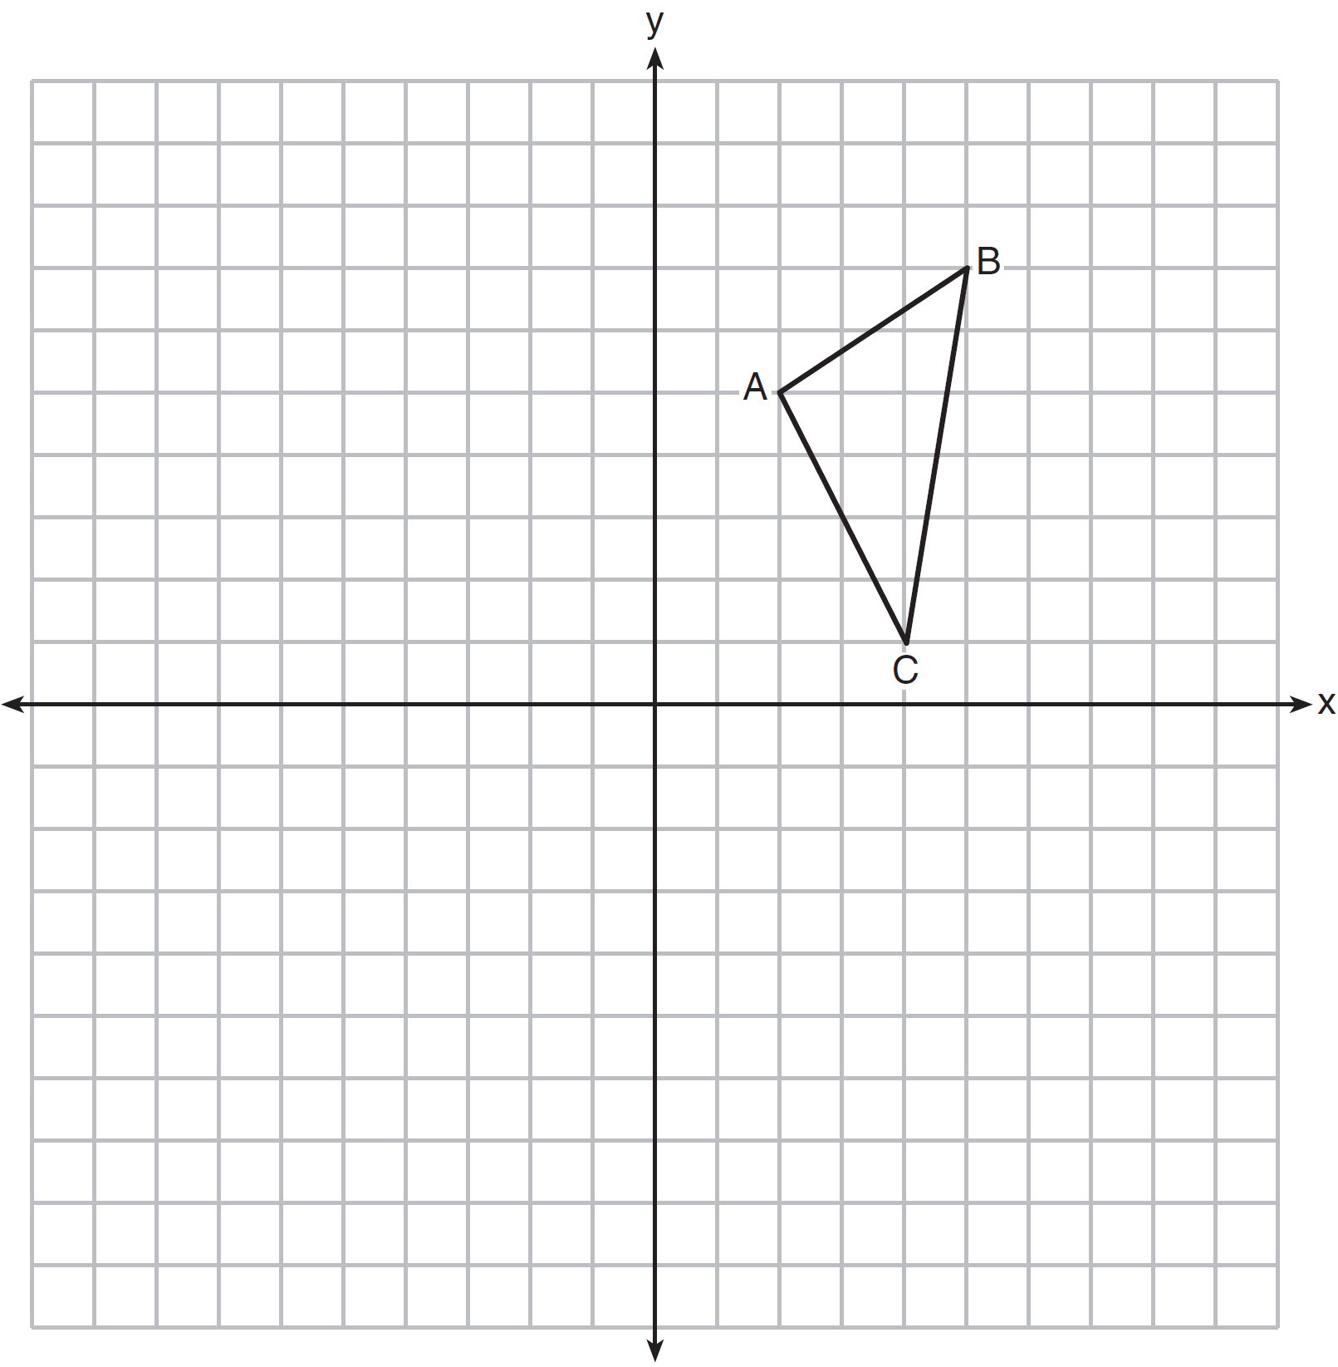

11 The vertices of are , , and . The image of after the composition is . State the coordinates of . [The use of the set of axes below is optional.]

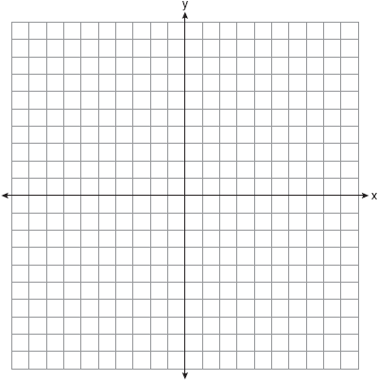

12 The coordinates of the vertices of are , , and . State and label the coordinates of the vertices of , the image of after the composition of transformations . [The use of the set of axes below is optional.]

13 On the accompanying grid, graph and label with vertices , , and . On the same grid, graph and label . the image of after the transformation .

14 Quadrilateral MATH has coordinates , , , and . The image of quadrilateral MATH after the composition is quadrilateral . State and label the coordinates of . [The use of the set of axes below is optional.]

15 Quadrilateral HYPE has vertices , , , and . State and label the coordinates of the vertices of H"Y"P"E" after the composition of transformations . [The use of the set of axes below is optional.]

16 The coordinates of the vertices of parallelogram ABCD are , , , and . State the coordinates of the vertices of parallelogram that result from the transformation . [The use of the set of axes below is optional. ]

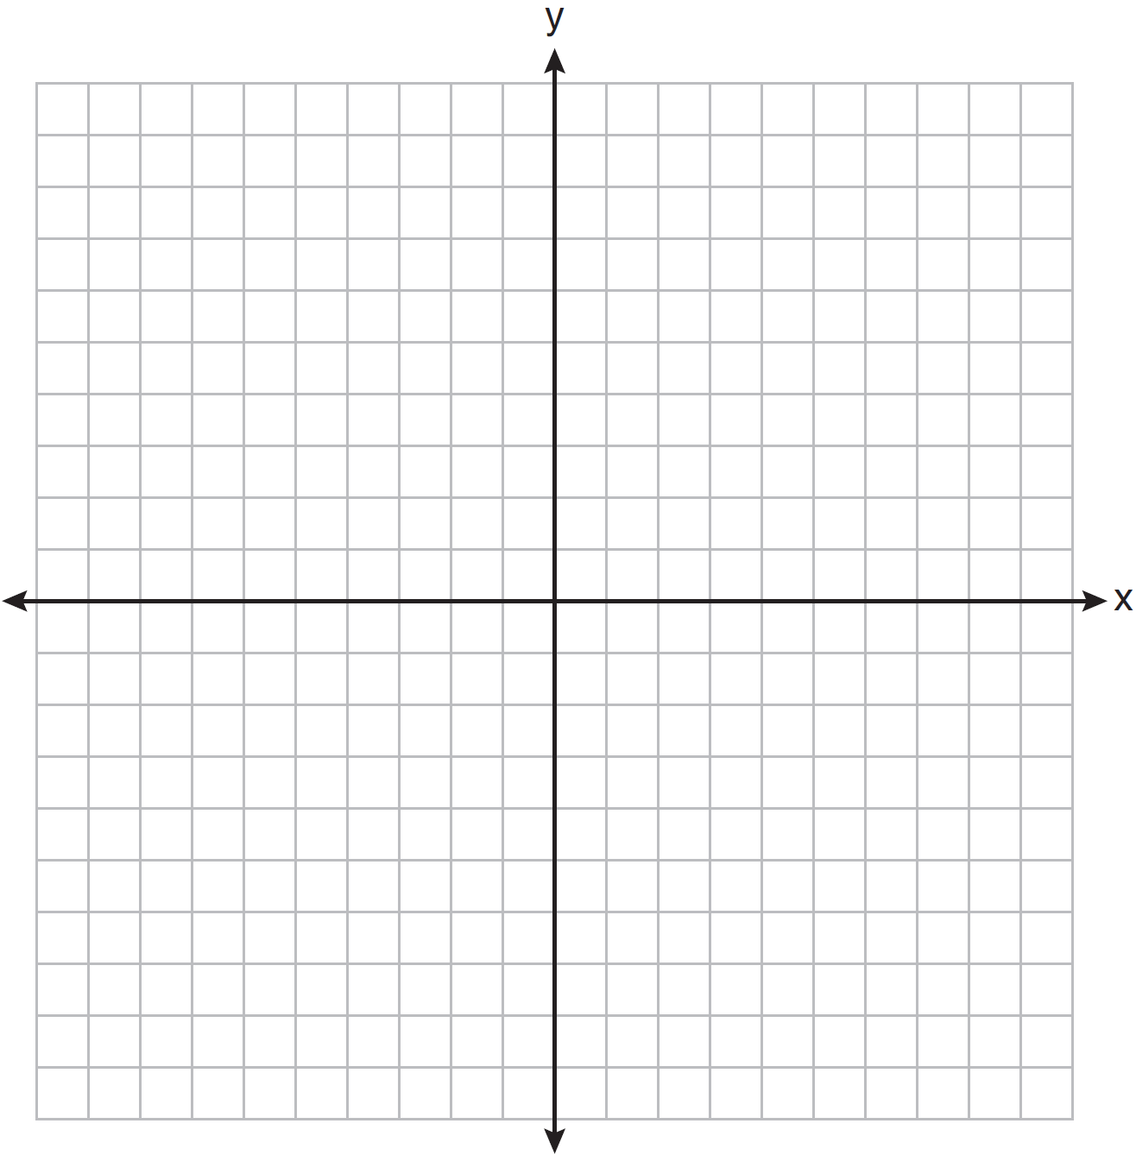

17 The coordinates of trapezoid ABCD are , , , and . Trapezoid is the image after the composition is performed on trapezoid ABCD. State the coordinates of trapezoid . [The use of the set of axes below is optional.]

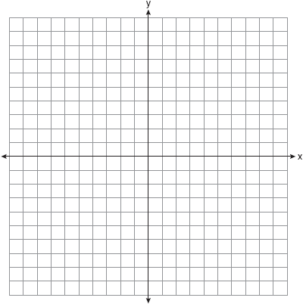

18 A shape to be used in a computer game is placed on a Cartesian coordinate plane. The equation of the shape is . On the accompanying grid, graph the shape and label it a. In the game, the shape is moved under the composition . Draw this image, label it b, and state its equation.

1 ANS: 1

REF: 011026ge

2 ANS: 4
After the rotation, the coordinates are (-1,1). After the reflection, the coordinates are (-1,-1).

REF: 080413b

3 ANS: 4
After the reflection, the coordinates of point A are (1,-4). After the rotation, the coordinates of point A' are (4,1).

REF: 010618b

4 ANS:
. 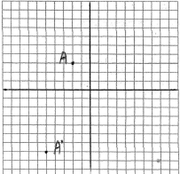. The coordinates of the image of A after the reflection are After the translation, the coordinates of the image of A are

REF: 080626b

5 ANS: 3 REF: 080219b

6 ANS:
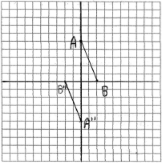 Single transformations include , , and .

REF: 080327b

7 ANS: 4 REF: 061103ge

8 ANS: 3
After the reflection, the coordinates are and
After the translation, the coordinates are and

REF: 080715b

9 ANS:
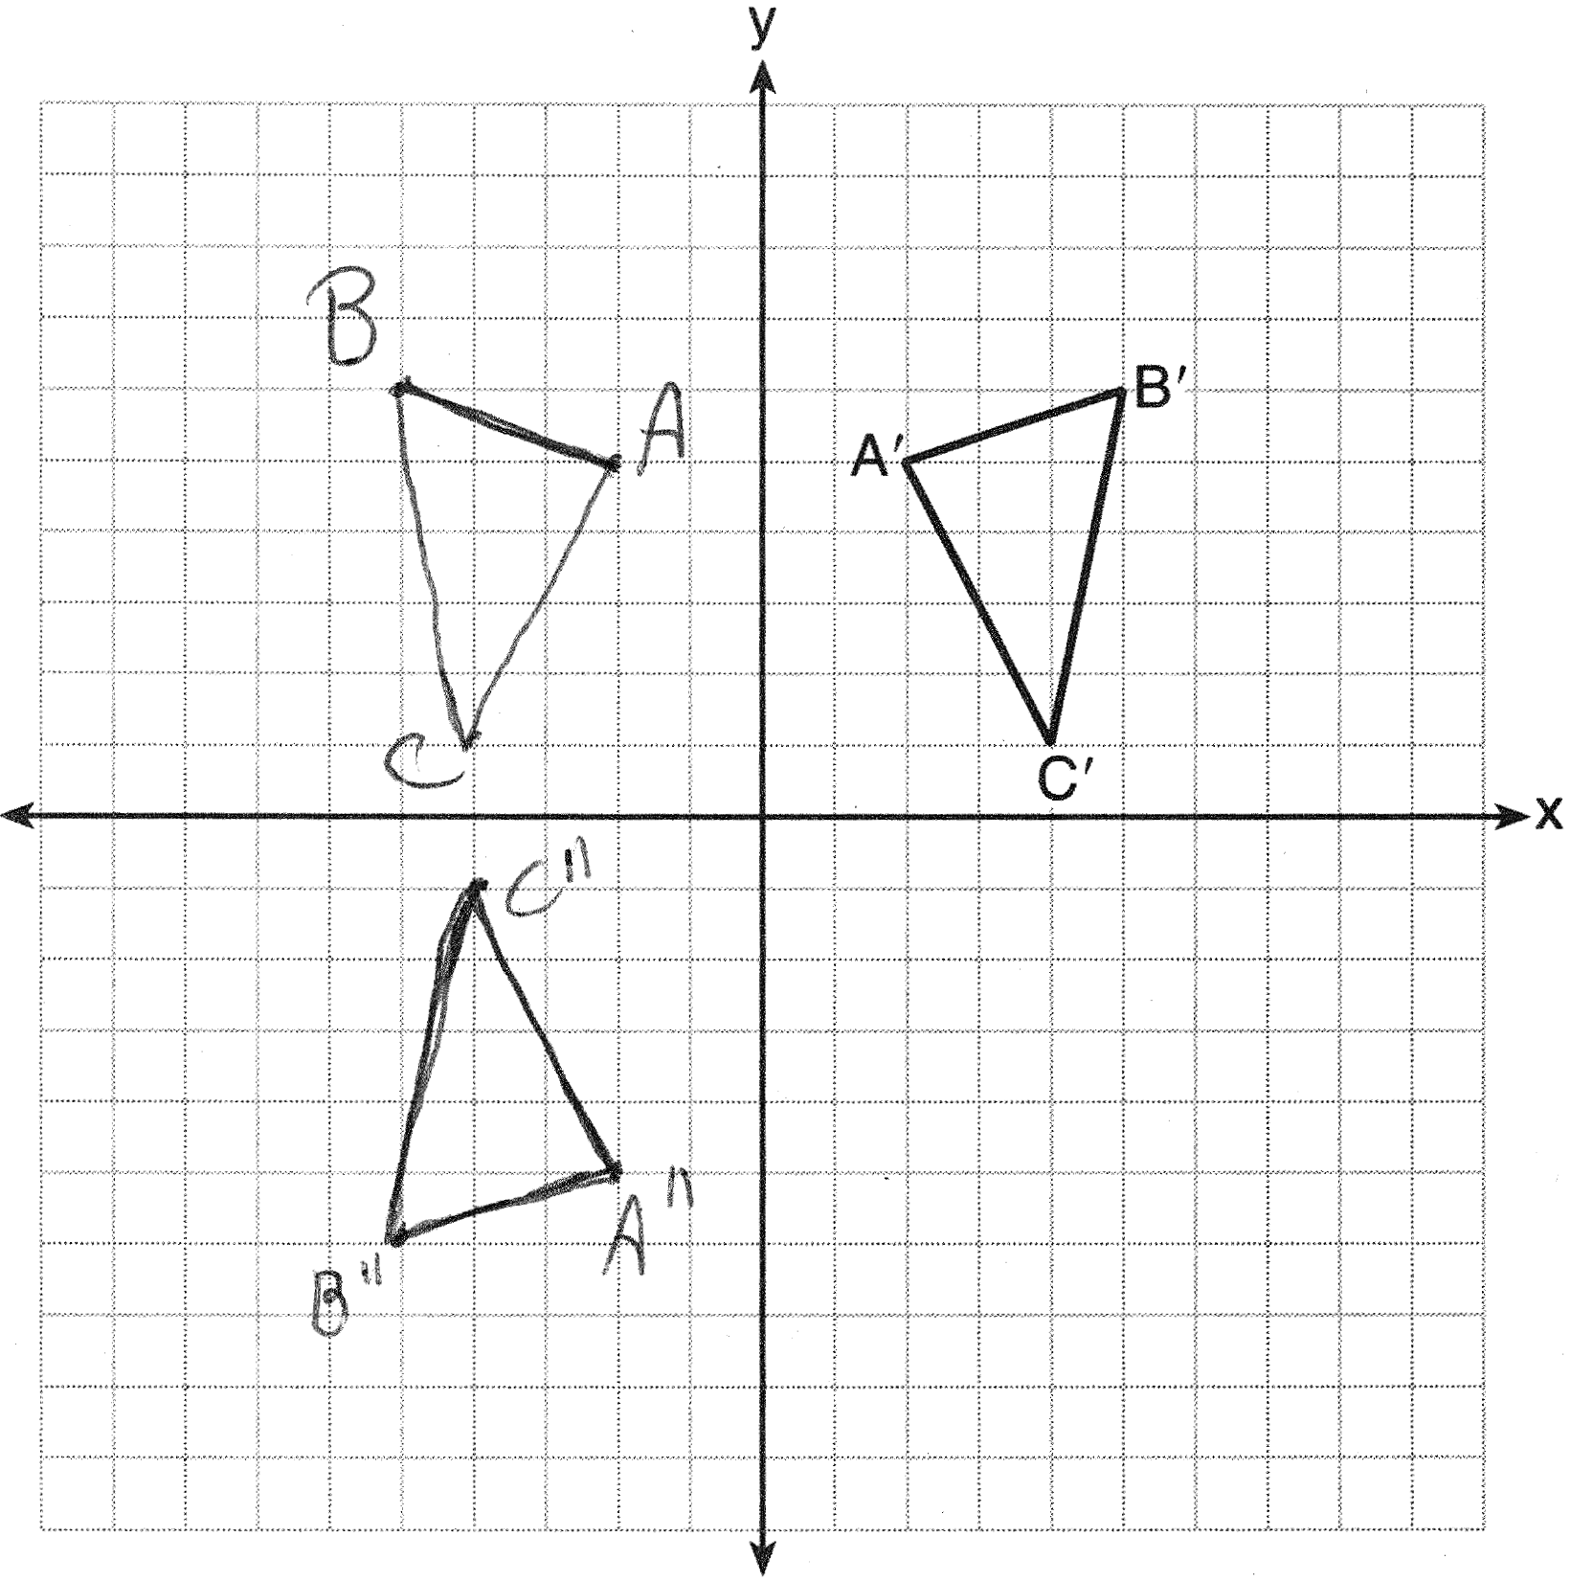

REF: 061435ge

10 ANS:
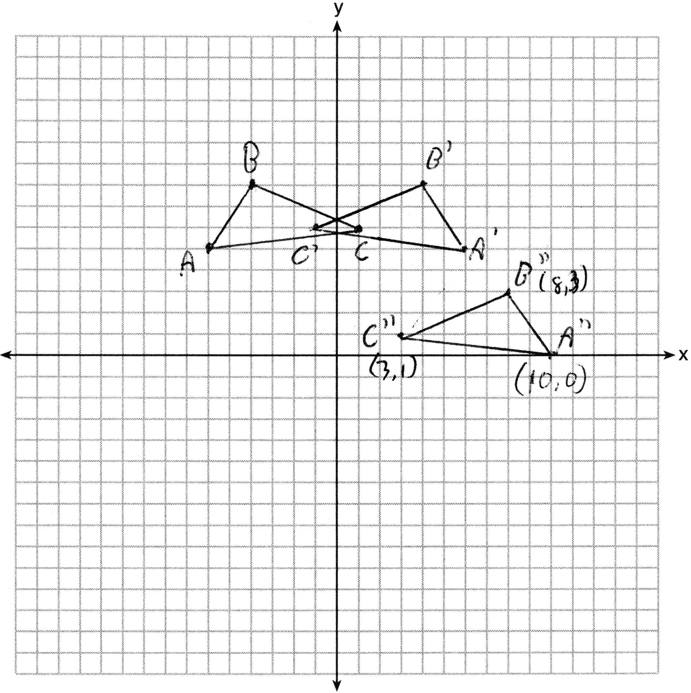

REF: 011635ge

11 ANS:
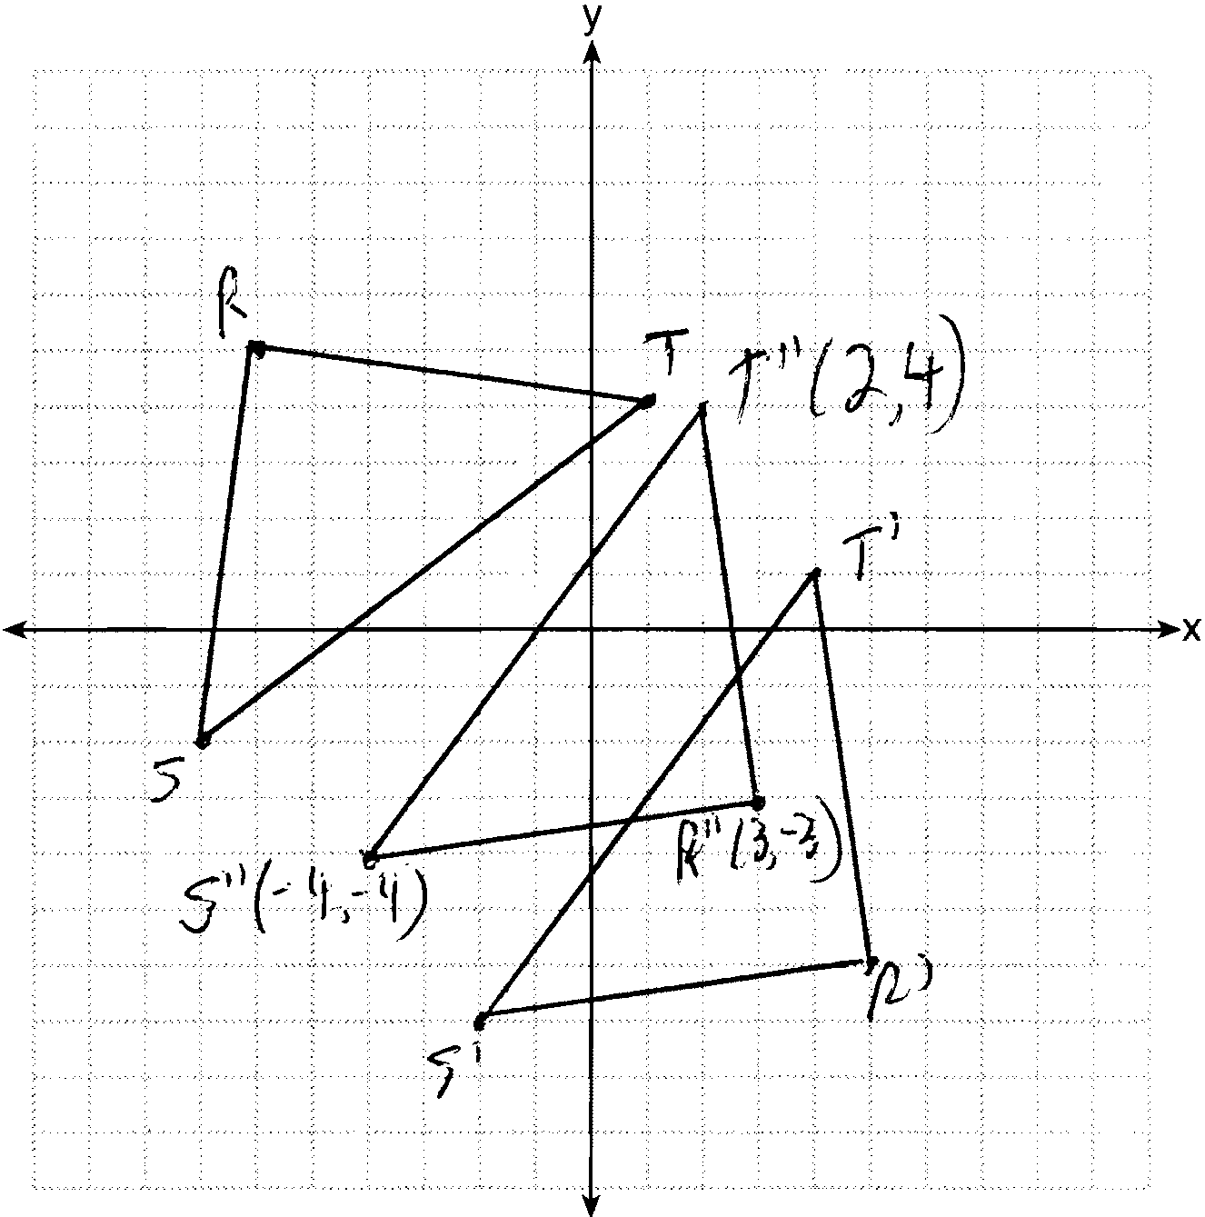

REF: 081236ge

12 ANS:

REF: 011436ge

13 ANS:
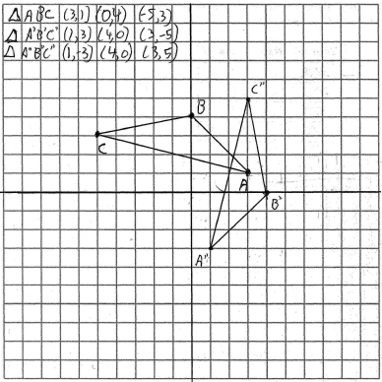

REF: 060928b

14 ANS:
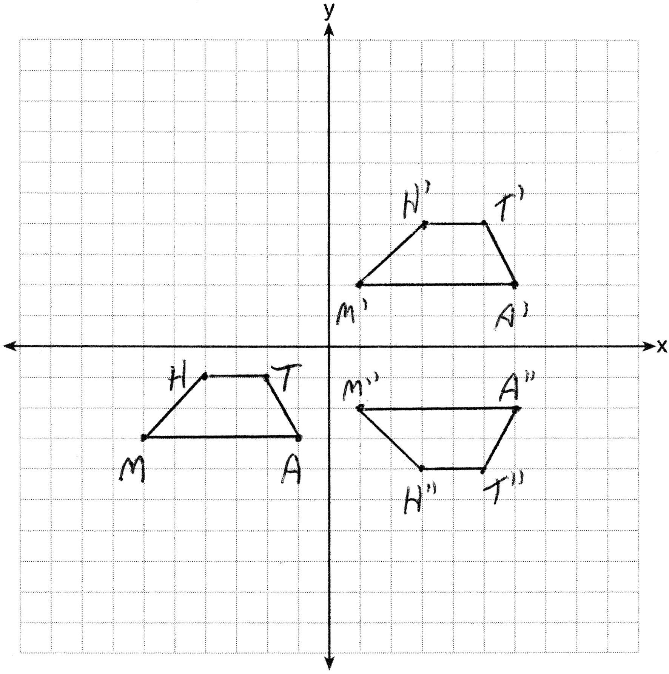

REF: 081336ge

15 ANS:
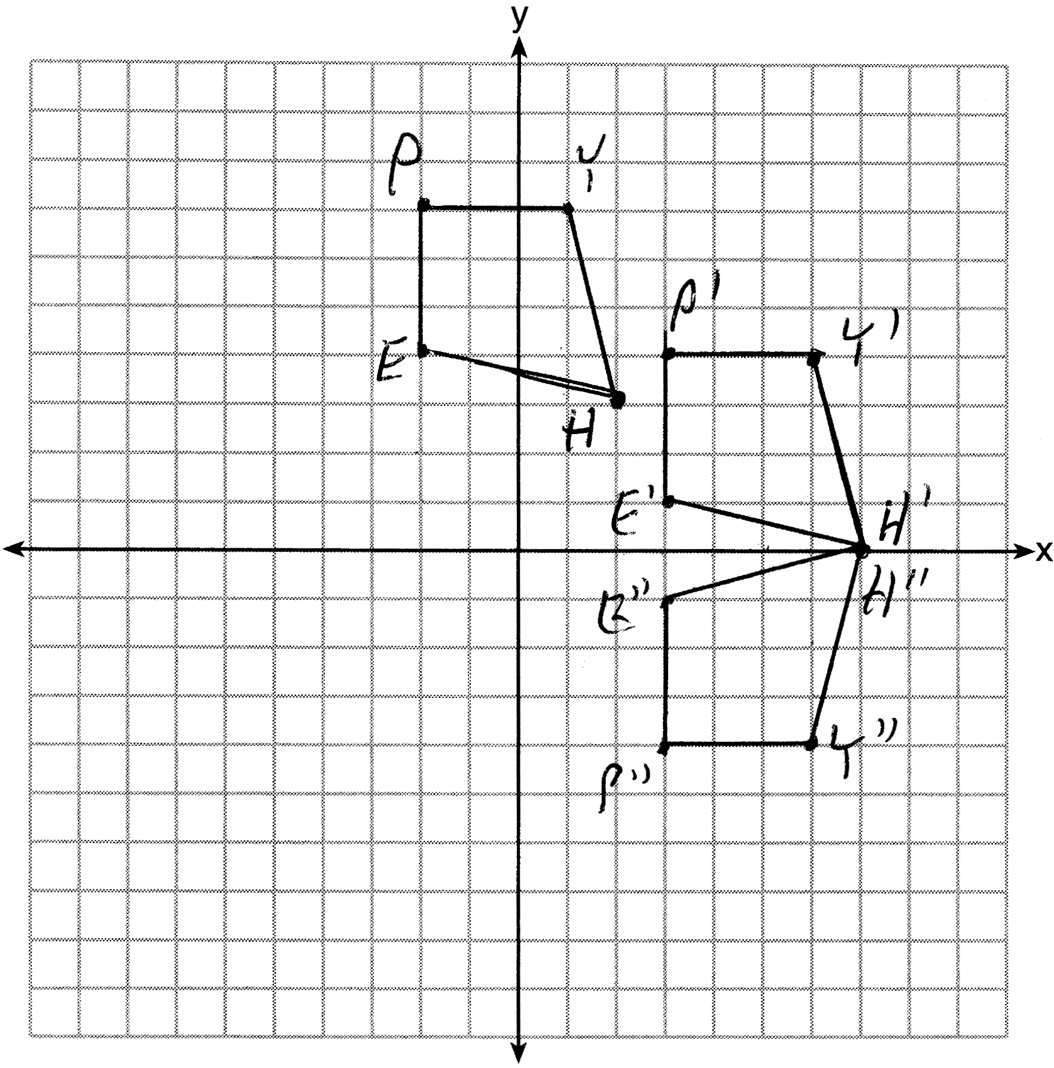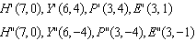

REF: 011535ge

16 ANS:
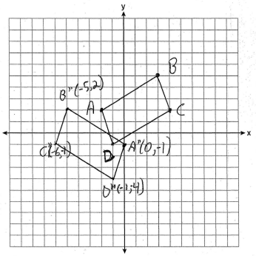

REF: 060937ge

17 ANS:
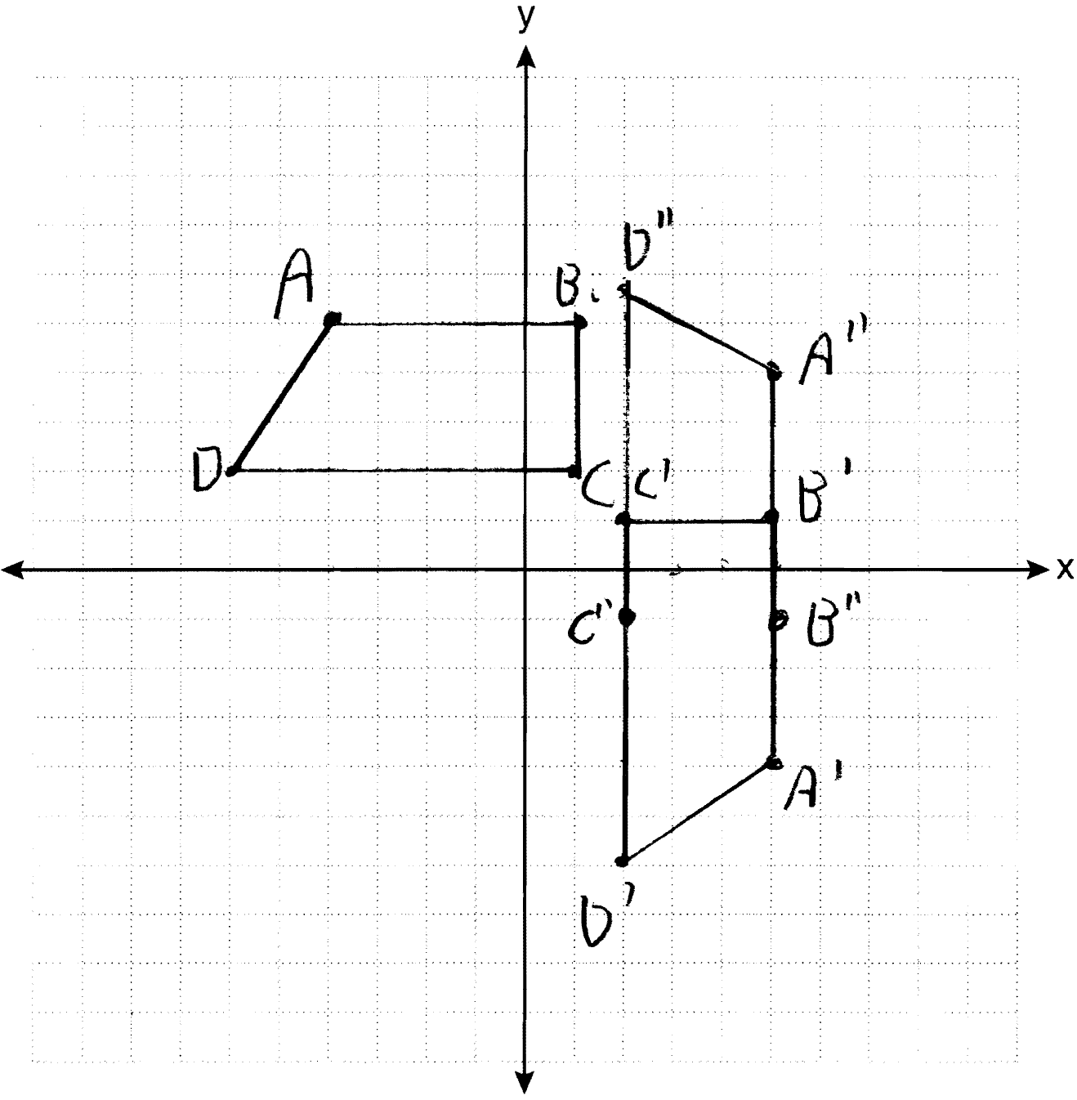 ;

REF: 061236ge

18 ANS:
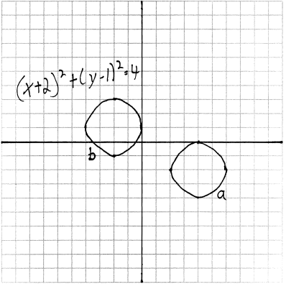

REF: 061029b

