1 On the set of axes below, is graphed with coordinates , , and . Triangle QRS, the image of , is graphed with coordinates , , and .

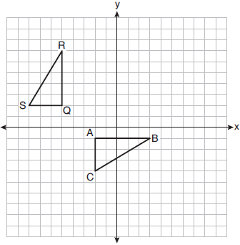

Describe a sequence of transformations that would map onto .

2 Describe a sequence of transformations that will map onto as shown below.

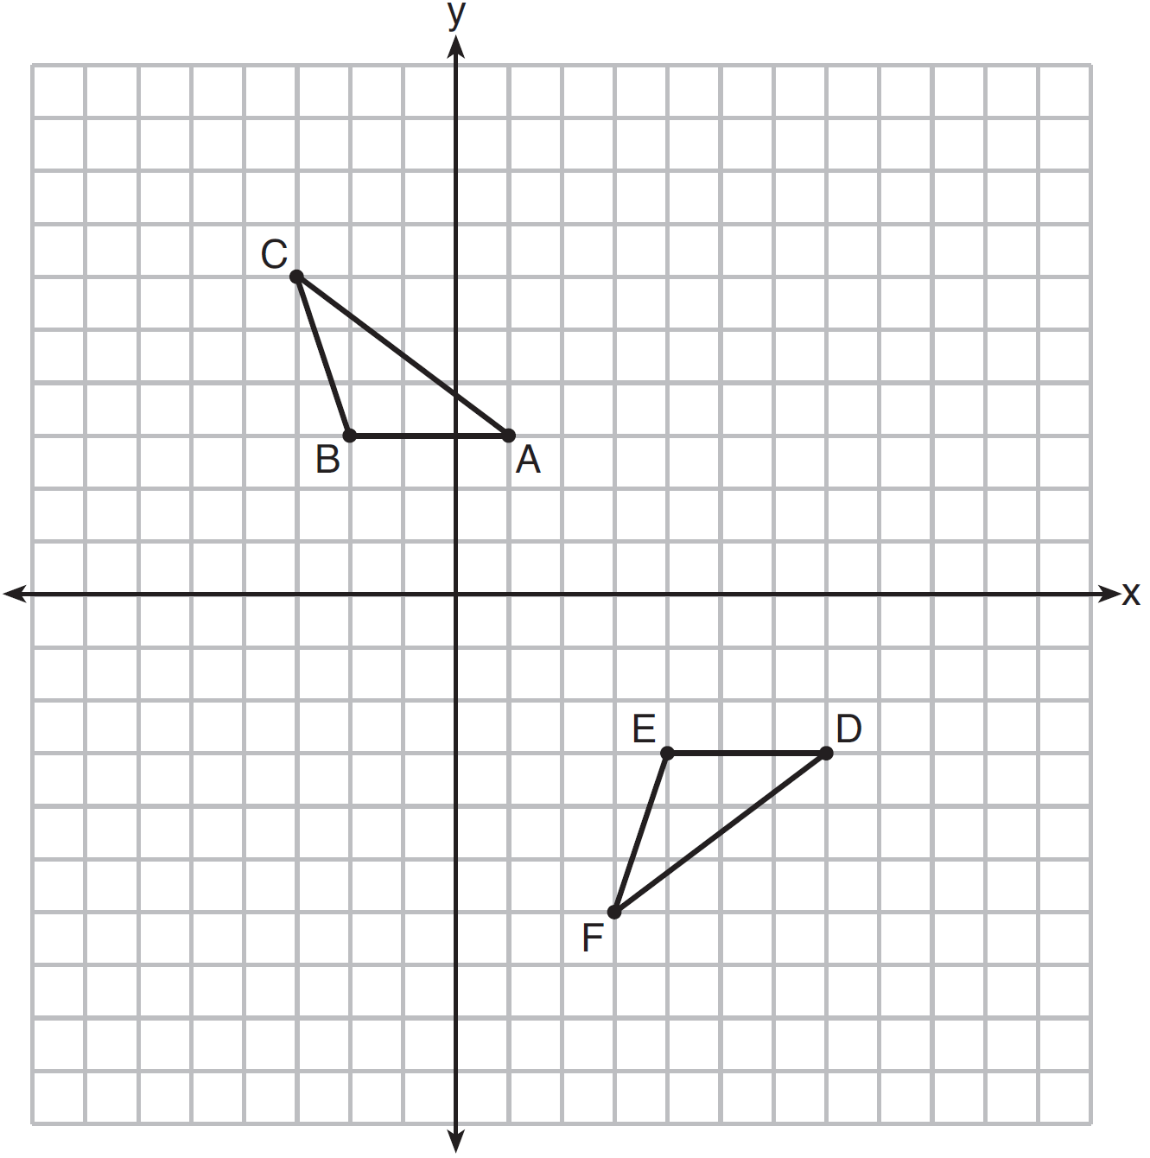

3 The graph below shows and its image, .

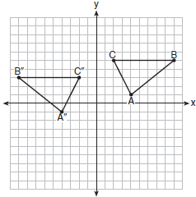

Describe a sequence of rigid motions which would map onto .

4 On the set of axes below, .

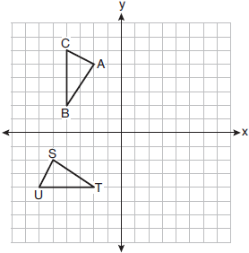

Describe a sequence of rigid motions that maps onto .

5 On the set of axes below, .

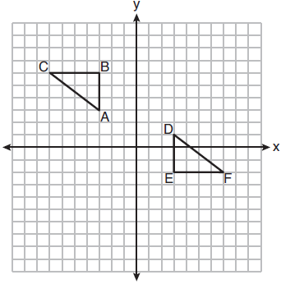

Describe a sequence of rigid motions that maps onto .

6 On the set of axes below, .

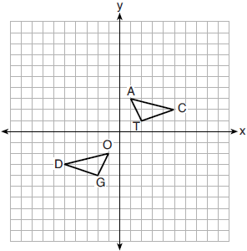

Describe a sequence of transformations that maps onto .

7 On the set of axes below, and are graphed.

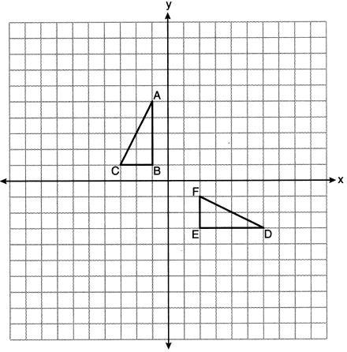

Describe a sequence of rigid motions that would map onto .

8 Triangles ABC and DEF are graphed on the set of axes below.

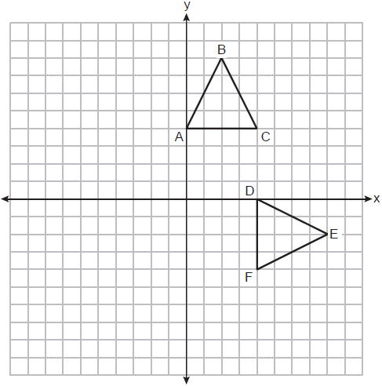

Describe a sequence of transformations that maps onto .

9 Triangle ABC and triangle DEF are drawn below.
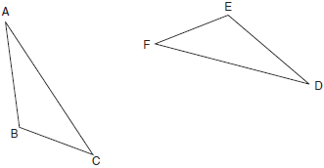
If , , and , write a sequence of transformations that maps triangle ABC onto triangle DEF.

10 Quadrilateral MATH and its image M"A"T"H" are graphed on the set of axes below.
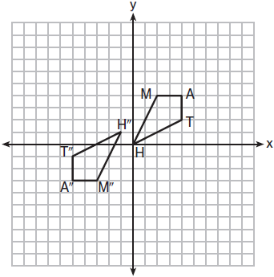
Describe a sequence of transformations that maps quadrilateral MATH onto quadrilateral M"A"T"H".

11 Quadrilaterals BIKE and GOLF are graphed on the set of axes below.
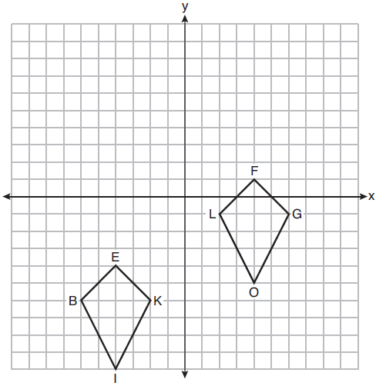
Describe a sequence of transformations that maps quadrilateral BIKE onto quadrilateral GOLF.

12 On the set of axes below, congruent quadrilaterals ROCK and R'O'C'K' are graphed.

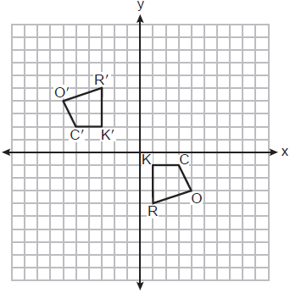

Describe a sequence of transformations that would map quadrilateral ROCK onto quadrilateral R'O'C'K'.

13 Trapezoids ABCD and A"B"C"D" are graphed on the set of axes below.

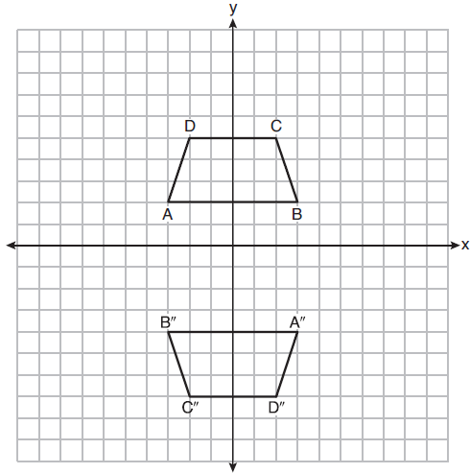

Describe a sequence of transformations that maps trapezoid ABCD onto trapezoid A"B"C"D".

14 Quadrilateral DEAR and its image, quadrilateral D'E'A'R', are graphed on the set of axes below.

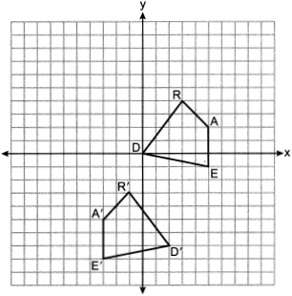

Describe a sequence of transformations that maps quadrilateral DEAR onto quadrilateral D'E'A'R'.

15 In the diagram below, has coordinates , , and . Graph and label , the image of after the translation five units to the right and two units up followed by the reflection over the line .

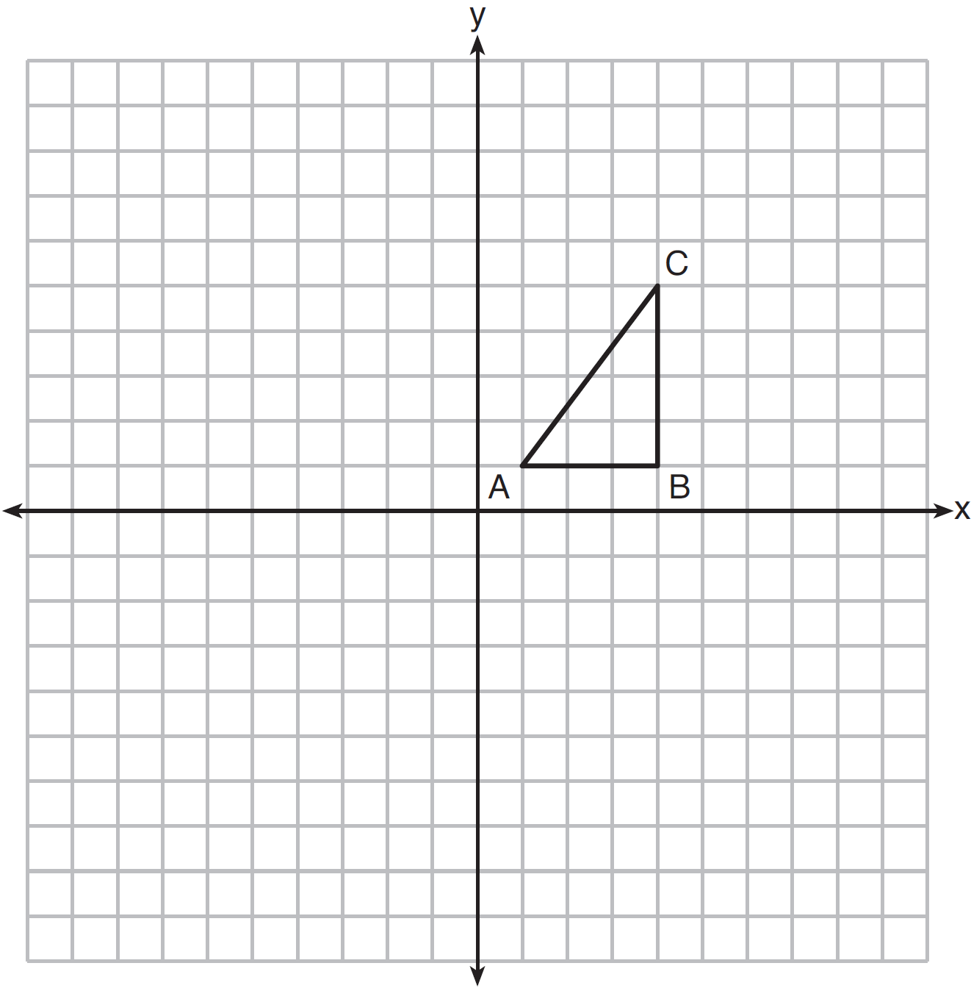
1 ANS:

REF: 011928geo

2 ANS:

REF: 061625geo

3 ANS:

REF: 011726geo

4 ANS:
or or

REF: 061929geo

5 ANS:

REF: 081927geo

6 ANS:

REF: 082225geo

7 ANS:
Rotate 90° clockwise about B and translate down 4 and right 3.

REF: 012326geo

8 ANS:
, followed by a 90º clockwise rotation about point D.

REF: 062326geo

9 ANS:
Rotate clockwise about point C until . Translate along so that C maps onto F.

REF: 061730geo

10 ANS:
about 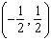

REF: 081727geo

11 ANS:
Reflection across the y-axis, then translation up 5.

REF: 061827geo

12 ANS:
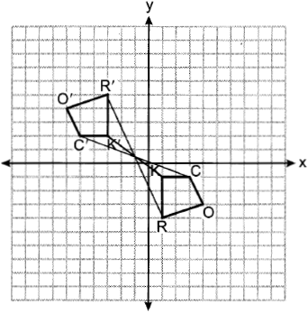 Rotate 180º about 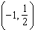.

REF: 082325geo

13 ANS:
rotation 180º about the origin, translation 2 units down; rotation 180º about B, translation 6 units down and 6 units left; or reflection over x-axis, translation 2 units down, reflection over y-axis

REF: 081828geo

14 ANS:

REF: 062427geo

15 ANS:
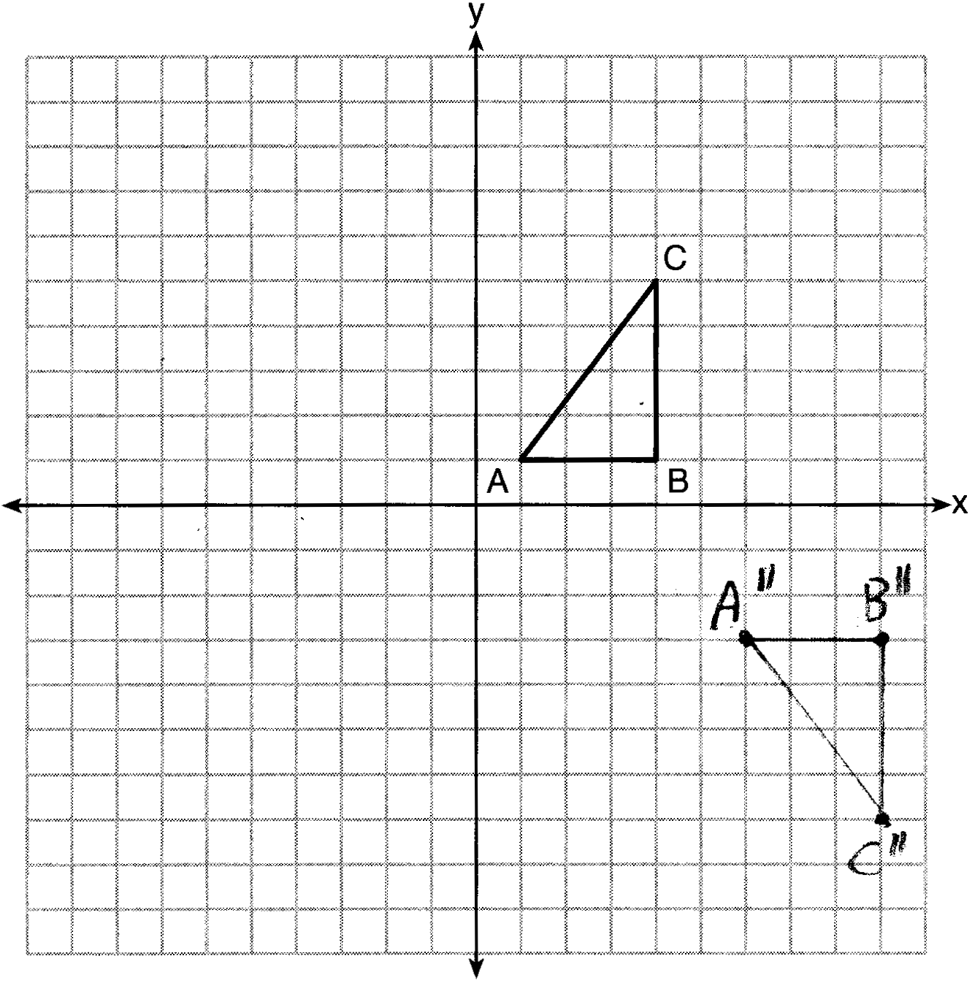

REF: 081626geo

