1 In the diagram below, which single transformation was used to map triangle A onto triangle B?

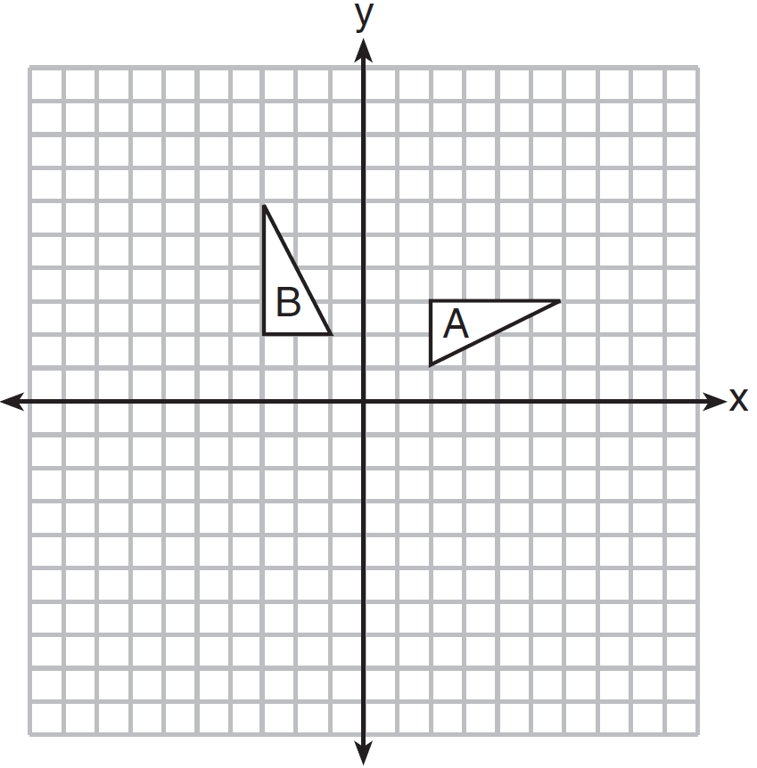
1) | line reflection
2) | rotation
3) | dilation
4) | translation

2 In the diagram below, line m is parallel to line n. Figure 2 is the image of Figure 1 after a reflection over line m. Figure 3 is the image of Figure 2 after a reflection over line n.

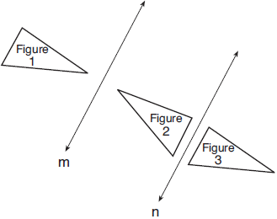

Which single transformation would carry Figure 1 onto Figure 3?
1) | a dilation
2) | a rotation
3) | a reflection
4) | a translation

3 In the diagram below, .

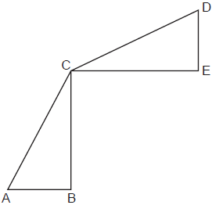

Which transformation will map onto ?
1) | a rotation
2) | a line reflection
3) | a translation followed by a dilation
4) | a line reflection followed by a second line reflection

4 Which transformation of would result in an image parallel to ?

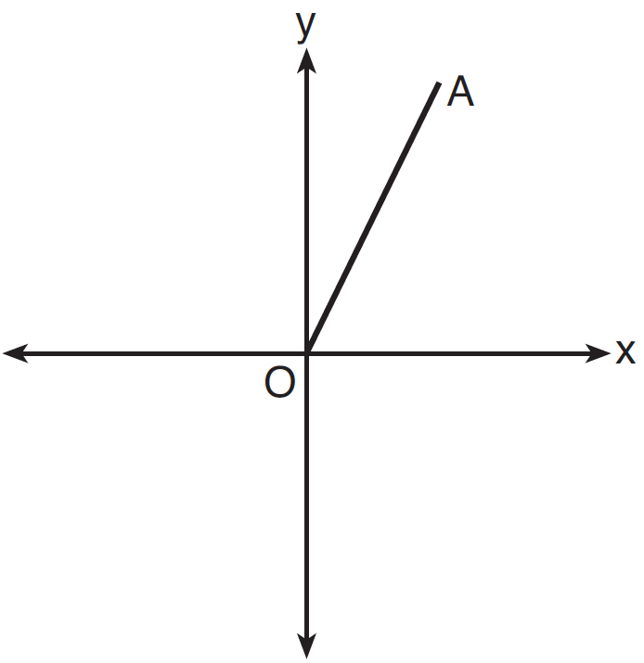
1) | a translation of two units down
2) | a reflection over the x-axis
3) | a reflection over the y-axis
4) | a clockwise rotation of 90° about the origin

5 Triangles ABC and DEF are graphed on the set of axes below.

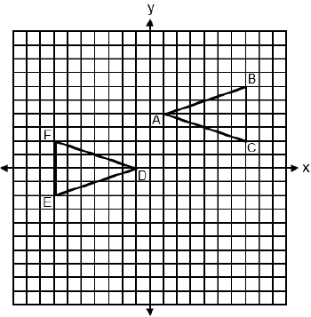

Which sequence of rigid motions maps onto ?
1) | A reflection over .
2) | A point reflection through .
3) | A translation 2 units left followed by a reflection over the x-axis.
4) | A translation 4 units down followed by a reflection over the y-axis.

6 The graph below shows two congruent triangles, ABC and A'B'C'.

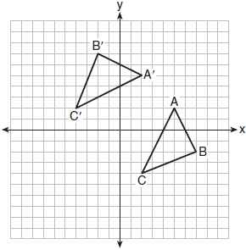

Which rigid motion would map onto ?
1) | a rotation of 90 degrees counterclockwise about the origin
2) | a translation of three units to the left and three units up
3) | a rotation of 180 degrees about the origin
4) | a reflection over the line

7 On the set of axes below, .

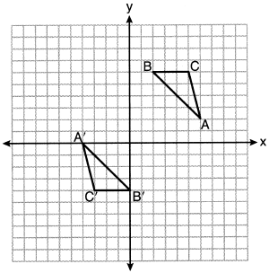
Triangle ABC maps onto after a
1) | reflection over the line
2) | reflection over the line
3) | rotation of 180° centered at (1,1)
4) | rotation of 180° centered at the origin

8 On the set of axes below, rectangle ABCD can be proven congruent to rectangle KLMN using which transformation?

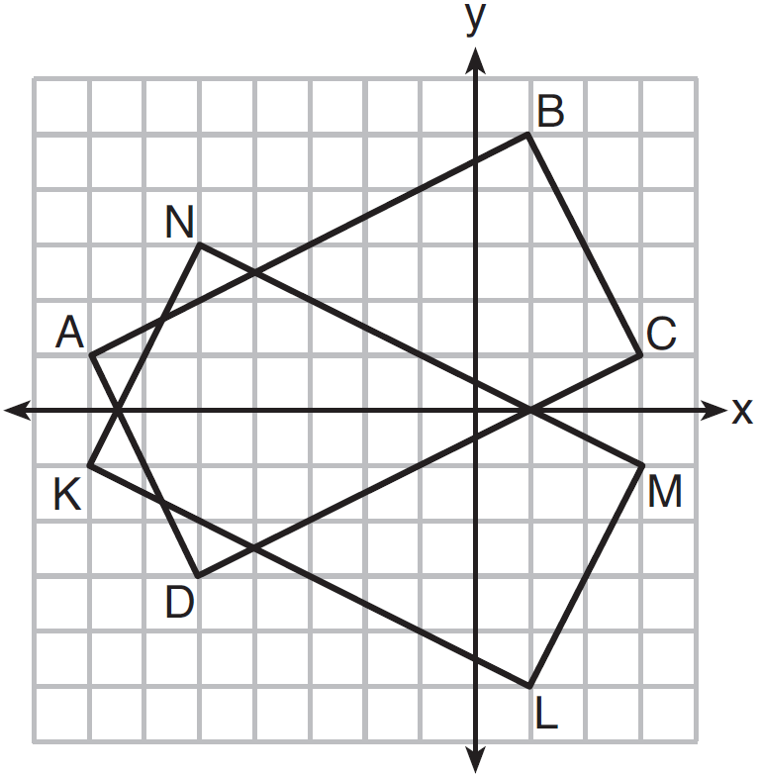
1) | rotation
2) | translation
3) | reflection over the x-axis
4) | reflection over the y-axis

9 Trapezoid ABCD is graphed on the set of axes below.

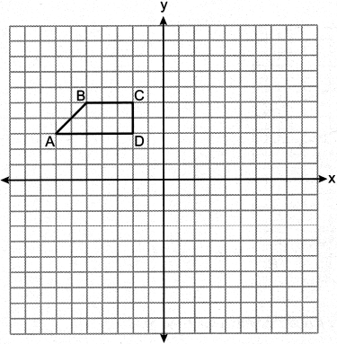

Which transformation would map point A onto ?
1) | reflection over
2) | reflection over the y-axis
3) | rotation of 180° about
4) | rotation of 90° counterclockwise about

10 Which transformation would not always produce an image that would be congruent to the original figure?
1) | translation
2) | dilation
3) | rotation
4) | reflection

11 The vertices of have coordinates , , and ). Under which transformation is the image not congruent to ?
1) | a translation of two units to the right and two units down
2) | a counterclockwise rotation of 180 degrees around the origin
3) | a reflection over the x-axis
4) | a dilation with a scale factor of 2 and centered at the origin

12 If is the image of , under which transformation will the triangles not be congruent?
1) | reflection over the x-axis
2) | translation to the left 5 and down 4
3) | dilation centered at the origin with scale factor 2
4) | rotation of 270° counterclockwise about the origin

13 Under which transformation would , the image of , not be congruent to ?
1) | reflection over the y-axis
2) | rotation of 90° clockwise about the origin
3) | translation of 3 units right and 2 units down
4) | dilation with a scale factor of 2 centered at the origin

14 The image of is . Under which transformation will he triangles not be congruent?
1) | a reflection through the origin
2) | a reflection over the line
3) | a dilation with a scale factor of 1 centered at
4) | a dilation with a scale factor of centered at the origin

15 On the set of axes below, congruent triangles ABC and DEF are graphed.

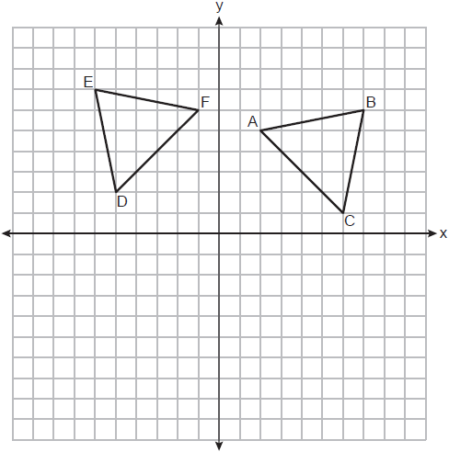

Describe a sequence of rigid motions that maps onto .

16 Triangle ABC has vertices at , , and , and triangle DEF has vertices at , , and . Graph and label and on the set of axes below. Determine and state the single transformation where is the image of . Use your transformation to explain why .

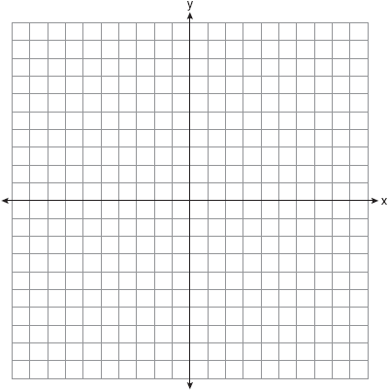
1 ANS: 2 REF: 081513geo

2 ANS: 4 REF: 061803geo

3 ANS: 2 REF: 082322geo

4 ANS: 1 REF: 061604geo

5 ANS: 2 REF: spr2401geo

6 ANS: 4 REF: 011803geo

7 ANS: 3
Since orientation is preserved, a reflection has not occurred.

REF: 062205geo

8 ANS: 3 REF: 061616geo

9 ANS: 1 REF: 082413geo

10 ANS: 2 REF: 081602geo

11 ANS: 4 REF: 061502geo

12 ANS: 3 REF: 081502geo

13 ANS: 4 REF: 011706geo

14 ANS: 4 REF: 081702geo

15 ANS:
Rotation of 90º counterclockwise about the origin.

REF: 012428geo

16 ANS:
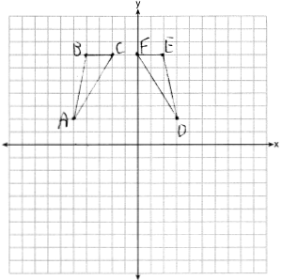 Reflections are rigid motions that preserve distance, so .

REF: 061732geo

