1 In the diagram below, under which transformation is the image of ?

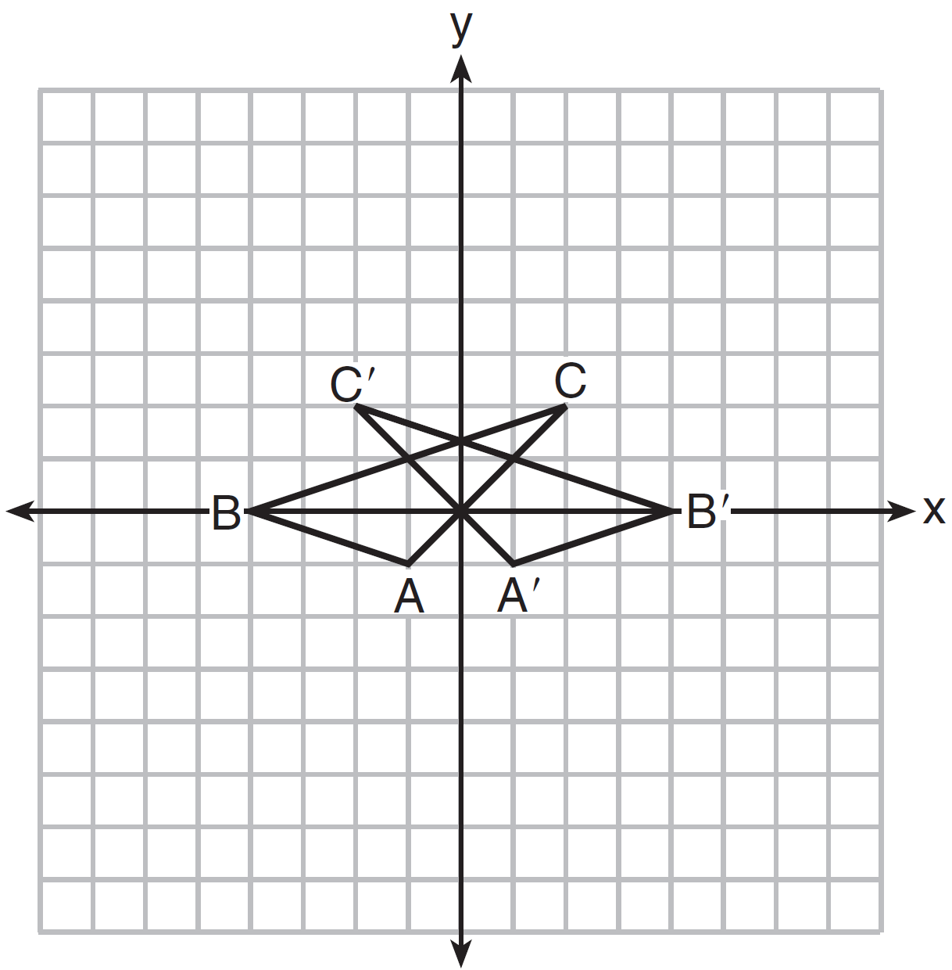
1)
2)
3)
4)

2 If and , which point on the accompanying graph represents ?

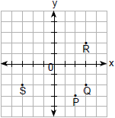
1) | P
2) | Q
3) | R
4) | S

3 If and , which point on the accompanying set of axes represents the translation ?

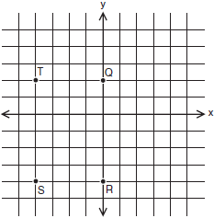
1) | Q
2) | R
3) | S
4) | T

4 In the accompanying graph, if point P has coordinates , which point has coordinates ?

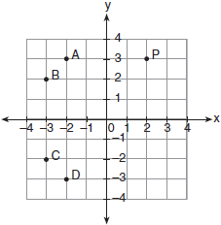
1) | A
2) | B
3) | C
4) | D

5 On the set of axes below, Geoff drew rectangle ABCD. He will transform the rectangle by using the translation and then will reflect the translated rectangle over the x-axis.

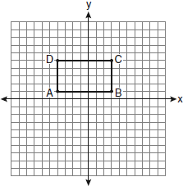

What will be the area of the rectangle after these transformations?
1) | exactly 28 square units
2) | less than 28 square units
3) | greater than 28 square units
4) | It cannot be determined from the information given.

6 In the accompanying graph, the shaded region represents set A of all points such that . The transformation T maps point to point .
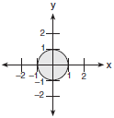
Which graph shows the mapping of set A by the transformation T?
1) | 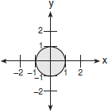
2) | 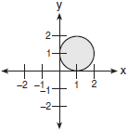
3) | 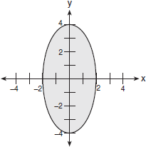
4) | 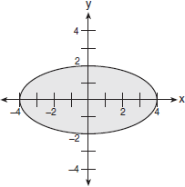

7 Matthew is a fan of the Air Force’s Thunderbirds flying team and is designing a jacket patch for the team, as shown in the accompanying diagram.

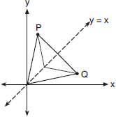

If P has the coordinates , what are the coordinates of Q, the reflection of P in the line ?
1)
2)
3)
4)

8 A triangle with vertices at , , and , is graphed on the set of axes below. A horizontal stretch of scale factor 2 with respect to , is represented by . Graph the image of this triangle, after the horizontal stretch on the same set of axes.

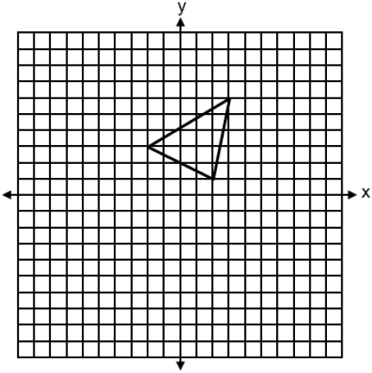

9 On the accompanying set of axes, draw , whose coordinates are , , and . Then draw, label, and state the coordinates of , the image of after the transformation that maps to . Based on your diagram, identify the type of transformation that was performed.

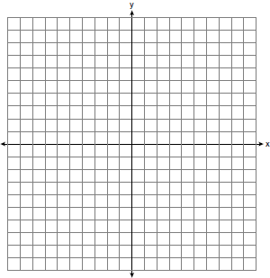

10 Triangle TAP has coordinates , , and . On the set of axes below, graph and label , the image of after the translation .

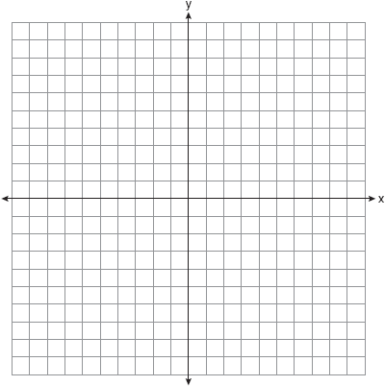

11 Given and and the transformations T, R, and S described below:
T:
R:
S:
a. Graph and its image after the transformation T.
b. Graph , the image of after the transformation R.
c. Graph , the image of after the transformation S.
d. Compare the slopes of the pairs of segments listed below and indicate whether these slopes are equal, reciprocals, additive inverses, or negative reciprocals.
(1) and
(2) and
(3) and

12 Triangle ABC has coordinates , , and . Given the transformations T, U, and W described below:
T:
U:
W:
a. Graph and graph and state the coordinates of its image , after transformation T.
b. Graph and state the coordinates of , the image of after transformation U.
c. Graph and state the coordinates of , the image of after transformation W.
d. Which transformation, T, U, or W, is not an isometry?
e. Which transformation, T, U, or W, does not preserve orientation?

13 Triangle ABC has vertices , , and .
a. On the set of axes below, graph and label and its image under each of the following transformations. State the coordinates of the vertices for each image of .
(1) T:
(2) U:
(3) W:
b. Which transformation, T, U, or W, is not an isometry?
c. Which transformation, T, U, or W, does not preserve orientation?

14 Given: F is the transformation
U is the transformation
N is the transformation
The coordinates of are , , and .
a. Sketch and its image after the transformation F.
b. Sketch , the image of after the transformation U.
c. Sketch , the image of after the transformation N.
d. Which transformation, F, U, or N, is a dilation?

15 The coordinates of the vertices of are , , and .
a On the graph below, draw and label .
b Graph and state the coordinates of , the image of after a reflection over the line .
c Graph and state the coordinates of , the image of after a reflection in the x-axis.
d Graph and state the coordinates of , the image of after the transformation .

1 ANS: 3 REF: 011304ge

2 ANS: 2 REF: 069908a

3 ANS: 2 REF: 080211a

4 ANS: 2 REF: 010418a

5 ANS: 1
Translations and reflections do not affect distance.

REF: 080908ge

6 ANS: 3 REF: 060405b

7 ANS: 2 REF: 010804b

8 ANS:
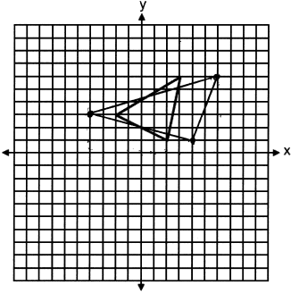

REF: spr2405geo

9 ANS:
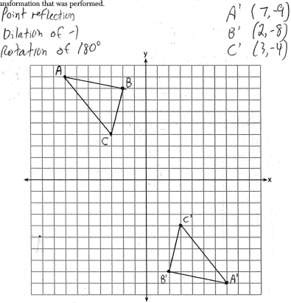

REF: 080838a

10 ANS:
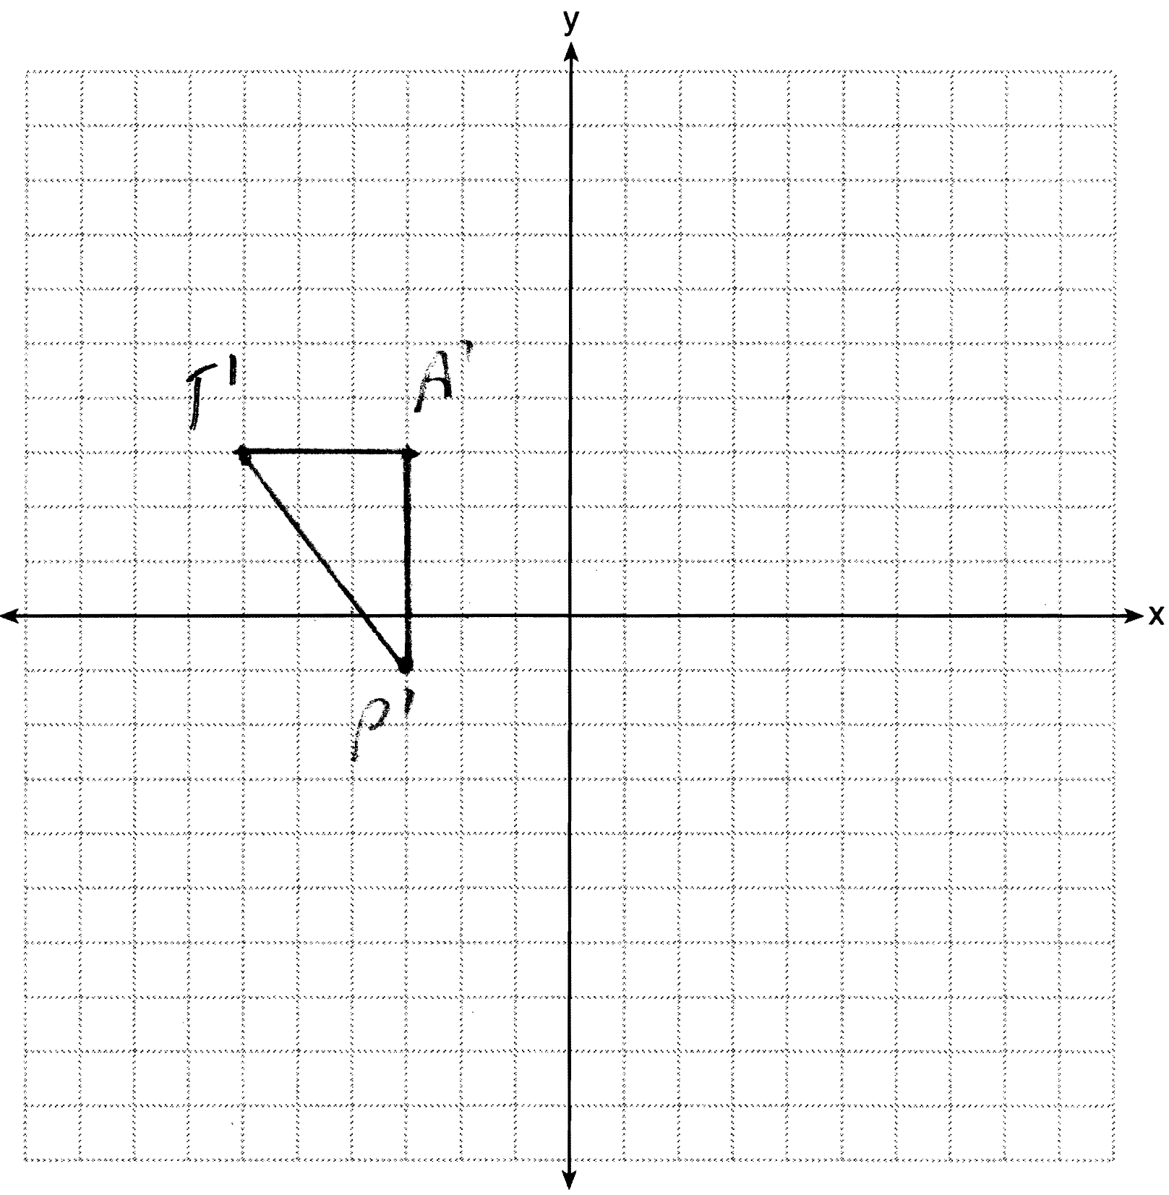

REF: 061229ge

11 ANS:
d (1) equal; (2) reciprocals; (3) additive inverses

REF: 068139siii

12 ANS:
a
b
c
d W
e T

REF: 018440siii

13 ANS:
a (1)
(2)
(3)
b W
c T

REF: 018639siii

14 ANS:
N

REF: 068041siii

15 ANS:
; ;

REF: 088440siii

