1 As shown in the diagram below, and intersect at point A and is perpendicular to both and at A.

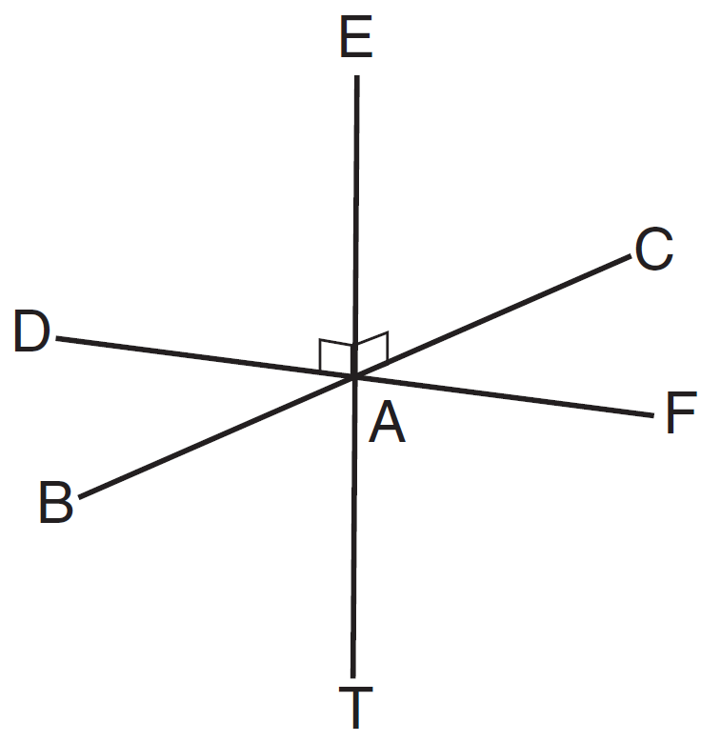

Which statement is not true?
1) | is perpendicular to plane BAD.
2) | is perpendicular to plane FAB.
3) | is perpendicular to plane CAD.
4) | is perpendicular to plane BAT.

2 In the prism shown below, and .

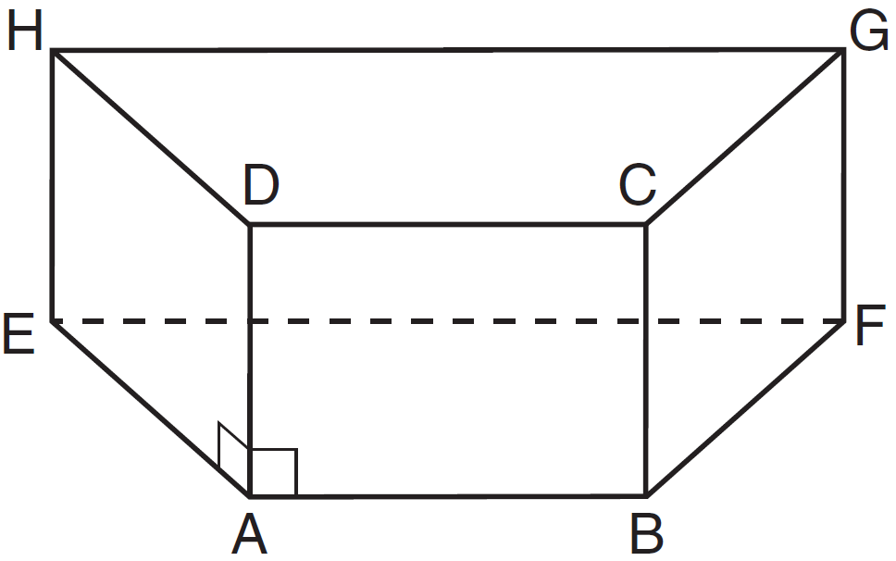

Which plane is perpendicular to ?
1) | HEA
2) | BAD
3) | EAB
4) | EHG

3 In the diagram below, point K is in plane P.

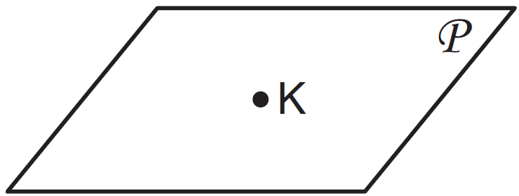

How many lines can be drawn through K, perpendicular to plane P ?
1) | 1
2) | 2
3) | 0
4) | an infinite number

4 As shown in the diagram below, is contained in plane R, and are contained in plane S, and , , and intersect at A.

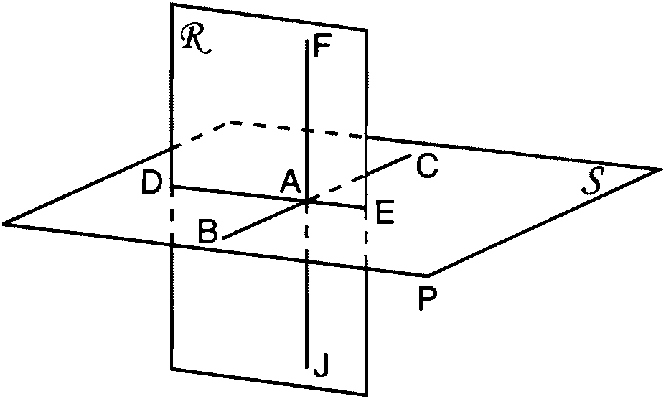

Which fact is sufficient to show that planes R and S are perpendicular?
1)
2)
3)
4)

5 In the diagram below, point P is not on line .

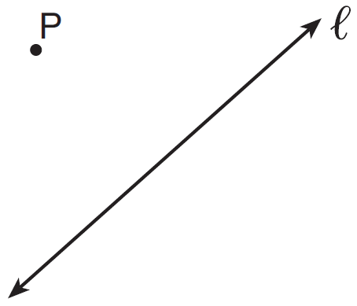

How many distinct planes that contain point P are also perpendicular to line ?
1) | 1
2) | 2
3) | 0
4) | an infinite amount

6 As shown in the diagram below, intersects planes P, Q, and R.

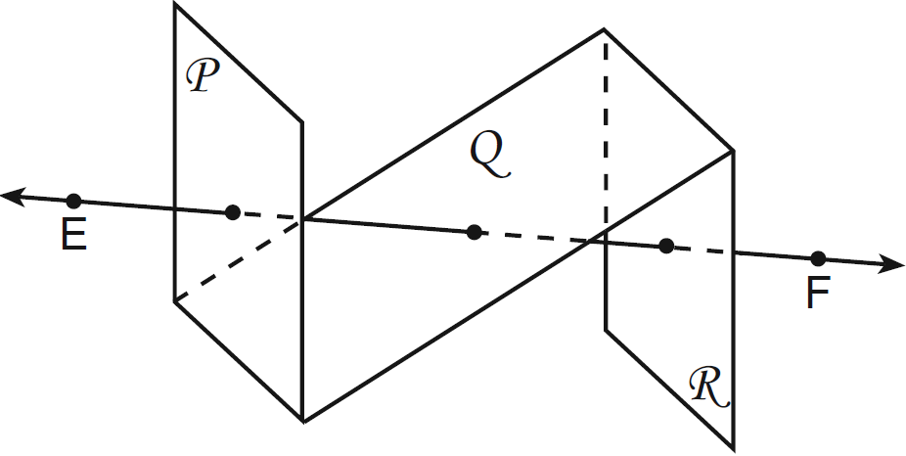

If is perpendicular to planes P and R, which statement must be true?
1) | Plane P is perpendicular to plane Q.
2) | Plane R is perpendicular to plane P.
3) | Plane P is parallel to plane Q.
4) | Plane R is parallel to plane P.

7 Point W is located in plane R . How many distinct lines passing through point W are perpendicular to plane R ?
1) | one
2) | two
3) | zero
4) | infinite

8 If line is perpendicular to distinct planes P and Q, then planes P and Q
1) | are parallel
2) | contain line
3) | are perpendicular
4) | intersect, but are not perpendicular

9 If distinct planes R and S are both perpendicular to line , which statement must always be true?
1) | Plane R is parallel to plane S.
2) | Plane R is perpendicular to plane S.
3) | Planes R and S and line are all parallel.
4) | The intersection of planes R and S is perpendicular to line .

10 Point A lies in plane B. How many lines can be drawn perpendicular to plane B through point A?
1) | one
2) | two
3) | zero
4) | infinite

11 Point A is on line m. How many distinct planes will be perpendicular to line m and pass through point A?
1) | one
2) | two
3) | zero
4) | infinite

12 Lines a and b intersect at point P. Line c passes through P and is perpendicular to the plane containing lines a and b. Which statement must be true?
1) | Lines a, b, and c are coplanar.
2) | Line a is perpendicular to line b.
3) | Line c is perpendicular to both line a and line b.
4) | Line c is perpendicular to line a or line b, but not both.

13 Plane A and plane B are two distinct planes that are both perpendicular to line . Which statement about planes A and B is true?
1) | Planes A and B have a common edge, which forms a line.
2) | Planes A and B are perpendicular to each other.
3) | Planes A and B intersect each other at exactly one point.
4) | Planes A and B are parallel to each other.

14 Plane P is parallel to plane Q. If plane P is perpendicular to line , then plane Q
1) | contains line
2) | is parallel to line
3) | is perpendicular to line
4) | intersects, but is not perpendicular to line

15 If is contained in plane P, and is perpendicular to plane R, which statement is true?
1) | is parallel to plane R.
2) | Plane P is parallel to plane R.
3) | is perpendicular to plane P.
4) | Plane P is perpendicular to plane R.

16 Point A lies on plane P. How many distinct lines passing through point A are perpendicular to plane P?
1) | 1
2) | 2
3) | 0
4) | infinite

1 ANS: 4 REF: 011315ge

2 ANS: 3 REF: 061522ge

3 ANS: 1 REF: 061418ge

4 ANS: 3
As originally administered, this question read, “Which fact is not sufficient to show that planes R and S are perpendicular?” The State Education Department stated that since a correct solution was not provided for Question 11, all students shall be awarded credit for this question.

REF: 081211ge

5 ANS: 1 REF: 081514ge

6 ANS: 4 REF: 061203ge

7 ANS: 1 REF: 011512ge

8 ANS: 1 REF: 081323ge

9 ANS: 1 REF: 011404ge

10 ANS: 1 REF: 011218ge

11 ANS: 1 REF: 061310ge

12 ANS: 3 REF: 081218ge

13 ANS: 4 REF: 011306ge

14 ANS: 3 REF: 061401ge

15 ANS: 4 REF: 061213ge

16 ANS: 1 REF: 061514ge

