1 In the diagram below, line k is perpendicular to plane P at point T.

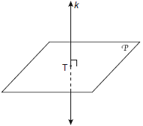

Which statement is true?
1) | Any point in plane P also will be on line k.
2) | Only one line in plane P will intersect line k.
3) | All planes that intersect plane P will pass through T.
4) | Any plane containing line k is perpendicular to plane P.

2 In the diagram below, is perpendicular to plane AEFG.

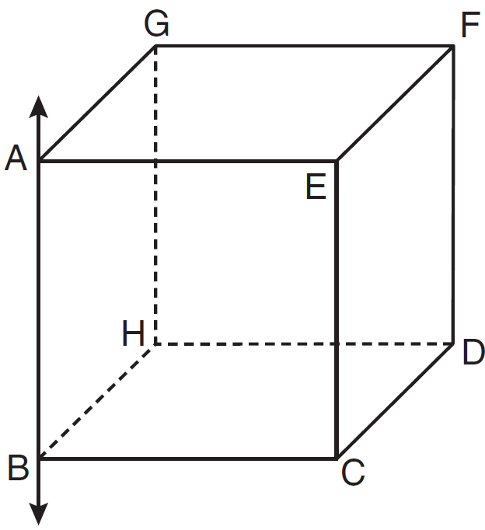

Which plane must be perpendicular to plane AEFG?
1) | ABCE
2) | BCDH
3) | CDFE
4) | HDFG

3 Lines and intersect at point E. Line m is perpendicular to lines and at point E.

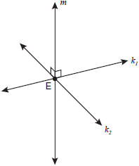

Which statement is always true?
1) | Lines and are perpendicular.
2) | Line m is parallel to the plane determined by lines and .
3) | Line m is perpendicular to the plane determined by lines and .
4) | Line m is coplanar with lines and .

4 If two different lines are perpendicular to the same plane, they are
1) | collinear
2) | coplanar
3) | congruent
4) | consecutive

5 Point P lies on line m. Point P is also included in distinct planes Q, R, S, and T. At most, how many of these planes could be perpendicular to line m?
1) | 1
2) | 2
3) | 3
4) | 4

6 In plane P, lines m and n intersect at point A. If line k is perpendicular to line m and line n at point A, then line k is
1) | contained in plane P
2) | parallel to plane P
3) | perpendicular to plane P
4) | skew to plane P

7 Lines j and k intersect at point P. Line m is drawn so that it is perpendicular to lines j and k at point P. Which statement is correct?
1) | Lines j and k are in perpendicular planes.
2) | Line m is in the same plane as lines j and k.
3) | Line m is parallel to the plane containing lines j and k.
4) | Line m is perpendicular to the plane containing lines j and k.

8 In three-dimensional space, two planes are parallel and a third plane intersects both of the parallel planes. The intersection of the planes is a
1) | plane
2) | point
3) | pair of parallel lines
4) | pair of intersecting lines

9 Line k is drawn so that it is perpendicular to two distinct planes, P and R. What must be true about planes P and R?
1) | Planes P and R are skew.
2) | Planes P and R are parallel.
3) | Planes P and R are perpendicular.
4) | Plane P intersects plane R but is not perpendicular to plane R.

10 Plane A is parallel to plane B. Plane C intersects plane A in line m and intersects plane B in line n. Lines m and n are
1) | intersecting
2) | parallel
3) | perpendicular
4) | skew

11 Lines m and n intersect at point A. Line k is perpendicular to both lines m and n at point A. Which statement must be true?
1) | Lines m, n, and k are in the same plane.
2) | Lines m and n are in two different planes.
3) | Lines m and n are perpendicular to each other.
4) | Line k is perpendicular to the plane containing lines m and n.

12 Point A is not contained in plane B. How many lines can be drawn through point A that will be perpendicular to plane B?
1) | one
2) | two
3) | zero
4) | infinite

13 Plane R is perpendicular to line k and plane D is perpendicular to line k. Which statement is correct?
1) | Plane R is perpendicular to plane D.
2) | Plane R is parallel to plane D.
3) | Plane R intersects plane D.
4) | Plane R bisects plane D.

14 Through a given point, P, on a plane, how many lines can be drawn that are perpendicular to that plane?
1) | 1
2) | 2
3) | more than 2
4) | none

15 If two distinct planes, A and B, are perpendicular to line c, then which statement is true?
1) | Planes A and B are parallel to each other.
2) | Planes A and B are perpendicular to each other.
3) | The intersection of planes A and B is a line parallel to line c.
4) | The intersection of planes A and B is a line perpendicular to line c.

16 A support beam between the floor and ceiling of a house forms a 90º angle with the floor. The builder wants to make sure that the floor and ceiling are parallel. Which angle should the support beam form with the ceiling?
1) | 45º
2) | 60º
3) | 90º
4) | 180º

17 Point P is on line m. What is the total number of planes that are perpendicular to line m and pass through point P?
1) | 1
2) | 2
3) | 0
4) | infinite

1 ANS: 4 REF: 080914ge

2 ANS: 1 REF: 081116ge

3 ANS: 3 REF: fall0816ge

4 ANS: 2 REF: 080927ge

5 ANS: 1 REF: 011128ge

6 ANS: 3 REF: 061017ge

7 ANS: 4 REF: 011012ge

8 ANS: 3 REF: 060928ge

9 ANS: 2 REF: fall0806ge

10 ANS: 2 REF: 081120ge

11 ANS: 4 REF: 061118ge

12 ANS: 1 REF: 081008ge

13 ANS: 2 REF: 011109ge

14 ANS: 1 REF: 011024ge

15 ANS: 1 REF: 061108ge

16 ANS: 3 REF: 081002ge

17 ANS: 1 REF: 060918ge

