1 What are the coordinates of the midpoint of the line segment with endpoints and ?
1) 2) 3) 4)

2 The endpoints of are and . What are the coordinates of the midpoint of ?
1) 2) 3) 4)

3 A line segment has endpoints and . What are the coordinates of the midpoint of ?
1) 2) 3) 4)

4 The coordinates of A are and the coordinates of G are . What are the coordinates of the midpoint of ?
1) 2) 3) 4)

5 Line segment AB has endpoints and . What are the coordinates of the midpoint of ?
1) 2) 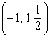 3) 4) 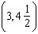

6 What is the midpoint of the line segment that joins points and ?
1) 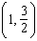 2) 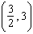 3) 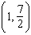 4) 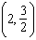

7 If a line segment has endpoints and , what are the coordinates of the midpoint of ?
1) 2) 3) 4)

8 Point M is the midpoint of . If the coordinates of A are and the coordinates of M are , what are the coordinates of B?
1) 2) 3) 4)

9 The midpoint of is . If the coordinates of A are , what are the coordinates of B?
1) 2) 3) 4)

10 Point M is the midpoint of . If the coordinates of M are and the coordinates of A are , what are the coordinates of B?
1) 2) 3) 4)

11 M is the midpoint of . If the coordinates of A are and the coordinates of M are , what are the coordinates of B?
1) 2) 3) 4)

12 The midpoint of has coordinates of . If the coordinates of A are , what are the coordinates of B?
1) 2) 3) 4)

13 The midpoint of is and the coordinates of point A are . What are the coordinates of point B?
1) 2) 3) 4)

14 A line segment on the coordinate plane has endpoints and . The midpoint of the segment is point (3,7). What is the value of y?
1) 11 2) 10 3) 5 4)

15 The midpoint M of line segment AB has coordinates . If point A is the origin, , what are the coordinates of point B? [The use of the accompanying grid is optional.]



16 The coordinates of the midpoint of are , and the coordinates of point B are . What are the coordinates of point A? [The use of the accompanying grid is optional.]



17 One endpoint of a line segment is . The midpoint of the segment is . Find the coordinates of the other endpoint. [The use of the grid is optional.]

1 ANS: 4
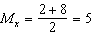. 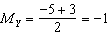.

REF: 011502ge

2 ANS: 2
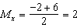. 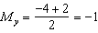

REF: 080910ge

3 ANS: 2
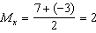. 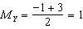.

REF: 011106ge

4 ANS: 1
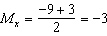. 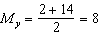.

REF: 080624a

5 ANS: 2
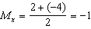. 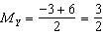.

REF: fall0813ge

6 ANS: 1
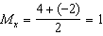. 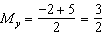.

REF: 060822a

7 ANS: 2
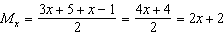. 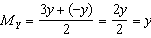.

REF: 081019ge

8 ANS: 4
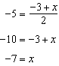. 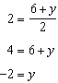

REF: 081203ge

9 ANS: 2
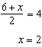. 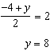

REF: 011401ge

10 ANS: 2
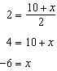. 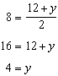

REF: 061505ge

11 ANS: 3
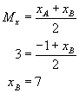. 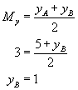.

REF: 080217a

12 ANS: 1
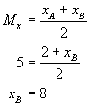. 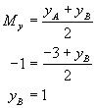.

REF: 010914a

13 ANS: 1
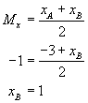. 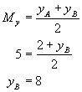.

REF: 010718a

14 ANS: 2
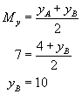

REF: 080515a

15 ANS:
. 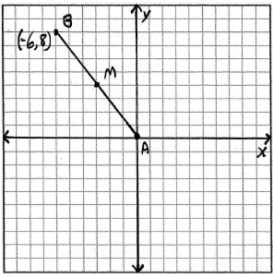

REF: 010021a

16 ANS:
. 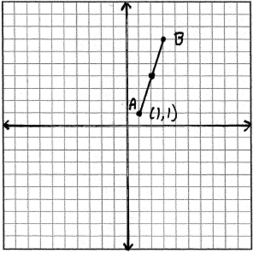

REF: 060434a

17 ANS:
. 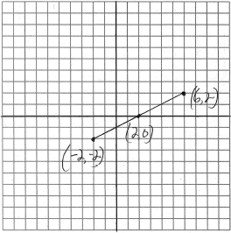

REF: 080834a

