1 A line segment has endpoints and . What is the length of the segment?
1) | 5
2) | 7
3) | 16
4) | 25

2 What is the length, to the nearest tenth, of the line segment joining the points and ?
1) | 141.4
2) | 150.5
3) | 151.9
4) | 158.1

3 What is the length of a line segment whose endpoints have coordinates and ?
1) | 5
2) | 25
3)
4)

4 What is the length of the line segment whose endpoints are and ?
1) | 5
2)
3) | 10
4)

5 What is the length of the line segment with endpoints and ?
1)
2)
3)
4)

6 What is the distance between points and ?
1)
2)
3)
4)

7 If the endpoints of are and , what is the length of ?
1)
2) | 2
3)
4) | 8

8 What is the length of with and ?
1)
2) | 40
3)
4)

9 What is the length of the line segment whose endpoints are and ?
1)
2)
3)
4)

10 What is the length of with endpoints and ?
1)
2)
3)
4)

11 What is the distance between the points and ?
1)
2)
3)
4)

12 The coordinates of point R are and the coordinates of point T are . What is the length of ?
1)
2)
3)
4)

13 What is the length of the line segment that joins the points whose coordinates are and ?
1)
2)
3)
4)

14 Line segment AB has endpoint A located at the origin. Line segment AB is longest when the coordinates of B are
1)
2)
3)
4)

15 Determine and state the length of a line segment whose endpoints are and .

16 The endpoints of are and . Find the length of .

17 The coordinates of the endpoints of are and . Find the length of in simplest radical form.

18 Find, in simplest radical form, the length of the line segment with endpoints whose coordinates are and .

19 The endpoints of are and . Determine and state the length of in simplest radical form.

20 The coordinates of the endpoints of are and . Find the length of in simplest radical form.

21 Jerry and Jean Jogger start at the same time from point A shown on the accompanying set of axes. Jerry jogs at a rate of 5 miles per hour traveling from point A to point R to point S and then to point C. Jean jogs directly from point A to point C on at the rate of 3 miles per hour. Which jogger reaches point C first? Explain or show your reasoning.
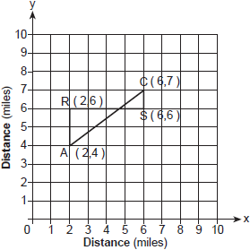

22 To get from his high school to his home, Jamal travels 5.0 miles east and then 4.0 miles north. When Sheila goes to her home from the same high school, she travels 8.0 miles east and 2.0 miles south. What is the measure of the shortest distance, to the nearest tenth of a mile, between Jamal’s home and Sheila’s home? [The use of the accompanying grid is optional.]

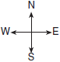

23 Two hikers started at the same location. One traveled 2 miles east and then 1 mile north. The other traveled 1 mile west and then 3 miles south. At the end of their hikes, how many miles apart are the two hikers? [The use of the accompanying grid is optional.]

24 Katrina hikes 5 miles north, 7 miles east, and then 3 miles north again. To the nearest tenth of a mile, how far, in a straight line, is Katrina from her starting point?
1 ANS: 1

REF: 011205ge

2 ANS: 4

REF: 061021ge

3 ANS: 1

REF: 011507ge

4 ANS: 3

REF: 081107ge

5 ANS: 4

REF: 081013ge

6 ANS: 4

REF: spring9811a

7 ANS: 1
.

REF: 080919ge

8 ANS: 3

REF: 061411ge

9 ANS: 2

REF: 061109ge

10 ANS: 3

REF: 061217ge

11 ANS: 4

REF: 011017ge

12 ANS: 2
.

REF: 010524a

13 ANS: 2
.

REF: 080726a

14 ANS: 2 REF: 081415ge

15 ANS:

REF: 011632ge

16 ANS:
25. .

REF: fall0831ge

17 ANS:
.

REF: 081232ge

18 ANS:

REF: 081331ge

19 ANS:
.

REF: 011431ge

20 ANS:
.

REF: 061533ge

21 ANS:
Since Jerry travels a distance of 7 miles at 5 mph, he arrives at Point C in 1.4 hours. Since Jean travels a distance of 5 () miles at 3 mph, she arrives at Point C in hours. Jerry reaches Point C first.

REF: 010226a

22 ANS:
6.7. . 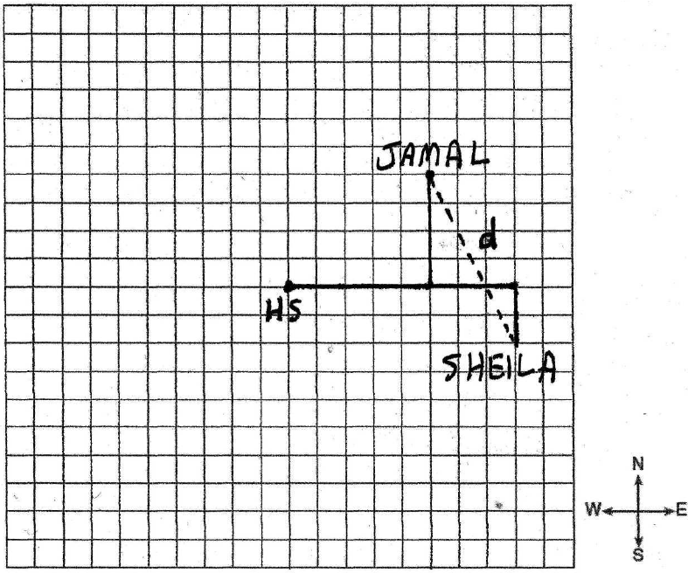

REF: 060330a

23 ANS:
5. . 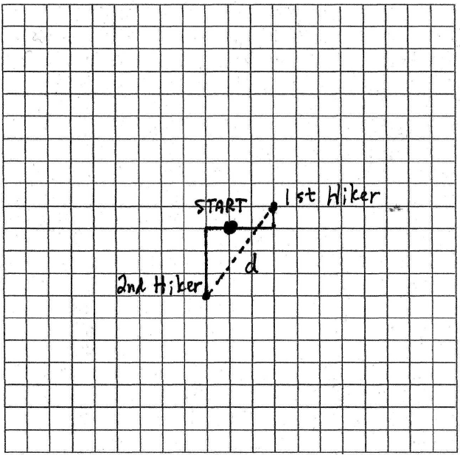

REF: 060633a

24 ANS:
10.6.

REF: 080030a

