1 A circle with a diameter of 10 cm and a central angle of 30° is drawn below.

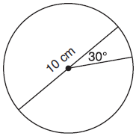

What is the area, to the nearest tenth of a square centimeter, of the sector formed by the 30° angle?
1) | 5.2
2) | 6.5
3) | 13.1
4) | 26.2

2 In the diagram below of circle O, and .

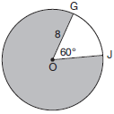

What is the area, in terms of , of the shaded region?
1)
2)
3)
4) | 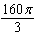

3 In circle O below, , and .

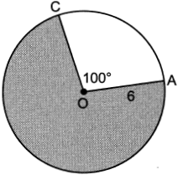

What is the area of the shaded sector?
1)
2)
3)
4)

4 Circle O with a radius of 9 is drawn below. The measure of central angle AOC is 120°.

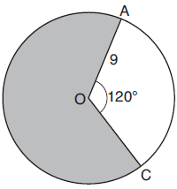

What is the area of the shaded sector of circle O?
1)
2)
3)
4)

5 Cerise waters her lawn with a sprinkler that sprays water in a circular pattern at a distance of 15 feet from the sprinkler. The sprinkler head rotates through an angle of 300°, as shown by the shaded area in the accompanying diagram.

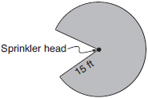

What is the area of the lawn, to the nearest square foot, that receives water from this sprinkler?
1) | 79
2) | 94
3) | 589
4) | 707

6 In circle P below, diameter and radius are drawn such that .

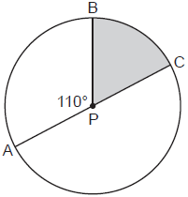

If , what is the area of shaded sector BPC?
1)
2)
3)
4)

7 Triangle FGH is inscribed in circle O, the length of radius is 6, and .

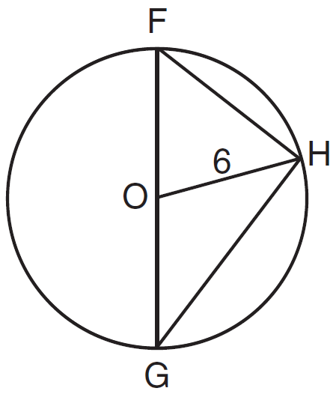

What is the area of the sector formed by angle FOH?
1)
2)
3)
4)

8 In the diagram below of circle O, and are chords, and .

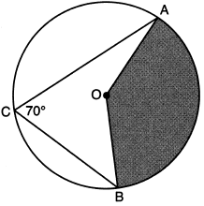

If , the area of the shaded sector AOB is
1)
2)
3)
4)

9 In circle B below, diameter , radius , and chord are drawn.

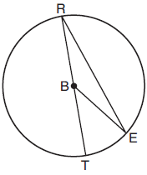

If and , then the area of sector EBR is
1)
2)
3)
4)

10 In the diagram below of circle O, tangent is drawn from external point B, and secant and diameter are drawn.

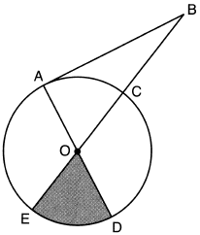

If and , what is the area of shaded sector DOE?
1)
2)
3)
4)

11 In the diagram below of circle O, the area of the shaded sector LOM is .

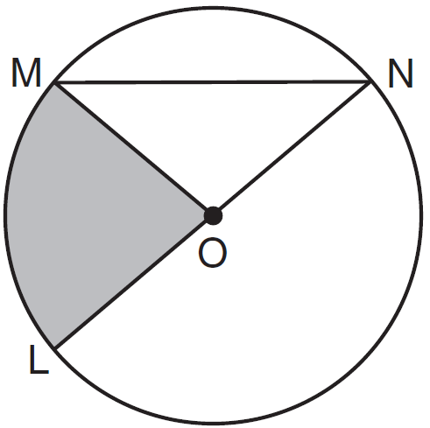

If the length of is 6 cm, what is ?
1) | 10º
2) | 20º
3) | 40º
4) | 80º

12 In circle O, diameter , chord , and radius are drawn, and the measure of arc BC is 108°.

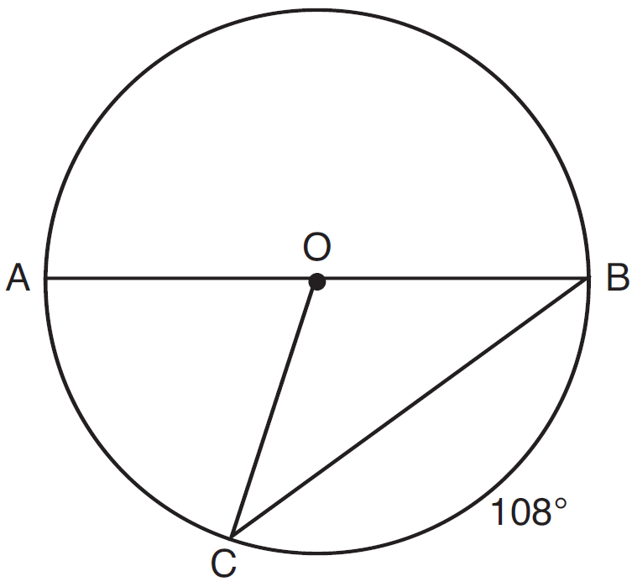

Some students wrote these formulas to find the area of sector COB:
Amy 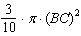
Beth 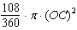
Carl 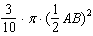
Dex 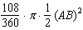
Which students wrote correct formulas?
1) | Amy and Dex
2) | Beth and Carl
3) | Carl and Amy
4) | Dex and Beth

13 The area of a sector of a circle with a radius measuring 15 cm is . What is the measure of the central angle that forms the sector?
1) | 72°
2) | 120°
3) | 144°
4) | 180°

14 What is the area of a sector of a circle with a radius of 8 inches and formed by a central angle that measures 60°?
1)
2)
3)
4)

15 In the diagram below, circle O has a radius of 10.
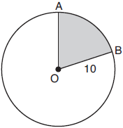

If , find the area of shaded sector AOB, in terms of .

16 The diagram below models the projection of light from a lighthouse, L. The sector has a radius of 38 miles and spans 102°.
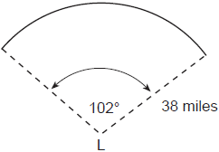
Determine and state the area of the sector, to the nearest square mile.

17 In the diagram below of circle O, diameter and radii and are drawn. The length of is 12 and the measure of is 20 degrees.

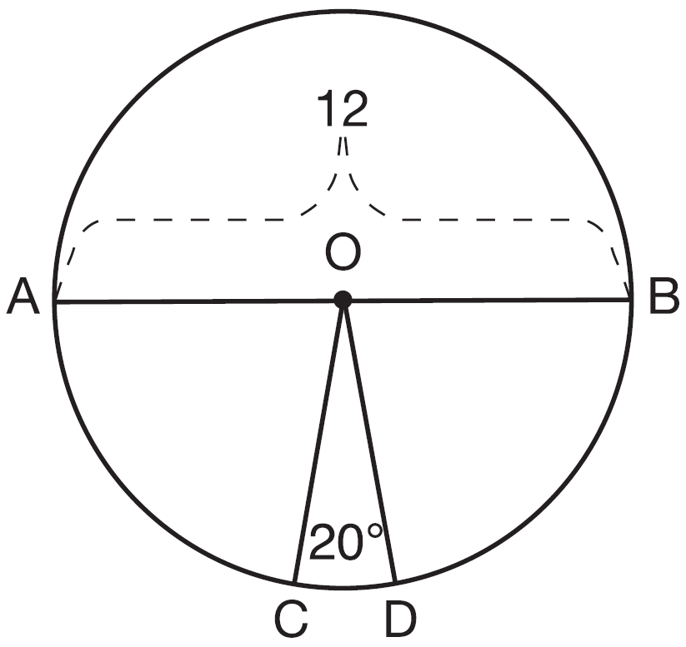

If , find the area of sector BOD in terms of .

18 In the diagram below of circle O, the measure of inscribed angle ABC is 36° and the length of is 4 inches.

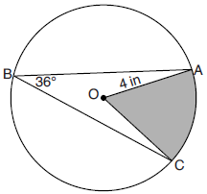

Determine and state, to the nearest tenth of a square inch, the area of the shaded sector.

19 In the diagram below of circle O, the area of the shaded sector AOC is and the length of is 6 inches. Determine and state .

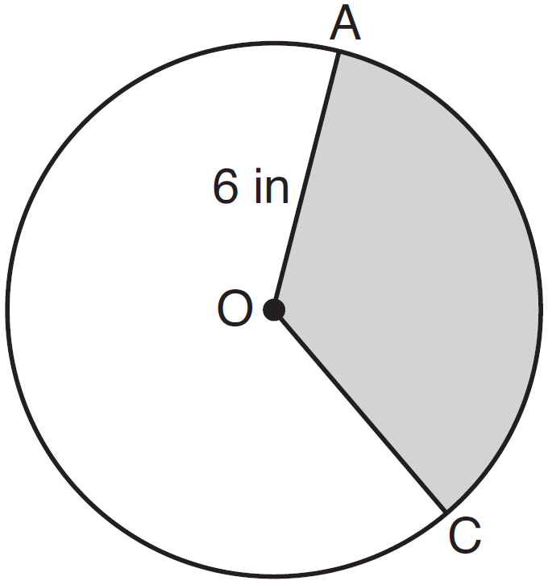

20 In the diagram below, the circle has a radius of 25 inches. The area of the unshaded sector is .

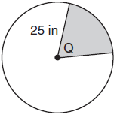

Determine and state the degree measure of angle Q, the central angle of the shaded sector.

21 A circle has a radius of 6.4 inches. Determine and state, to the nearest square inch, the area of a sector whose arc measures 80°.

22 Determine and state, in terms of π, the area of a sector that intercepts a 40° arc of a circle with a radius of 4.5.
1 ANS: 2
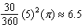

REF: 081818geo

2 ANS: 4
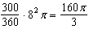

REF: 011721geo

3 ANS: 2
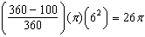

REF: 062411geo

4 ANS: 4
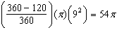

REF: 081912geo

5 ANS: 3
The area of the entire circle is The shaded area has an area of 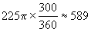

REF: 060716b

6 ANS: 2
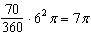

REF: 082309geo

7 ANS: 3
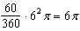

REF: 081518geo

8 ANS: 4
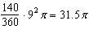

REF: 012317geo

9 ANS: 3
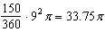

REF: 012013geo

10 ANS: 4
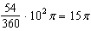

REF: 062224geo

11 ANS: 3
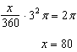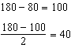

REF: 011612geo

12 ANS: 2 REF: 081619geo

13 ANS: 2
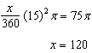

REF: 011914geo

14 ANS: 3
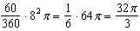

REF: 061624geo

15 ANS:
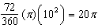

REF: 061928geo

16 ANS:
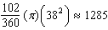

REF: 012426geo

17 ANS:
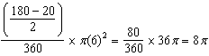

REF: spr1410geo

18 ANS:
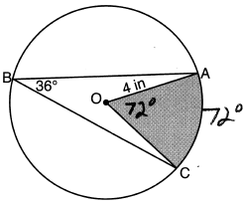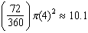

REF: 082231geo

19 ANS:
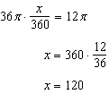

REF: 061529geo

20 ANS:
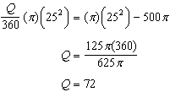

REF: 011828geo

21 ANS:
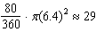

REF: 062328geo

22 ANS:
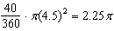

REF: 061726geo

