1 A circle is drawn to represent a pizza with a 12 inch diameter. The circle is cut into eight congruent pieces. What is the length of the outer edge of any one piece of this circle?
1)
2)
3)
4)

2 Ileana buys a large circular pizza that is divided into eight equal slices. She measures along the outer edge of the crust from one piece and finds it to be inches. What is the diameter of the pizza to the nearest inch?
1) | 14
2) | 8
3) | 7
4) | 4

3 The diagram below shows circle O with radii and . The measure of angle AOB is 120°, and the length of a radius is 6 inches.

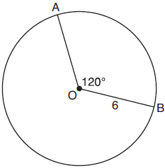

Which expression represents the length of arc AB, in inches?
1) | 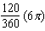
2)
3) | 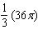
4) | 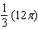

4 A ball is rolling in a circular path that has a radius of 10 inches, as shown in the accompanying diagram. What distance has the ball rolled when the subtended arc is 54°? Express your answer to the nearest hundredth of an inch.
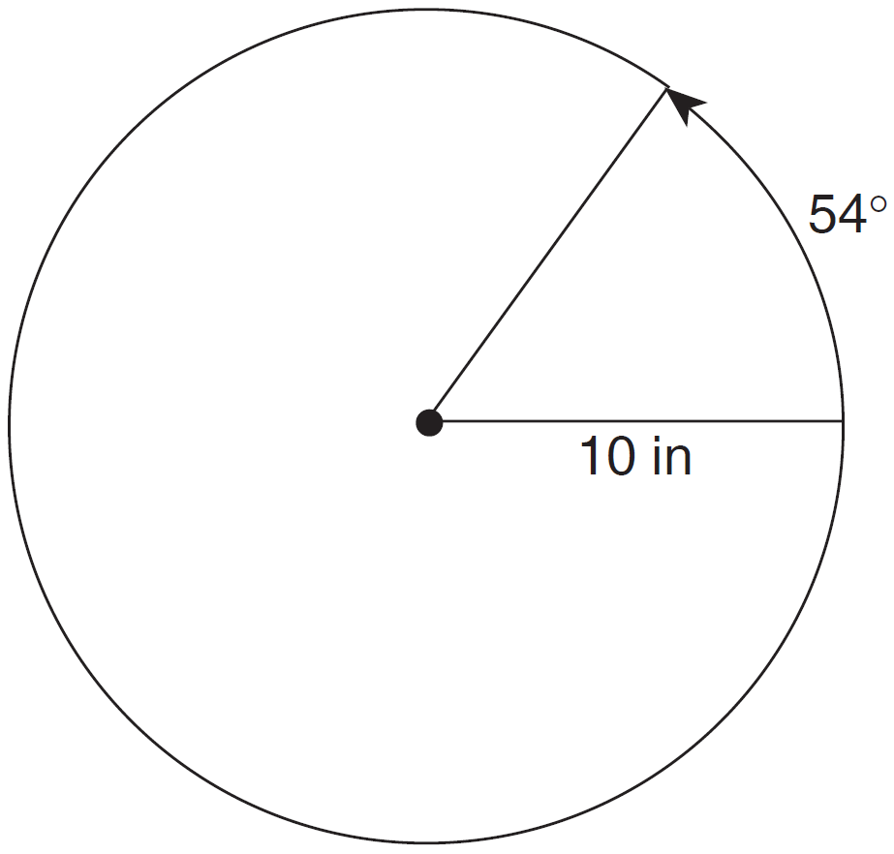

5 Cities H and K are located on the same line of longitude and the difference in the latitude of these cities is 9°, as shown in the accompanying diagram. If Earth’s radius is 3,954 miles, how many miles north of city K is city H along arc HK? Round your answer to the nearest tenth of a mile.
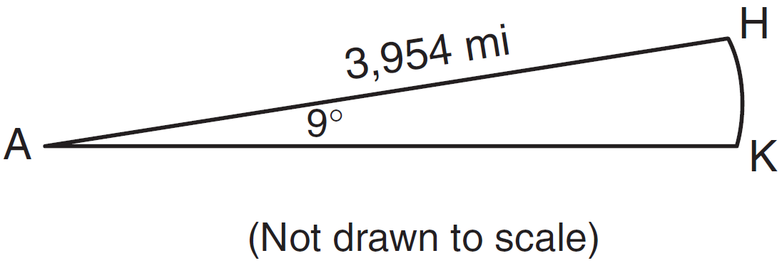

6 The accompanying diagram shows the path of a cart traveling on a circular track of radius 2.40 meters. The cart starts at point A and stops at point B, moving in a counterclockwise direction. What is the length of minor arc AB, over which the cart traveled, to the nearest tenth of a meter?
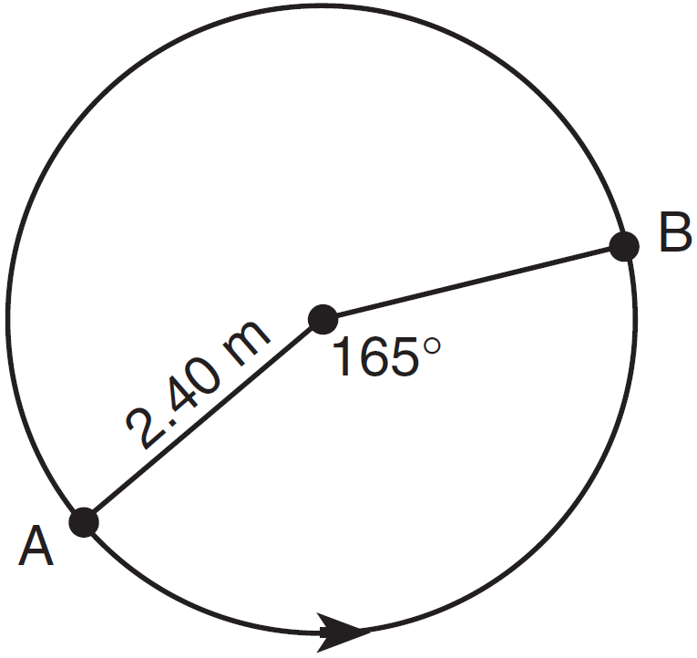

7 An electron travels along a circular path with a radius of 4.6 miles. What is the number of miles the electron traveled during an interval when the central angle formed by the electron’s path was 220°?
1) | 3.84
2) | 8.83
3) | 17.66
4) | 1012

8 A circle has a radius of 4.5. What is the measure of the central angle that intercepts an arc whose length is 6.2, to the nearest degree?
1) | 35º
2) | 42º
3) | 64º
4) | 79º

9 Kathy and Tami are at point A on a circular track that has a radius of 150 feet, as shown in the accompanying diagram. They run counterclockwise along the track from A to S, a distance of 247 feet. Find, to the nearest degree, the measure of minor arc AS.
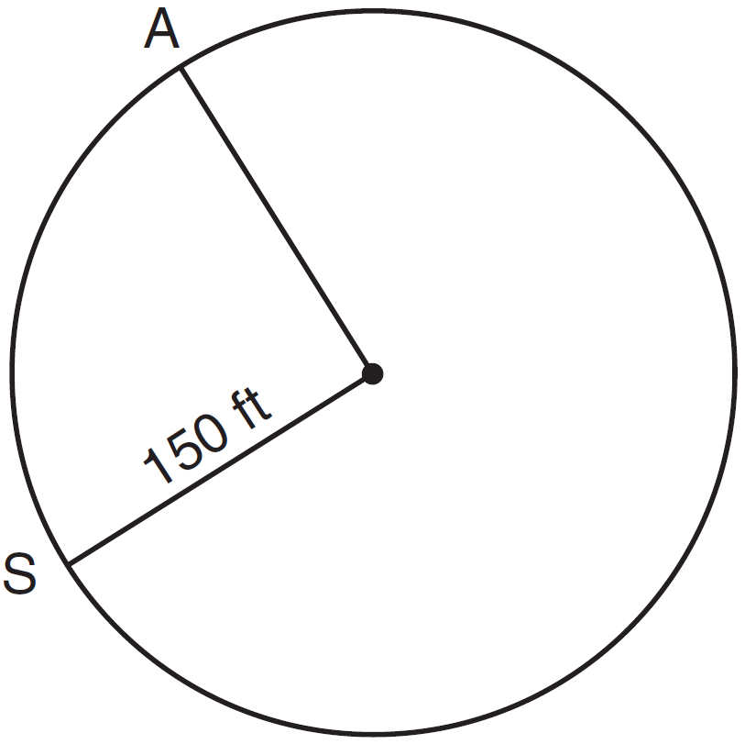

10 In the diagram below, two concentric circles with center O, and radii , , , and are drawn.
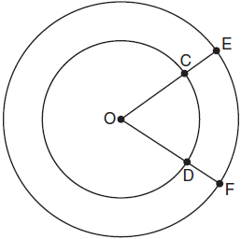

If and , which relationship between the length of arc EF and the length of arc CD is always true?
1) | The length of arc EF is 2 units longer than the length of arc CD.
2) | The length of arc EF is 4 units longer than the length of arc CD.
3) | The length of arc EF is 1.5 times the length of arc CD.
4) | The length of arc EF is 2.0 times the length of arc CD.

11 A regular hexagon is inscribed in a circle. What is the ratio of the length of a side of the hexagon to the minor arc that it intercepts?
1)
2)
3)
4)

1 ANS: 3
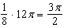

REF: 061212a2

2 ANS: 1
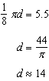

REF: 010307b

3 ANS: 4
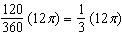

REF: 061822geo

4 ANS:
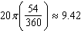

REF: 010223b

5 ANS:
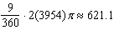

REF: 080426b

6 ANS:
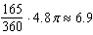

REF: 080524b

7 ANS: 3
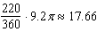

REF: 081622a2

8 ANS: 4
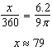

REF: 082424geo

9 ANS:
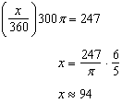

REF: 060531b

10 ANS: 3
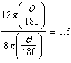

REF: 011824geo

11 ANS: 3
Assume the circle has a radius of 1. The hexagon can be divided into six equal equilateral triangles with sides of 1. The side of the hexagon is 1. The central angle created by the two legs of the triangle, , is 60º. 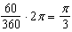. The ratio of the length of a side of the hexagon to the minor arc that it intercepts is or 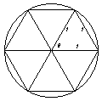

REF: 080109b

