1 In the diagram below, quadrilateral JUMP is inscribed in a circle..

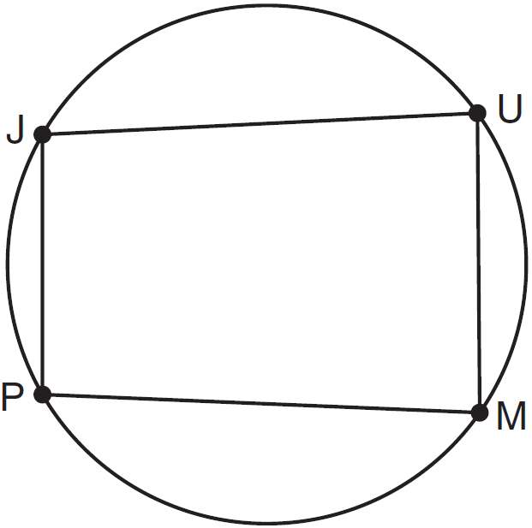

Opposite angles J and M must be
1) | right
2) | complementary
3) | congruent
4) | supplementary

2 In the diagram below, quadrilateral ABCD is inscribed in circle P.

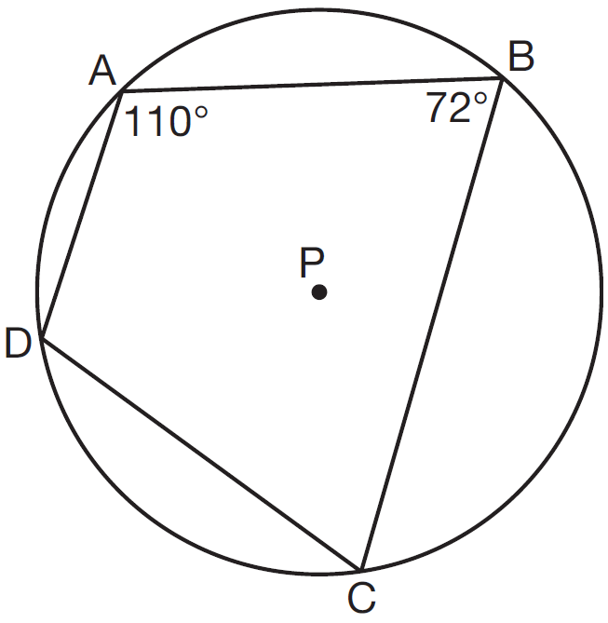

What is ?
1) | 70°
2) | 72°
3) | 108°
4) | 110°

3 Quadrilateral ABCD is inscribed in circle O, as shown below.

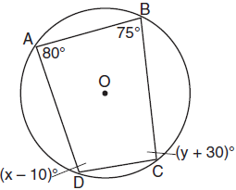

If , , , and , which statement is true?
1) | and
2) | and
3) | and
4) | and

4 In the diagram below, quadrilateral ABCD is inscribed in circle O, , , and .

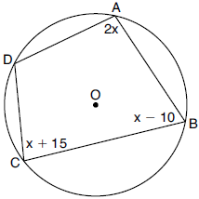

What is ?
1) | 55°
2) | 70°
3) | 110°
4) | 135°

5 Linda is designing a circular piece of stained glass with a diameter of 7 inches. She is going to sketch a square inside the circular region. To the nearest tenth of an inch, the largest possible length of a side of the square is
1) | 3.5
2) | 4.9
3) | 5.0
4) | 6.9

6 In the diagram below, trapezoid ABCD, with bases and , is inscribed in circle O, with diameter . If , find .

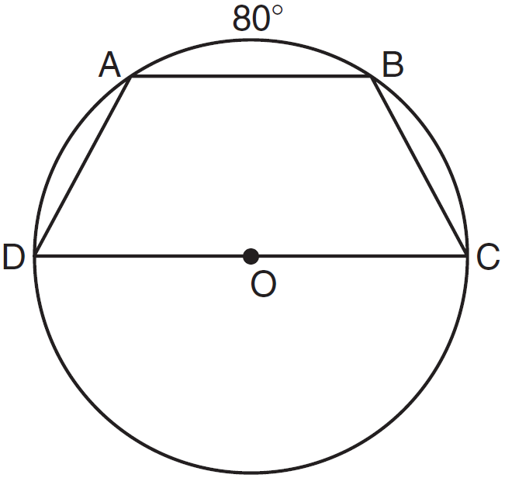

7 As shown in the diagram below, quadrilateral DEFG is inscribed in a circle and .

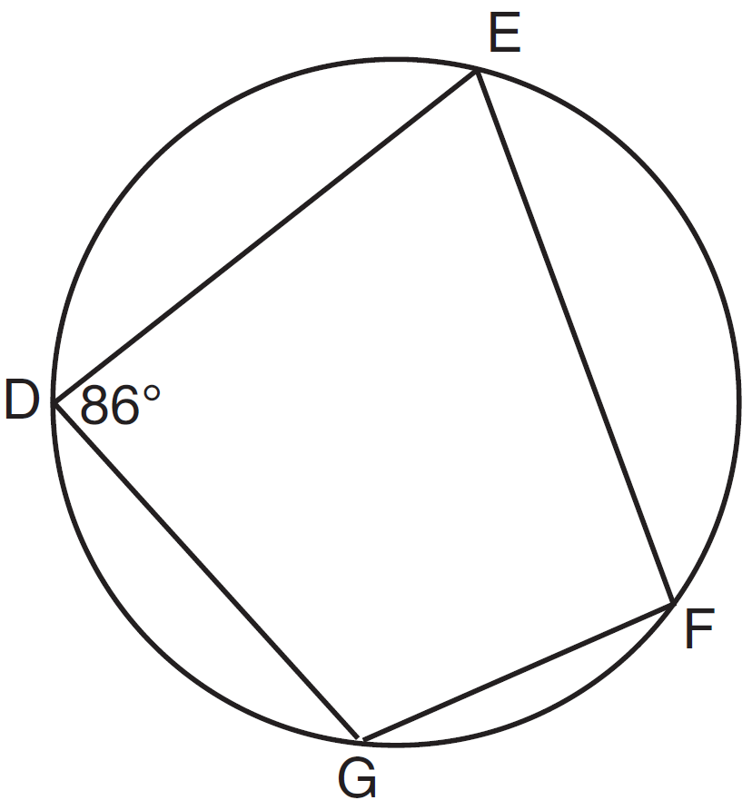

Determine and state . Determine and state .

8 In the accompanying diagram, quadrilateral ABCD is inscribed in circle O. If and , find .

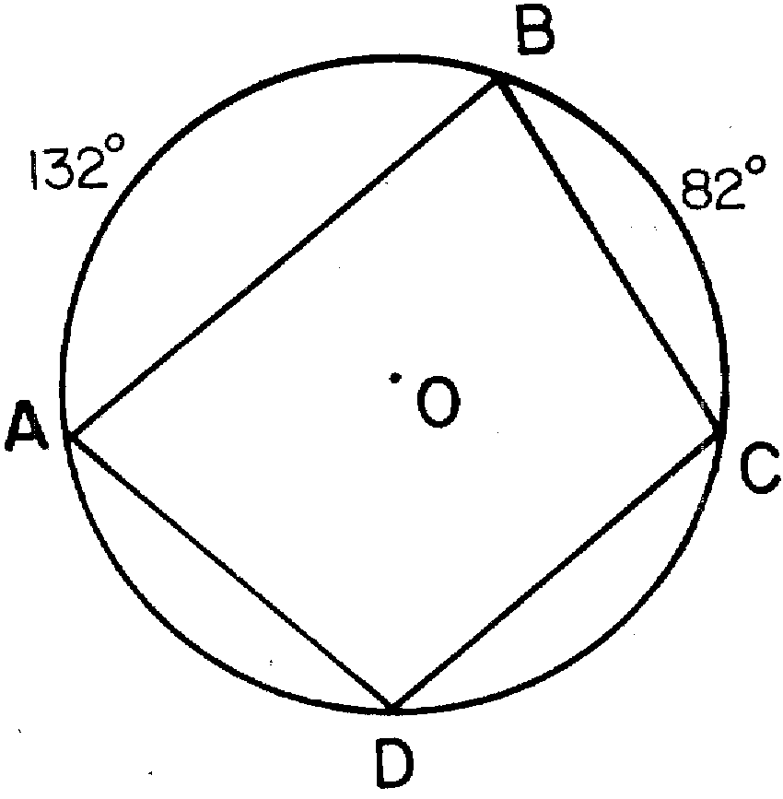

9 In the diagram below, quadrilateral ABCD is inscribed in circle O, and .

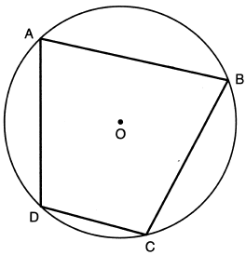

Determine and state .
1 ANS: 4 REF: 011124ge

2 ANS: 3 REF: 081515geo

3 ANS: 4
Opposite angles of an inscribed quadrilateral are supplementary.

REF: 011821geo

4 ANS: 4
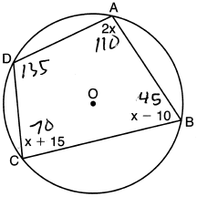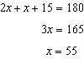

REF: 082224geo

5 ANS: 2
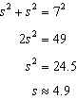

REF: 081511geo

6 ANS:
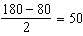

REF: 081129ge

7 ANS:

REF: 081432ge

8 ANS:
107

REF: 088408siii

9 ANS:
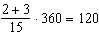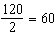
REF: 062226geo

