1 In the diagram of circle O below, chord is parallel to diameter and .

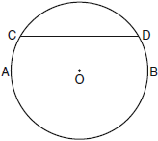

What is ?
1) | 150
2) | 120
3) | 100
4) | 60

2 In the diagram below of circle O, diameter is parallel to chord .

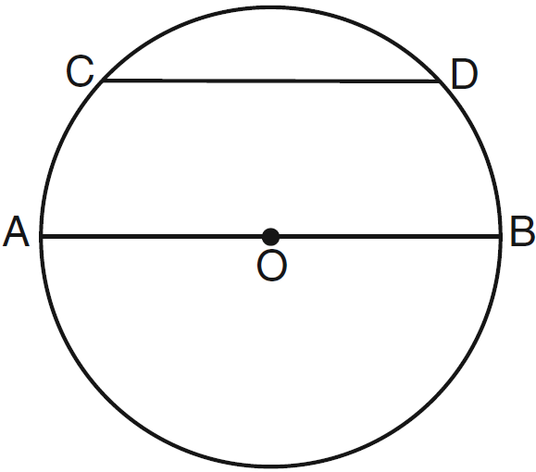

If , what is ?
1) | 110
2) | 70
3) | 55
4) | 35

3 In the diagram below of circle O, chord is parallel to diameter and .

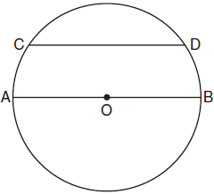

What is ?
1) | 25
2) | 50
3) | 65
4) | 115

4 In circle O shown in the diagram below, chords and are parallel.

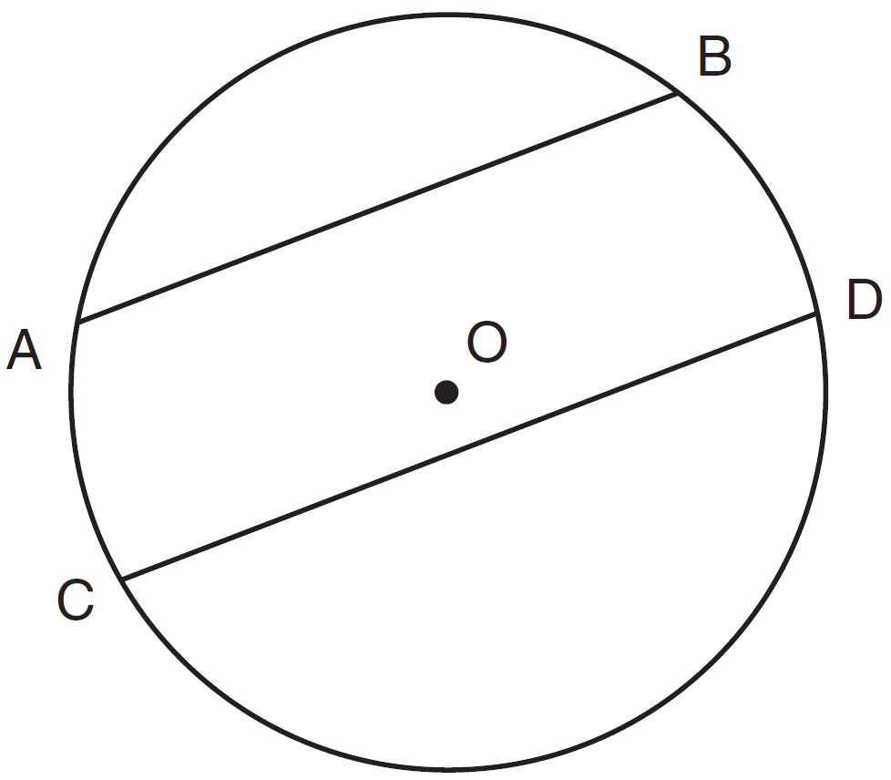

If and , what is ?
1) | 38
2) | 44
3) | 88
4) | 96

5 In the diagram of circle O below, chord is parallel to diameter and .

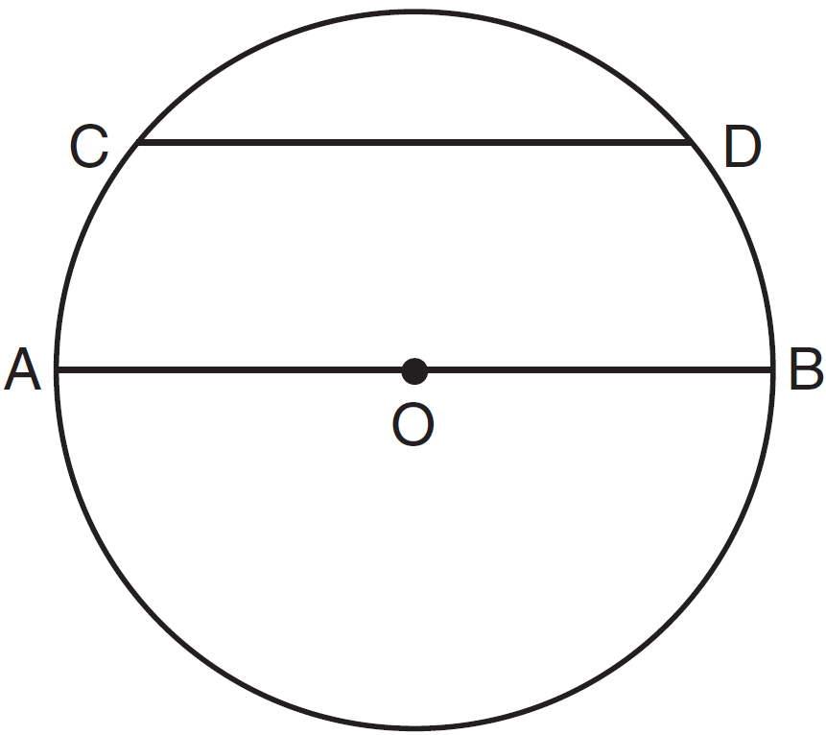

What is ?
1) | 35
2) | 55
3) | 70
4) | 110

6 In the diagram of the circle below, , , and .

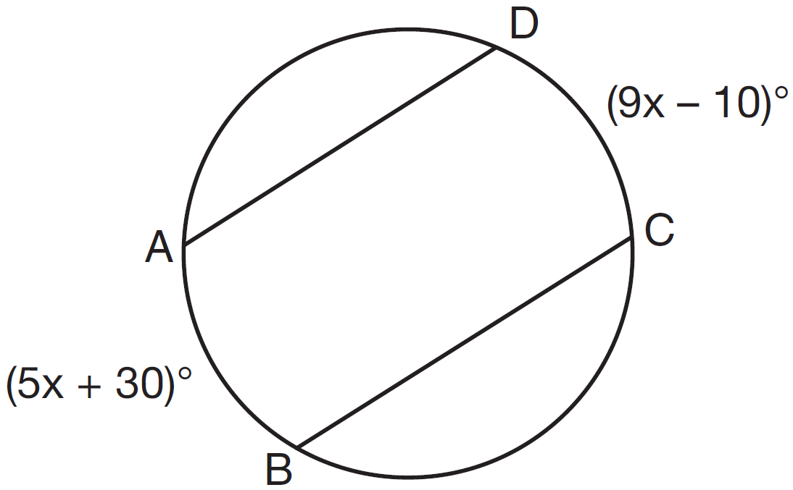

What is ?
1) | 5
2) | 10
3) | 55
4) | 80

7 In the diagram below, two parallel lines intersect circle O at points A, B, C, and D, with and . Find .

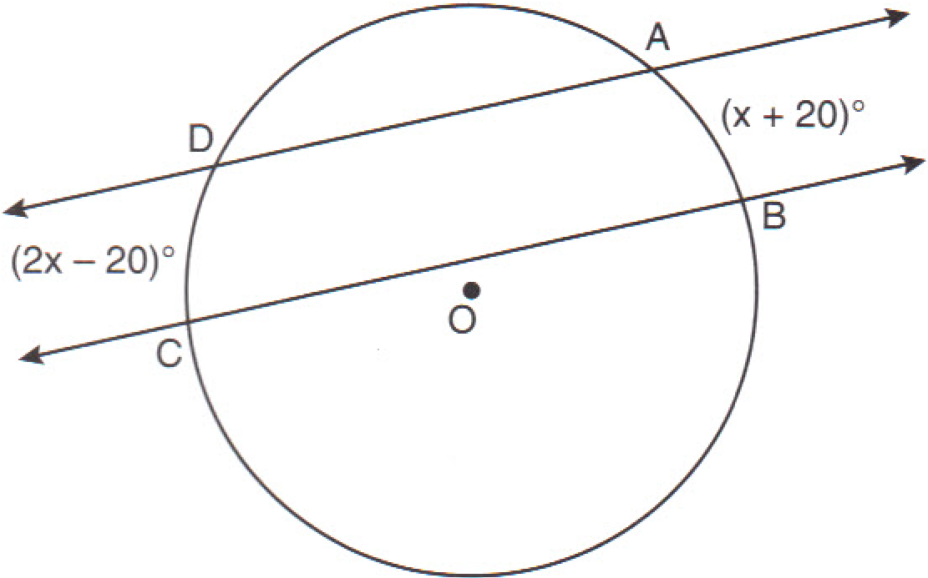

8 Parallel secants and intersect circle O, as shown in the diagram below.

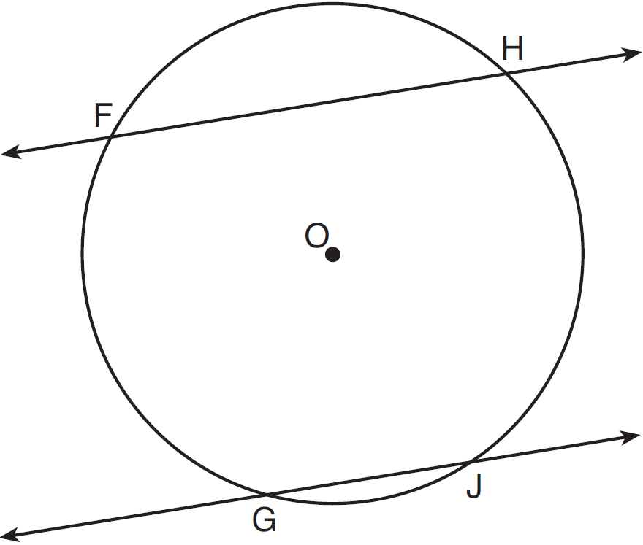

If and , then equals
1) | 106
2) | 115
3) | 130
4) | 156

9 In the diagram of circle O below, chords and are parallel, and is a diameter of the circle.

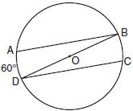

If , what is ?
1) | 20
2) | 30
3) | 60
4) | 120

10 In the accompanying diagram of circle O, chords and are drawn, is a diameter, , and . Find .

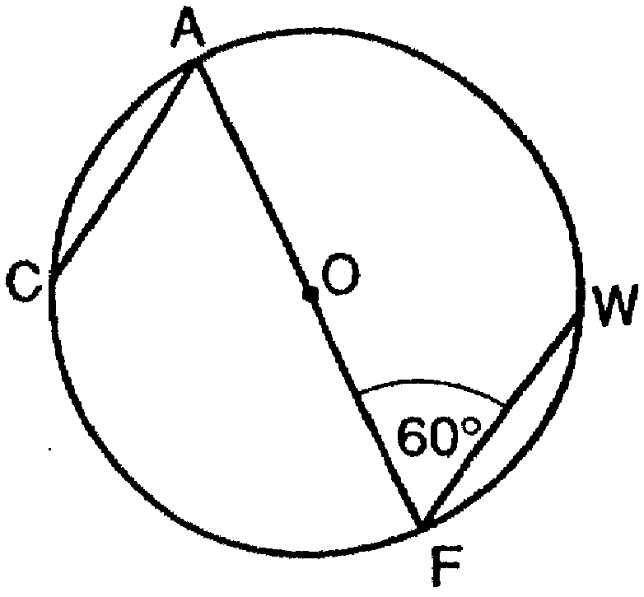

11 In the accompanying diagram of circle O, chord is parallel to diameter , is drawn, and .

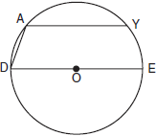

What is ?
1) | 90
2) | 110
3) | 130
4) | 150

12 In the diagram below of circle O with diameter and radius , chord is parallel to chord .

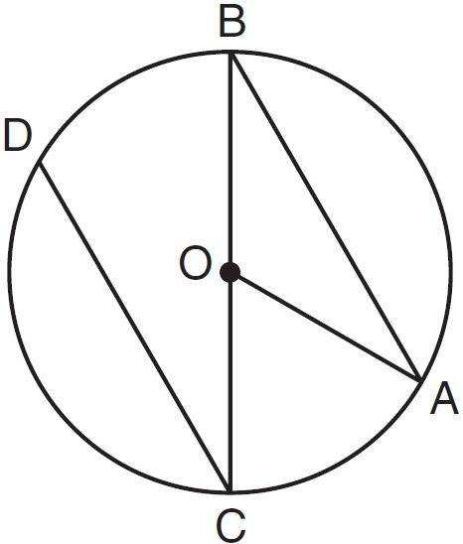

If , determine and state .

13 In the accompanying diagram, chord is parallel to diameter . If , what is ?

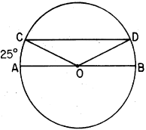
1) | 25
2) | 65
3) | 130
4) | 155

14 In the accompanying diagram of circle O, , is a diameter, and radius is drawn. If , find .

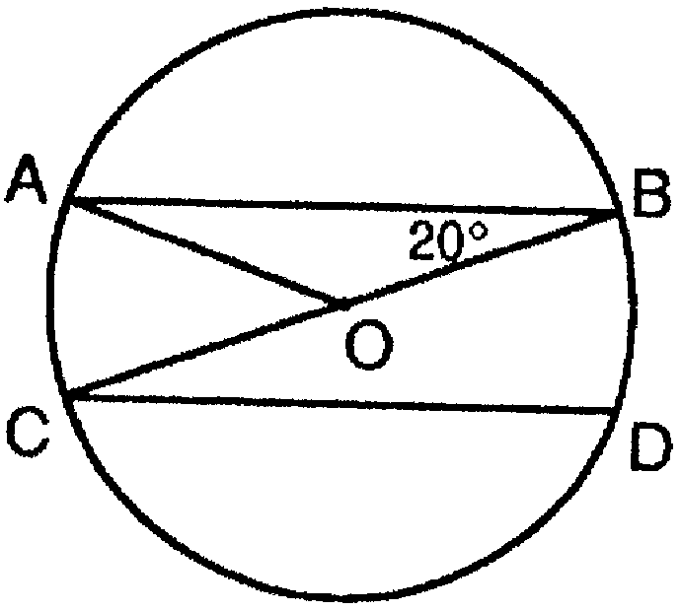

15 In the diagram below of circle O, chord is parallel to chord .

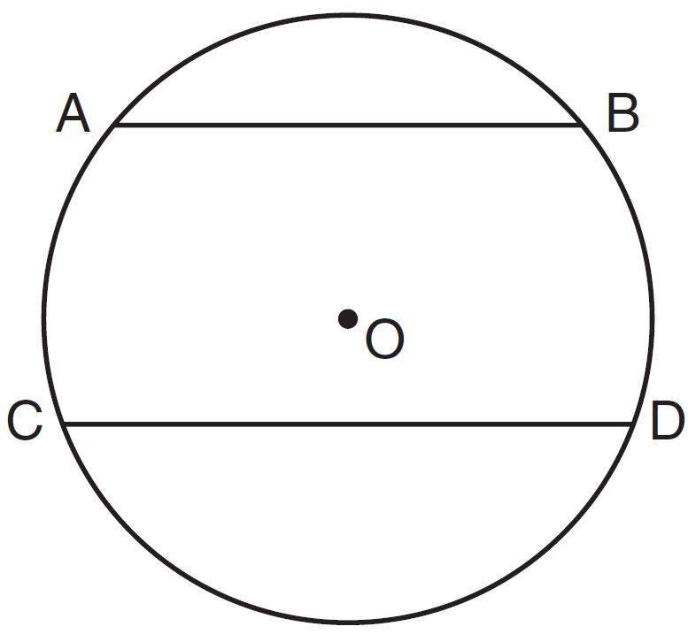

A correct justification for in circle O is
1) | parallel chords intercept congruent arcs
2) | congruent chords intercept congruent arcs
3) | if two chords are parallel, then they are congruent
4) | if two chords are equidistant from the center, then the arcs they intercept are congruent

16 In the diagram below of circle O, is parallel to .

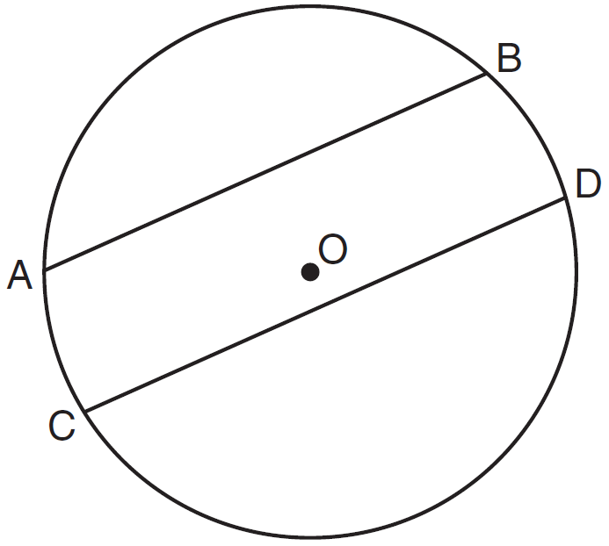

Which statement must be true?
1)
2)
3)
4)

17 In the diagram below of circle O, , and .

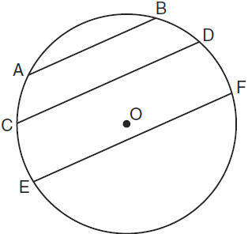

Which statement must be true?
1)
2)
3)
4)

18 In the accompanying diagram of circle O, .

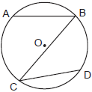

Which statement is true?
1)
2)
3)
4)

19 In the diagram below of circle O, chord is parallel to chord . Chord intersects at E and at F.

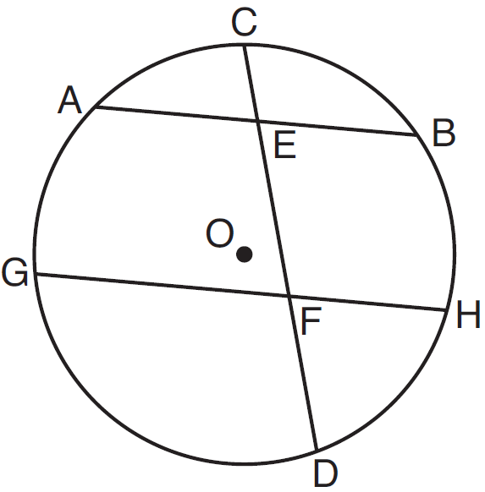

Which statement must always be true?
1)
2)
3)
4)

20 In the diagram of the circle shown below, chords and intersect at Q, and chords and are parallel.

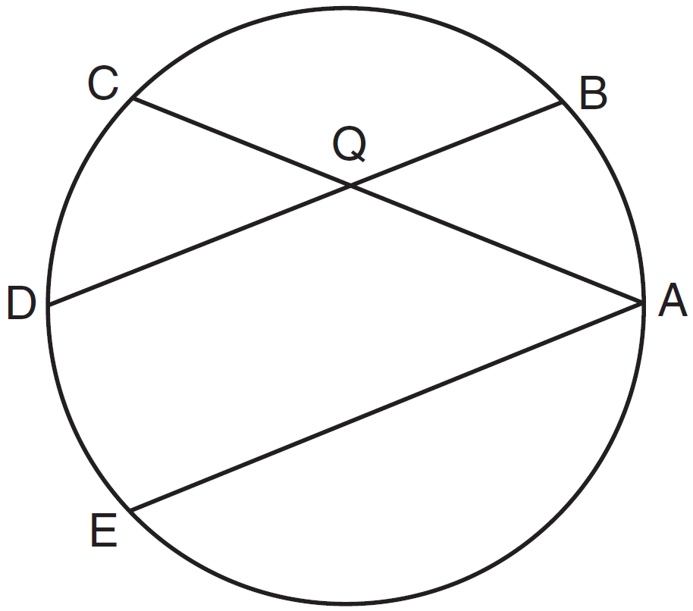

Which statement must always be true?
1)
2)
3)
4)

21 In circle O shown below, chord and diameter are parallel, and chords and intersect at point E.

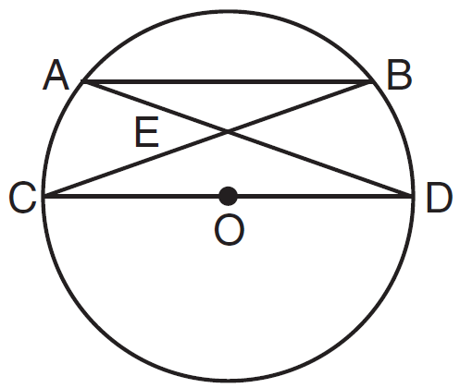

Which statement is false?
1)
2)
3)
4)

22 Points A, B, C, and D are located on circle O, forming trapezoid ABCD with . Which statement must be true?
1)
2)
3)
4)

1 ANS: 2
Parallel chords intercept congruent arcs. . .

REF: 080904ge

2 ANS: 3
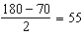

REF: 061205ge

3 ANS: 1
Parallel chords intercept congruent arcs. 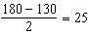

REF: 081704geo

4 ANS: 2
Parallel chords intercept congruent arcs. 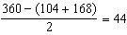

REF: 011302ge

5 ANS: 1
Parallel chords intercept congruent arcs. . 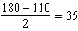.

REF: 081302ge

6 ANS: 4
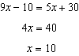

REF: 011525ge

7 ANS:
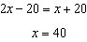.

REF: 011229ge

8 ANS: 2
Parallel secants intercept congruent arcs. 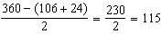

REF: 081503ge

9 ANS: 2
Parallel chords intercept congruent arcs. . 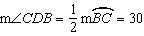.

REF: 060906ge

10 ANS:
60
REF: 019501siii

11 ANS: 2
Parallel chords intercept equal arcs. If then as well. The diameter of a circle divides the circle into two 180° arcs. So The measure of an inscribed angle is half that of its intercepted arc. So 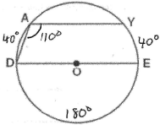
REF: 060603b

12 ANS:
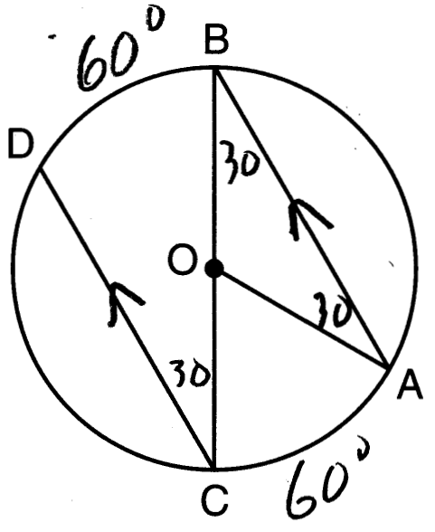
REF: 011626geo

13 ANS: 3 REF: 088519siii

14 ANS:
40
REF: 069403siii

15 ANS: 1
Parallel lines intercept congruent arcs.
REF: 081413ge

16 ANS: 1
Parallel lines intercept congruent arcs.
REF: 061105ge

17 ANS: 1
Parallel lines intercept congruent arcs.
REF: 061001ge

18 ANS: 1 REF: 060811b

19 ANS: 4
Parallel lines intercept congruent arcs.
REF: 081201ge

20 ANS: 3
Parallel lines intercept congruent arcs.

REF: 061409ge

21 ANS: 2 REF: 011616ge

22 ANS: 2 REF: 061516ge

