1 In the accompanying diagram, is tangent to circle O at A, is a secant, , and .

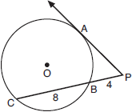

What is the length of ?
1)
2)
3)
4) | 4

2 In the diagram below, tangent and secant are drawn to circle O from external point P.

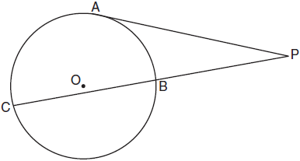

If and , what is the length of ?
1) | 20
2) | 9
3) | 8
4) | 6

3 In the diagram below, is a tangent to circle O at point S, is a secant, , , and .

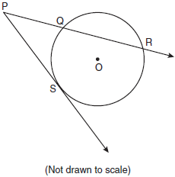

What is the length of ?
1) | 6
2) | 9
3) | 3
4) | 27

4 In the diagram shown below, is tangent to circle T at A, and secant is drawn where point B is on circle T.

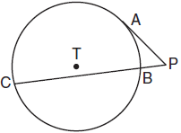

If and , what is the length of ?
1)
2)
3) | 3
4) | 9

5 Circle O is drawn below with secant . The length of tangent is 24.

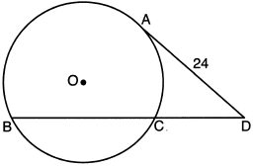

If the ratio of is , what is the length of ?
1) | 36
2) | 20
3) | 16
4) | 4

6 In the accompanying diagram, cabins B and G are located on the shore of a circular lake, and cabin L is located near the lake. Point D is a dock on the lake shore and is collinear with cabins B and L. The road between cabins G and L is 8 miles long and is tangent to the lake. The path between cabin L and dock D is 4 miles long.

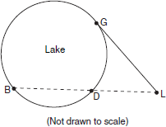

What is the length, in miles, of ?
1) | 24
2) | 12
3) | 8
4) | 4

7 In the accompanying diagram, is tangent to circle O at A, secant is drawn, , and . Find PA.

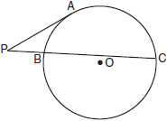

8 In the accompanying diagram, is tangent to circle O at B. If and , what is the length of ?

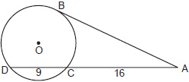

9 In the accompanying diagram of circle O, is a tangent and is a secant. If and , find PA.

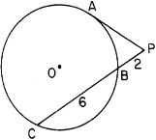

10 In the accompanying figure, is tangent to circle O at A, and is a secant. If and , find PA.

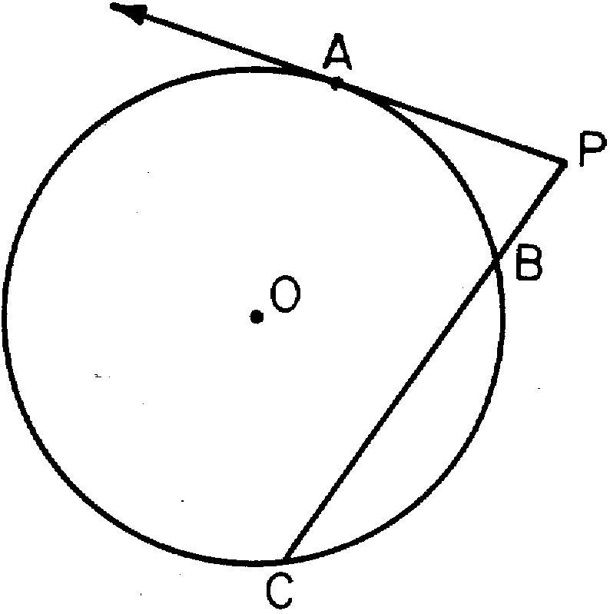

11 In the accompanying diagram, is tangent to circle at and is a secant. If and , find the length of .

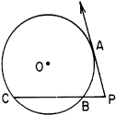

12 In circle P below, tangent and secant are drawn.

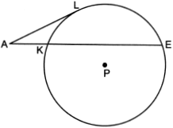

If and , determine and state the length of .

13 In the diagram below of circle O, secant and tangent are drawn.

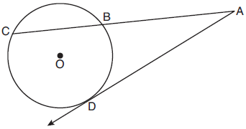

If and , determine and state the length of .

14 In the accompanying diagram, tangent and secant are drawn to circle O from point A, , and . Find AD.

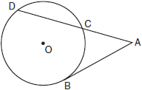

15 In the accompanying diagram, is tangent to circle O at D and is a secant. If and , find AB.

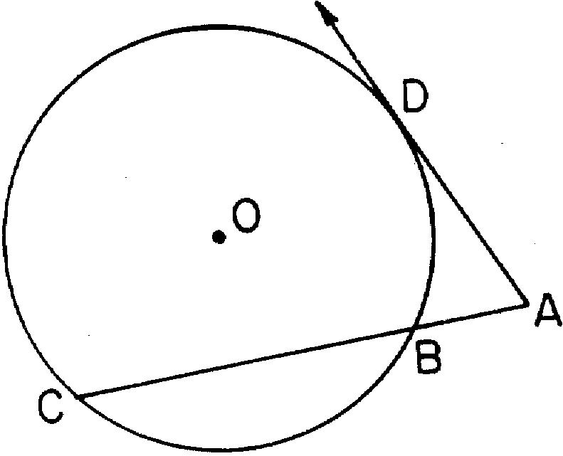

16 In the accompanying diagram, is tangent to circle O and is a secant. If and , find PB.

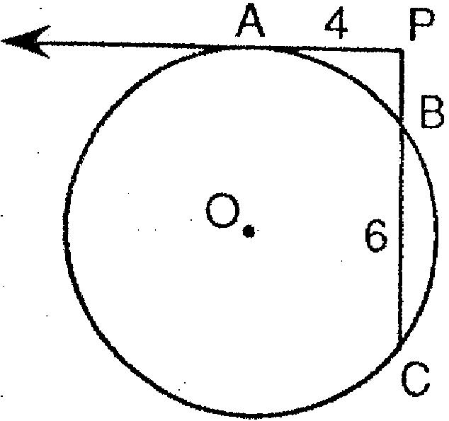

17 In the accompanying diagram, is tangent to circle O at B and is a secant. If and , find AC.

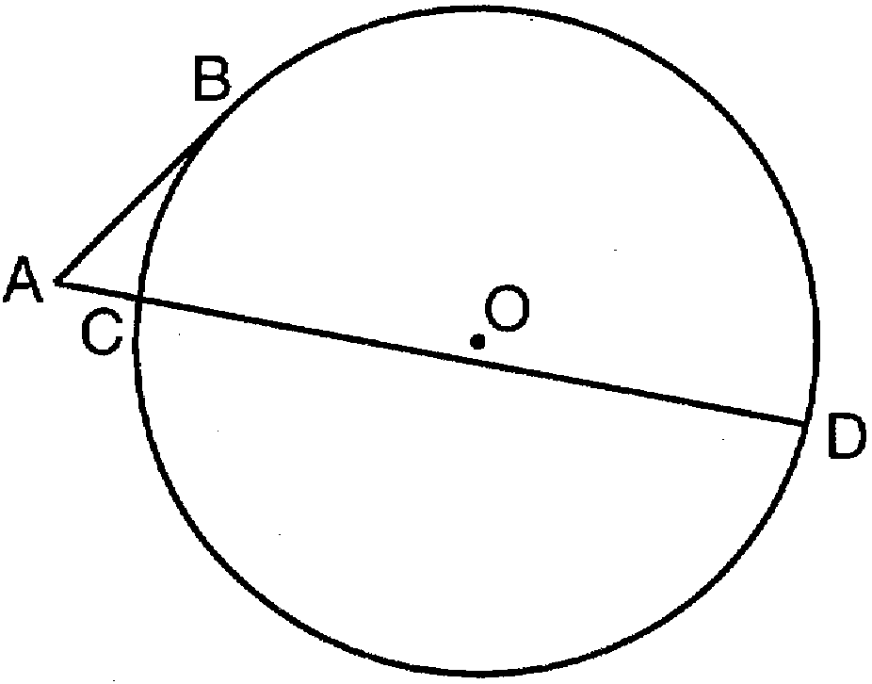

18 In the accompanying diagram, is tangent to circle O at D and is a secant. If and , find AB.

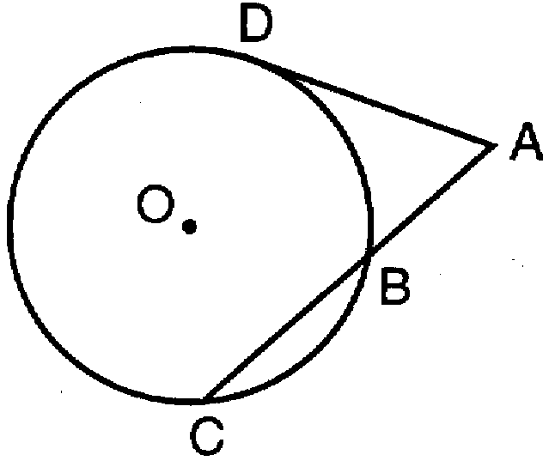

19 In the accompanying diagram, tangent and secant are drawn to circle O from external point P. If and , find the length of .

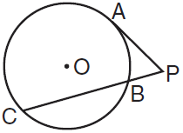

20 In the accompanying diagram, is tangent to circle O, is a secant, , and . Find AB.
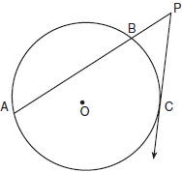

21 In the diagram below of circle O, chords and intersect at M. Secant and tangent are drawn to circle O. The length of is two more than the length of , , , and .
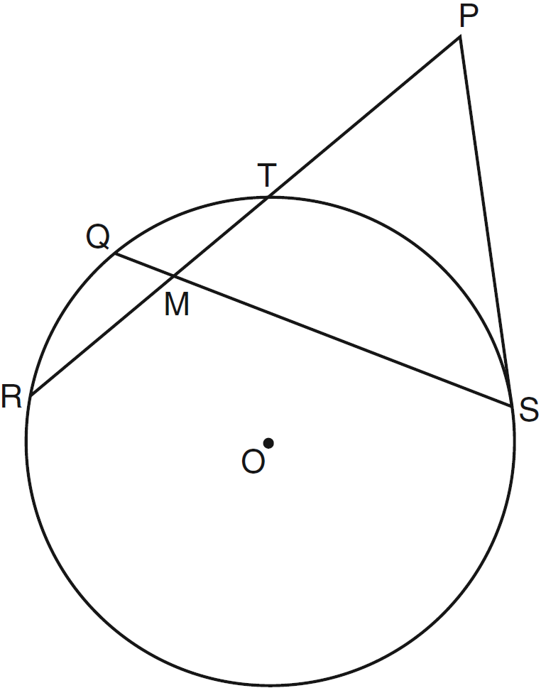

Find the length of . Find the length of .
1 ANS: 3
If a tangent and a secant intersect outside a circle, the tangent squared will equal the product of the secant and its external segment. 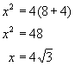.

REF: 080719b

2 ANS: 4
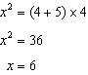

REF: 011008ge

3 ANS: 2
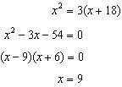

REF: fall0817ge

4 ANS: 2
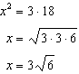

REF: 081712geo

5 ANS: 2
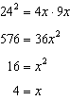

REF: 012312geo

6 ANS: 2
If a tangent and a secant intersect outside a circle, the tangent squared will equal the product of the secant and its external segment. 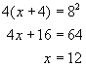. 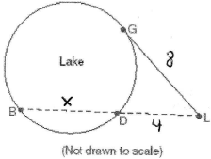

REF: 080103b

7 ANS:
8. If a tangent and a secant intersect outside a circle, the tangent squared will equal the product of the secant and its external segment. 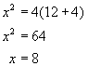. 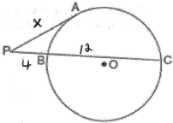

REF: 010623b

8 ANS:
20. If a tangent and a secant intersect outside a circle, the tangent squared will equal the product of the secant and its external segment. 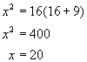.

REF: 010821b

9 ANS:
4

REF: 068805siii

10 ANS:
8

REF: 068914siii

11 ANS:
6

REF: 089011siii

12 ANS:
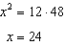

REF: 062428geo

13 ANS:
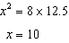

REF: 012028geo

14 ANS:
9

REF: 010416siii

15 ANS:
2

REF: 068607siii

16 ANS:
2

REF: 019408siii

17 ANS:
3

REF: 019701siii

18 ANS:
4

REF: 089715siii

19 ANS:
12
REF: 010314siii

20 ANS:
9
REF: 060314siii

21 ANS:
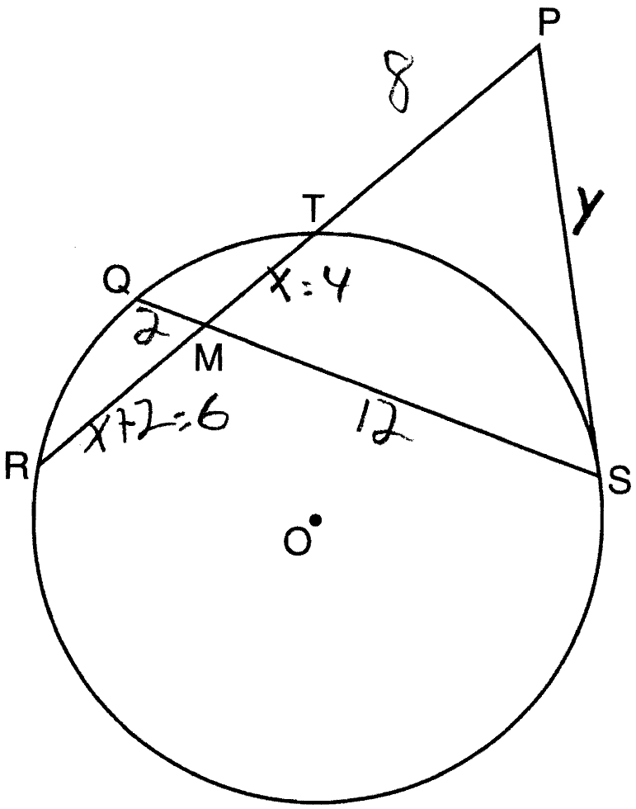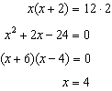. . 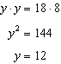
REF: 061237ge

