1 In the circle below, secants and intersect at T, , , , and .

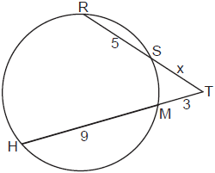

Which equation could be used to find the value of x?
1)
2)
3)
4)

2 In the accompanying diagram, and are secants drawn to circle O, , , and .

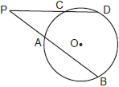

What is PC?
1) | 6.4
2) | 10
3) | 12
4) | 40

3 In the diagram below of circle O, secant intersects circle O at D, secant intersects circle O at E, , , and .

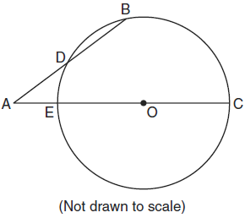

What is the length of ?
1) | 4.5
2) | 7
3) | 9
4) | 14

4 Secants and are drawn to circle O from an external point, J. If , , and , what is the length of ?
1) | 16
2) | 12
3) | 10
4) | 8

5 In circle O, secants and a re drawn from external point A such that points D, B, E, and C are on circle O. If , , and EC is 12 more than BD, the length of is
1) | 6
2) | 22
3) | 36
4) | 48

6 In the accompanying diagram of circle O, secant and intersect at C. If , , and , find EC.

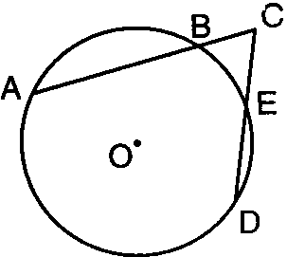

7 In the accompanying diagram, secant intersects circle O at D, secant intersects circle O at E, , , and . Find AD.

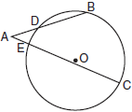

8 In the diagram below, secants and , drawn from point R, intersect circle O at S, T, Q, and P.

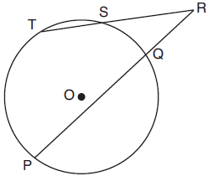

If , , and , what is the length of ?

9 In the diagram below, secants and are drawn to a circle from point P.

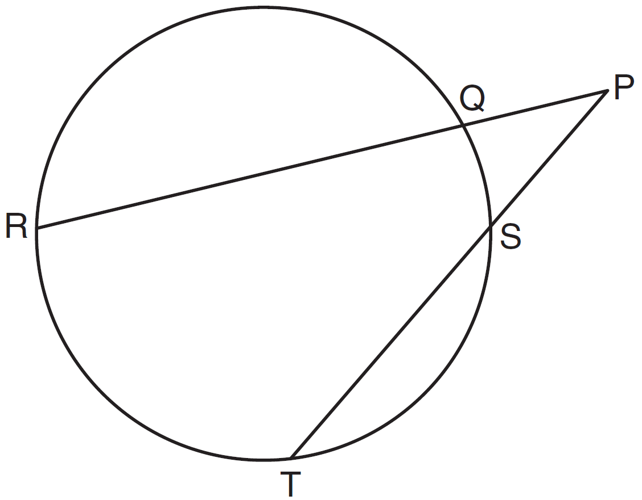

If , , and , determine and state the length of .
1 ANS: 1 REF: 082320geo

2 ANS: 2 REF: 080026siii

3 ANS: 2
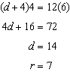

REF: 061023ge

4 ANS: 1
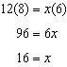

REF: 061328ge

5 ANS: 2
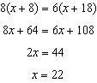

REF: 011715geo

6 ANS:
4

REF: 069810siii

7 ANS:
6

REF: 080310siii

8 ANS:
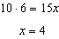

REF: 061828geo

9 ANS:
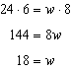

REF: 011533ge

