1 How many common tangent lines can be drawn to the circles shown below?


1) 1 2) 2 3) 3 4) 4

2 In the diagram below, circles A and B are tangent at point C and is drawn. Sketch all common tangent lines.

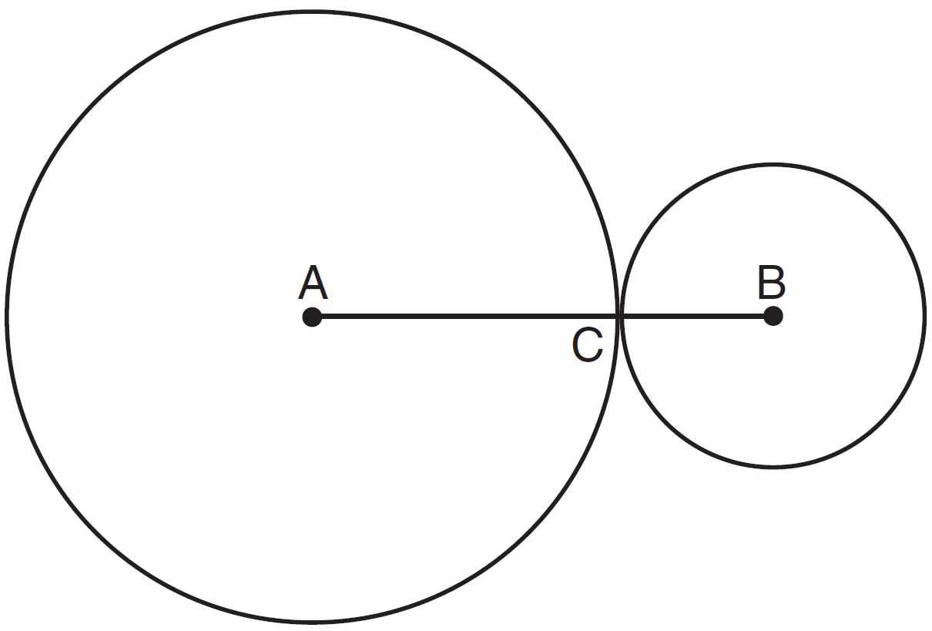

3 Lines AE and BD are tangent to circles O and P at A, E, B, and D, as shown in the diagram below. If , and , determine and state the length of .

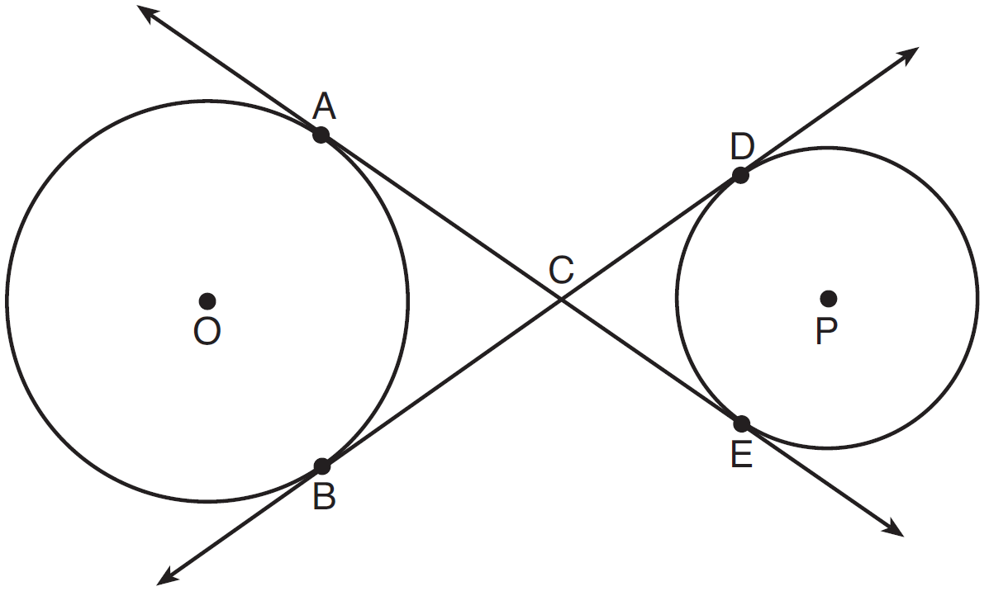

4 In the diagram below, circles X and Y have two tangents drawn to them from external point T. The points of tangency are C, A, S, and E. The ratio of TA to AC is . If , find the length of .

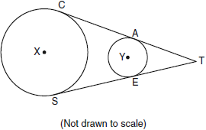

5 In the diagram shown below, is tangent to circle O at A and to circle P at C, intersects at B, , , and .

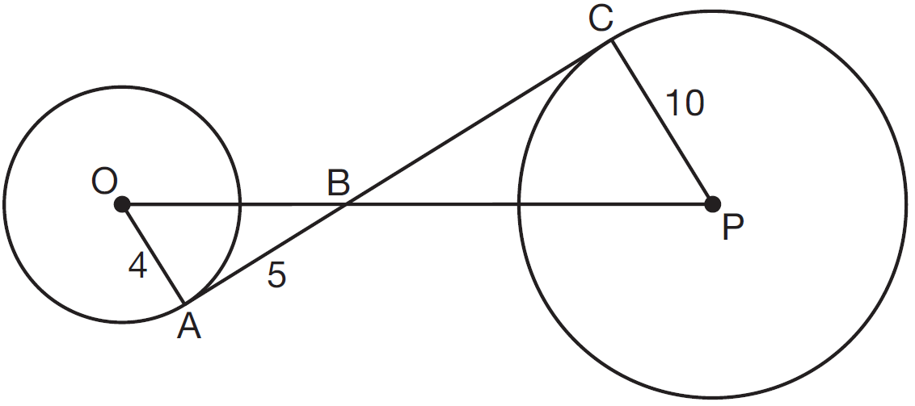

What is the length of ?
1) 6.4 2) 8 3) 12.5 4) 16
1 ANS: 4 REF: 011428ge

2 ANS:
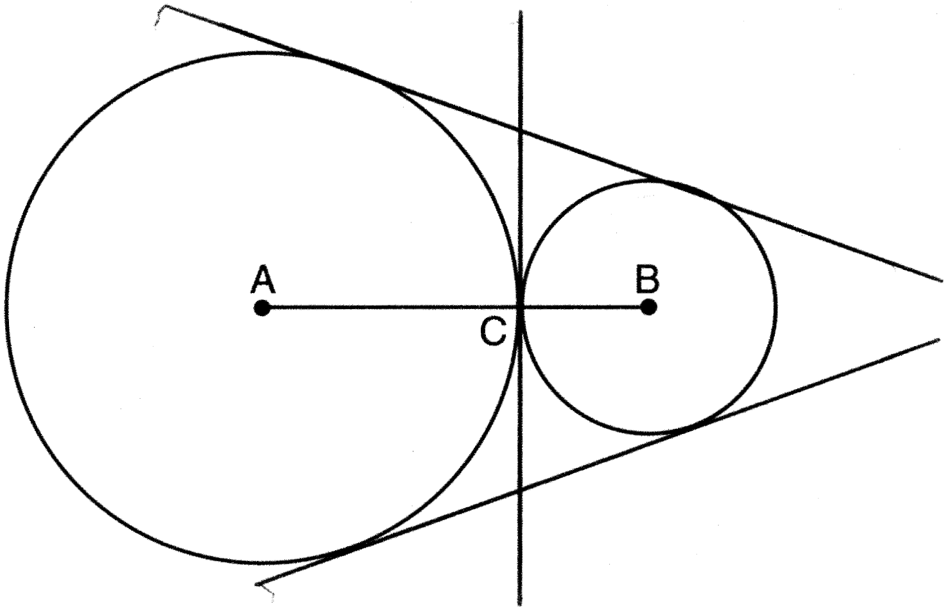

REF: 011330ge

3 ANS:
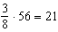

REF: 081625geo

4 ANS:
18. If the ratio of TA to AC is 1:3, the ratio of TE to ES is also 1:3. 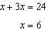. .

REF: 060935ge

5 ANS: 3
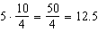

REF: 081512geo

