1 In the diagram below, is circumscribed about circle O and the sides of are tangent to the circle at points D, E, and F.

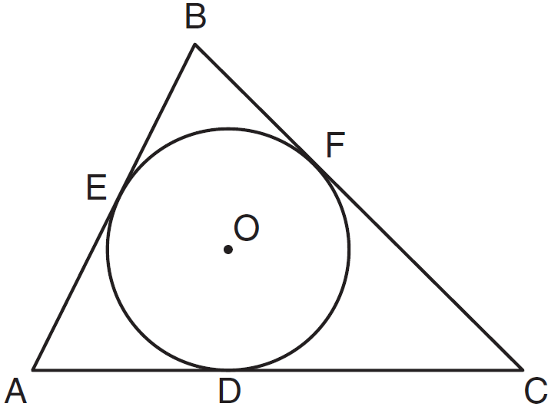

If , , and , what is the length of ?
1) | 8
2) | 15
3) | 23
4) | 27

2 In the diagram below, , , and are tangents to circle O at points F, E, and D, respectively, , , and .

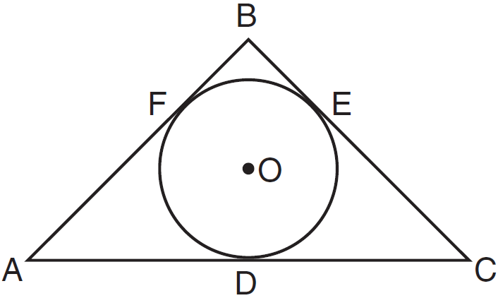

What is the perimeter of ?
1) | 15
2) | 25
3) | 30
4) | 60

3 In the figure shown below, quadrilateral TAEO is circumscribed around circle D. The midpoint of is R, and .

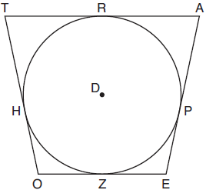

If and , what is the perimeter of quadrilateral TAEO?
1) | 56
2) | 64
3) | 72
4) | 76

4 In the accompanying diagram, circle O is inscribed in so that the circle is tangent to at F, to at E, and to at D. If and , find the perimeter of .

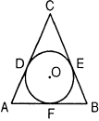

5 In the accompanying diagram, , , and are tangent to circle O at F, E, and G, respectively. If , , and , find BC.

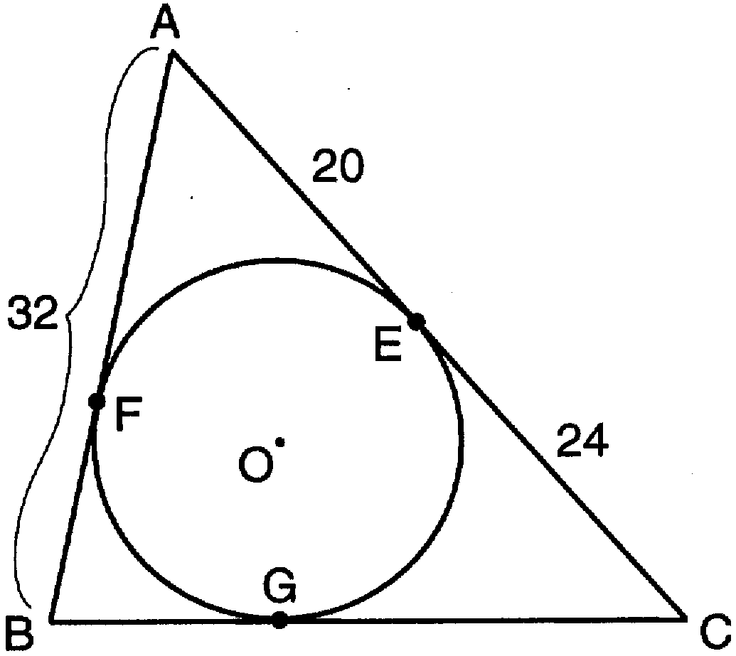

6 In the accompanying diagram, segments , , and are tangent to circle O at A, B, and C, respectively. If , , and , what is the measure of ?

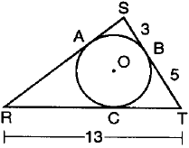

7 Two docks, A and B, are located on a circular pond as shown in the diagram below. A surveyor wants to determine the distance these two docks are from each other across the pond. The surveyor, located at point S, knows that he is 200 yards from both docks and his measuring equipment indicates that there is a 90° angle between his sight lines to dock A and to dock B. How far, to the nearest tenth of a yard, is it across the pond from dock A to dock B?

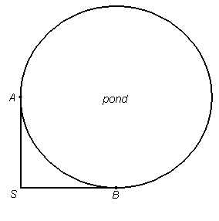
1 ANS: 4 REF: 011208ge STA: G.G.53

2 ANS: 3
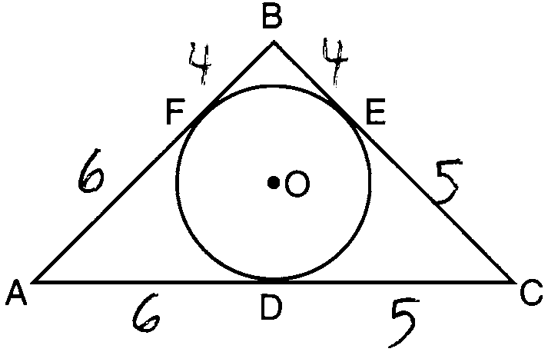

REF: 011101ge STA: G.G.53

3 ANS: 2
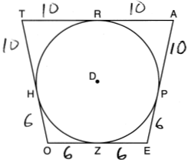

REF: 081814geo

4 ANS:
34

REF: 089311siii

5 ANS:
36

REF: 069615siii

6 ANS:
11

REF: 019804siii

7 ANS:
282.8. 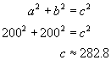

REF: fall9926b

