1 The angle formed by the radius of a circle and a tangent to that circle has a measure of
1) 45° 2) 90° 3) 135° 4) 180°

2 Line segment AB is tangent to circle O at A. Which type of triangle is always formed when points A, B, and O are connected?
1) right 2) obtuse 3) scalene 4) isosceles

3 In the diagram below of , is tangent to circle O at point A, , and .

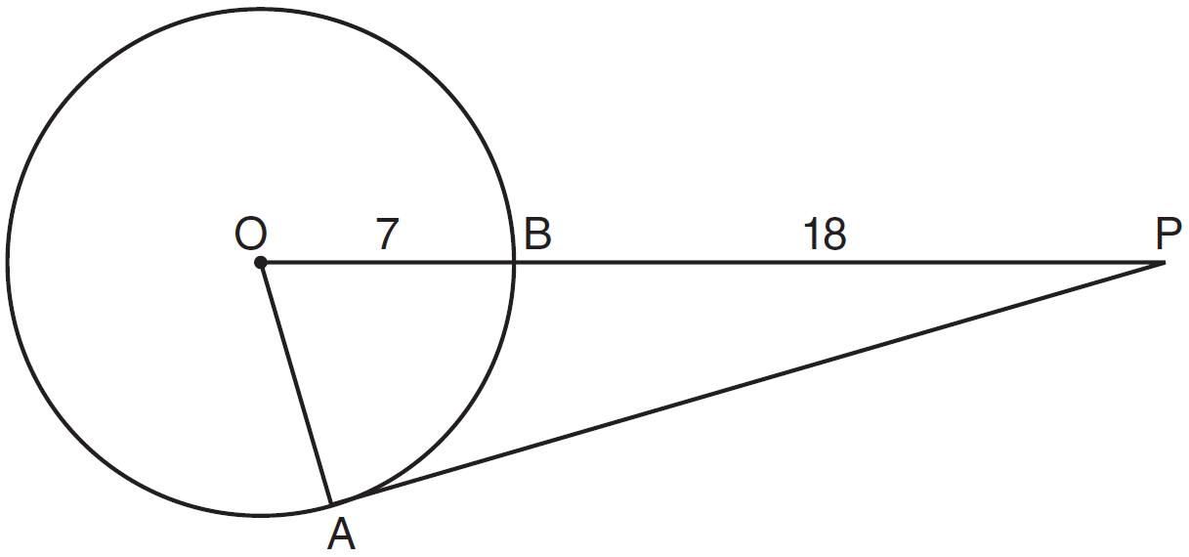

What is the length of ?
1) 10 2) 12 3) 17 4) 24

4 In the diagram below of circle O with radius , tangent and secant are drawn.

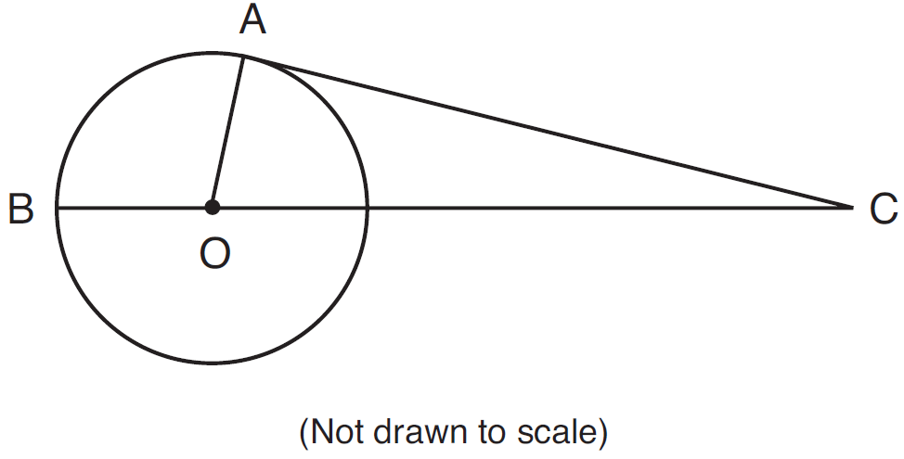

If cm and cm, what is the length of , to the nearest centimeter?
1) 19 2) 20 3) 21 4) 27

5 Kimi wants to determine the radius of a circular pool without getting wet. She is located at point K, which is 4 feet from the pool and 12 feet from the point of tangency, as shown in the accompanying diagram.
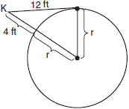

What is the radius of the pool?
1) 2) 3) 4)

6 In the accompanying diagram, is tangent to circle O at A. Radii and are drawn, and is extended to intersect at B. If and , find the measure of a radius of circle O.
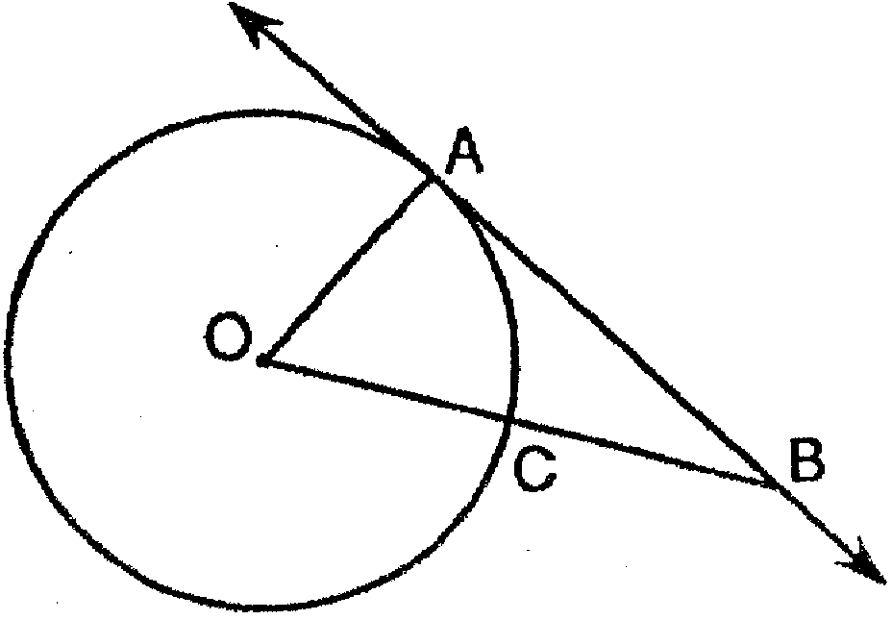

7 A circle centered at the origin passes through .
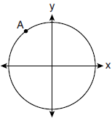

What is the equation of the line tangent to the circle at A?
1) 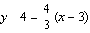 2) 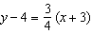 3) 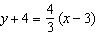 4) 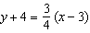
1 ANS: 2 REF: 081214ge

2 ANS: 1 REF: 061013ge

3 ANS: 4

REF: 081105ge

4 ANS: 3

REF: 081525ge

5 ANS: 1
The tangent meets the radius at the point of tangency at 90º. 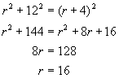

REF: 080518b

6 ANS:
8

REF: 089408siii

7 ANS: 2
slope of 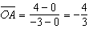 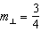

REF: 082223geo

