1 In the diagram below of circle O, radius is 5 cm. Chord is 8 cm and is perpendicular to at point P.

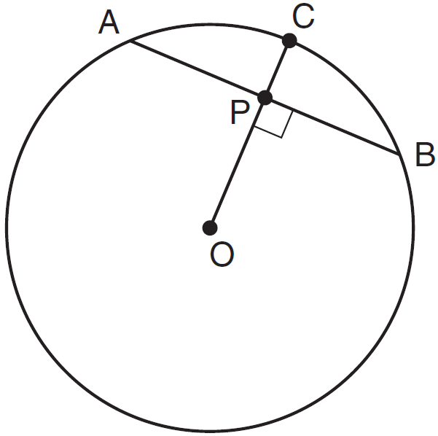

What is the length of , in centimeters?
1) | 8
2) | 2
3) | 3
4) | 4

2 In the diagram below of circle O, diameter is perpendicular to chord at point E, , and .

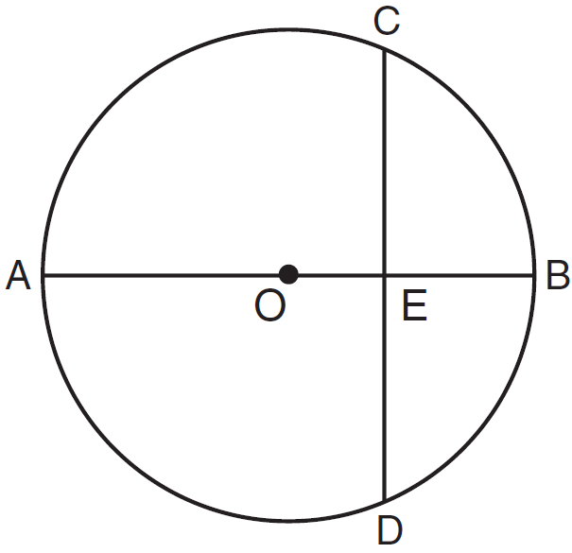

What is the length of ?
1)
2)
3)
4)

3 In circle O shown below, diameter is perpendicular to chord at E.

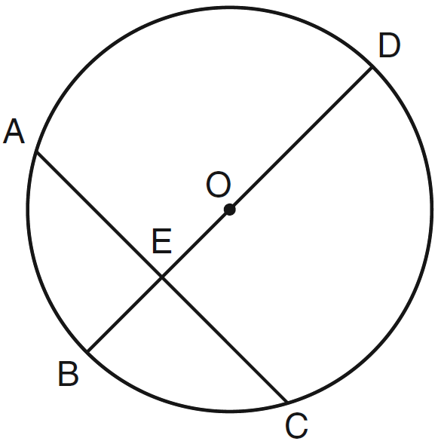

If , , and , what is the length of ?
1) | 8
2) | 9
3) | 16
4) | 25

4 In the diagram below, diameter bisects chord at point E in circle F.

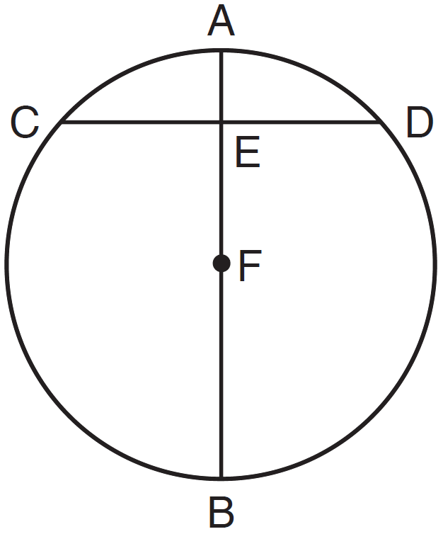

If and , then the length of is
1) | 7
2) | 8
3) | 15
4) | 16

5 In the accompanying diagram of circle O, diameter is perpendicular to chord and intersects at E, , and .

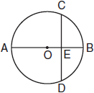

What is ED?
1) | 8
2) | 7
3) | 6
4) | 4

6 In the diagram below of circle O, diameter is perpendicular to chord at E. If and , find the length of .

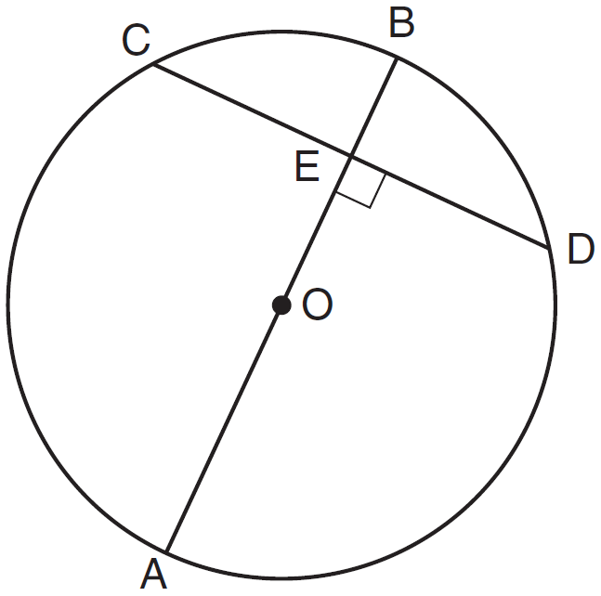

7 In the accompanying diagram of circle O, diameter is perpendicular to chord at E, , and . What is the length of the diameter of circle O?

8 In the accompanying diagram of circle O, diameter . and . Find CE.

9 In the diagram below, circle O has a radius of 5, and . Diameter is perpendicular to chord at E.

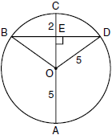

What is the length of ?
1) | 12
2) | 10
3) | 8
4) | 4

10 In circle O shown below, chords and and radius are drawn, such that , , , , , and .

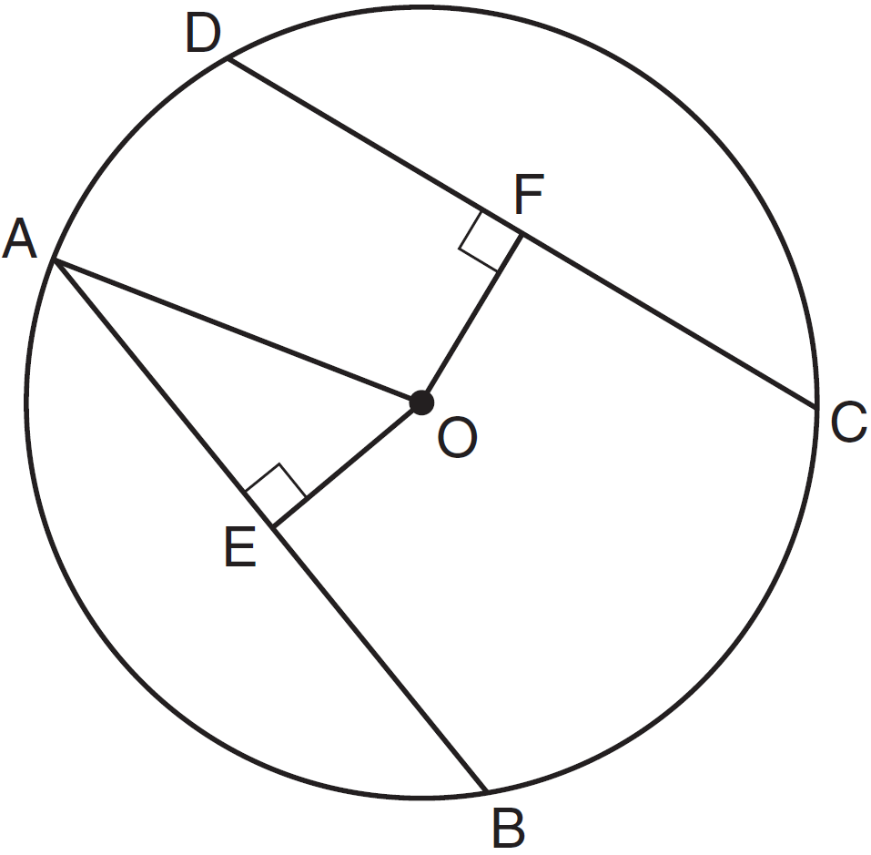

Determine the length of . Determine the length of .

11 The accompanying diagram shows a semicircular arch over a street that has a radius of 14 feet. A banner is attached to the arch at points A and B, such that . How many feet above the ground are these points of attachment for the banner?

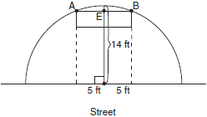

12 In circle O, diameter intersects chord at E. If , then is which type of angle?
1) | straight
2) | obtuse
3) | acute
4) | right

13 In a circle, diameter is perpendicular to chord at L. Which statement will always be true about this circle?
1)
2)
3)
4)

14 In the accompanying diagram of circle , diameter is perpendicular to chord at point . What is the image of in ?

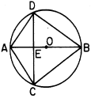
1)
2)
3)
4)

15 In circle R shown below, diameter is perpendicular to chord at point L.

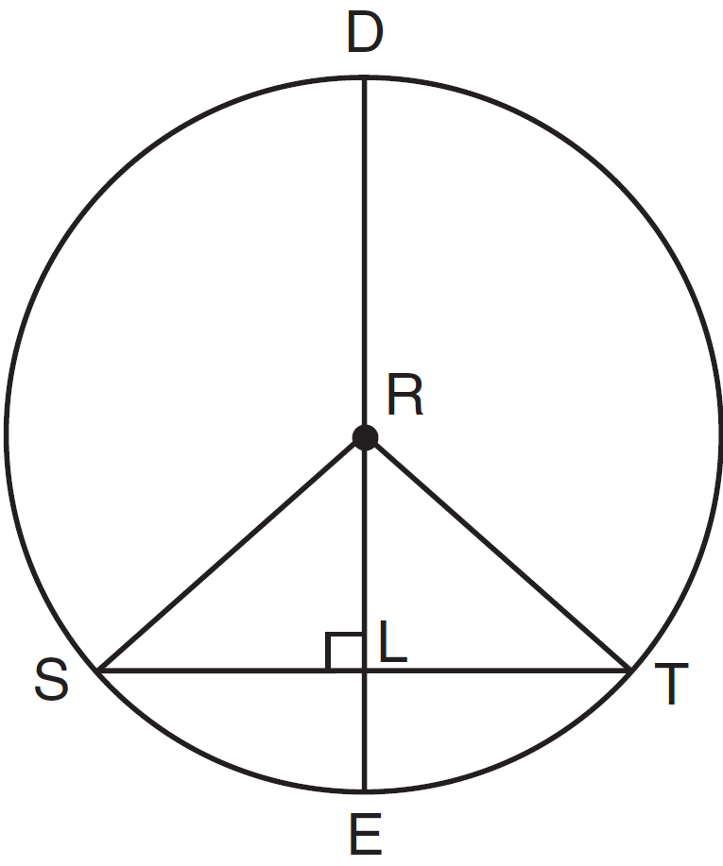

Which statement is not always true?
1)
2)
3)
4)

16 In the diagram below of circle O, diameter and chord intersect at E.

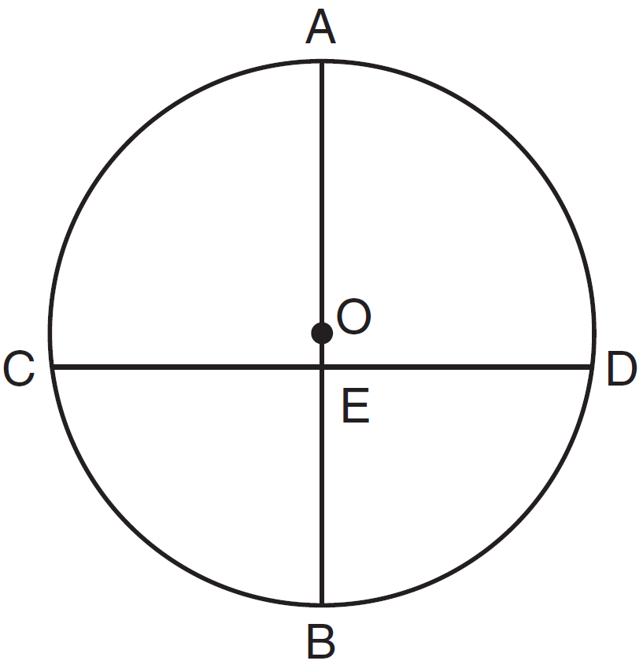

If , which statement is always true?
1)
2)
3)
4)

17 In the diagram below, is inscribed in circle P. The distances from the center of circle P to each side of the triangle are shown.

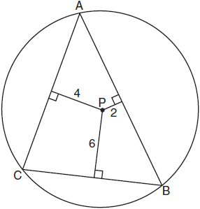

Which statement about the sides of the triangle is true?
1)
2)
3)
4)

1 ANS: 3
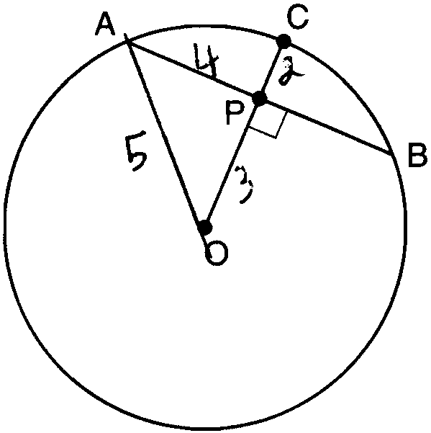

REF: 011113ge

2 ANS: 4

REF: 081124ge

3 ANS: 2
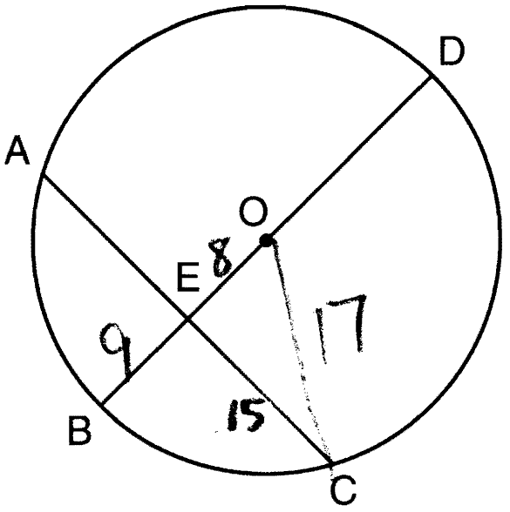 .

REF: 061221ge

4 ANS: 2

REF: 011424ge

5 ANS: 3 REF: 080114siii

6 ANS:
.

REF: 011234ge

7 ANS:
10. 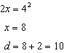

REF: 019907siii

8 ANS:
7

REF: 068104siii

9 ANS: 3
Because is a radius, its length is 5. Since . is a 3-4-5 triangle. If , .

REF: fall0811ge

10 ANS:
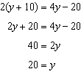. .

REF: 061336ge

11 ANS:
. The distance from A to the point on the street directly below E is also a radius of 14 feet. 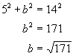.

REF: 080124b

12 ANS: 4 REF: 081308ge

13 ANS: 1 REF: 089617siii

14 ANS: 1 REF: 069018siii

15 ANS: 3 REF: 011322ge

16 ANS: 4 REF: 081403ge

17 ANS: 1
The closer a chord is to the center of a circle, the longer the chord.

REF: 011005ge

