1 In the accompanying diagram, is inscribed in circle O, bisects , is tangent to circle O at B, and

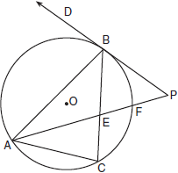

Find: , , , ,

2 In the accompanying diagram of circle O, diameters and , secants and , and chords and are drawn; ; and .

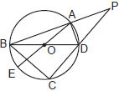

Find: , , , ,

3 In the accompanying diagram of circle O, diameter intersects chord at F; is a tangent; is a secant, , , and are chords; ; and .

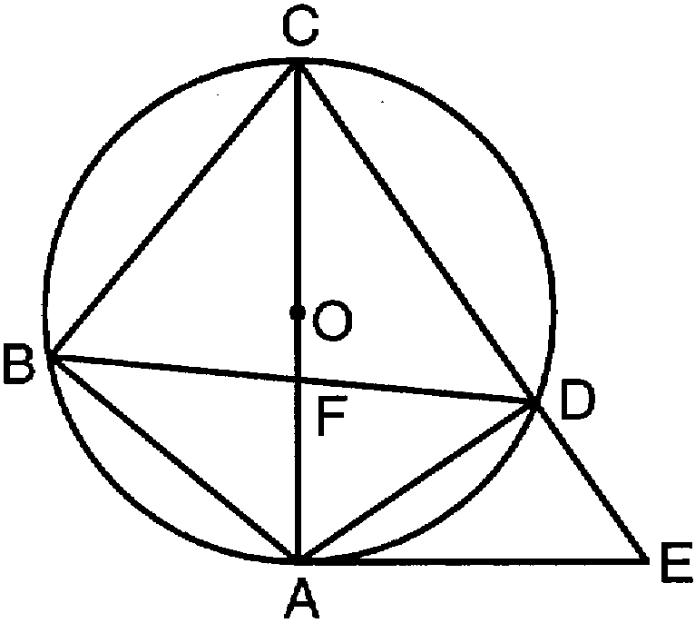

Find: , , , , .

4 In the accompanying diagram of circle O with inscribed isosceles triangle ABC, , , is a tangent, and secant intersects diameter at E.

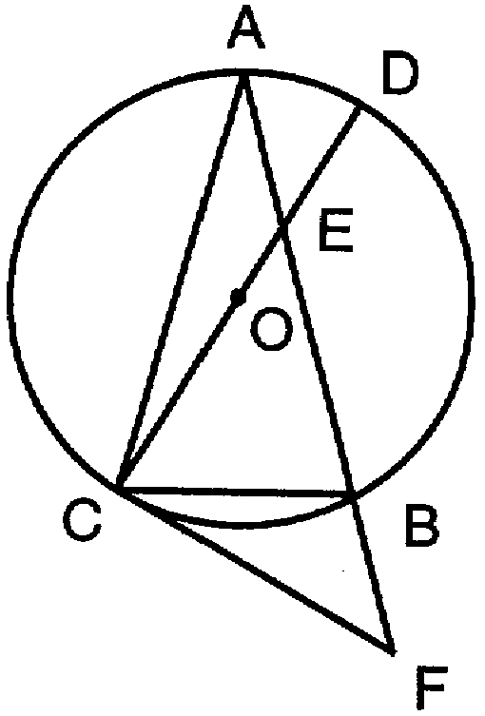

Find: , , , ,

5 In the accompanying diagram, is tangent to circle O at point A, secant intersects diameter at point E, chord is drawn, , and .

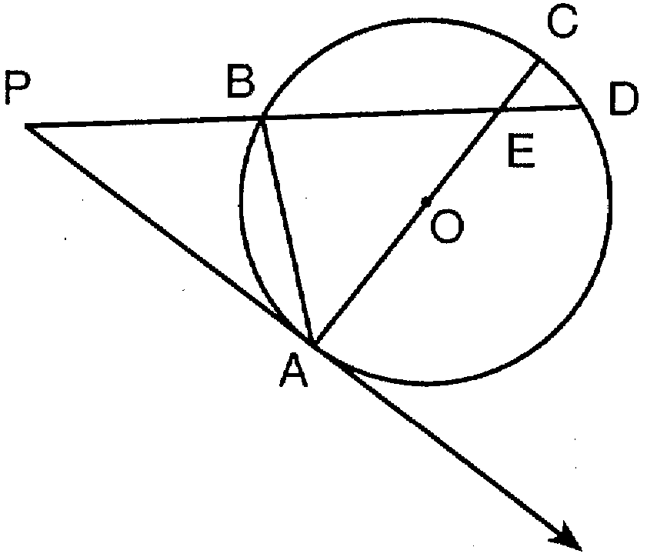

Find: , , , , .

6 In the accompanying diagram, isosceles triangle ABC is inscribed in circle O, and vertex angle BAC measures 40º. Tangent , secant , and diameters and are drawn.

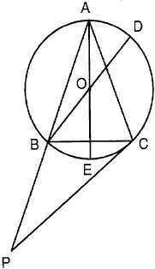

Find: , , , , .

7 In the accompanying diagram, regular pentagon ABCDE is inscribed in circle O, chords and intersect at F, chord is extended to G, and tangent is drawn.

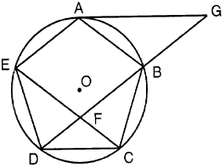

Find: , ,

8 In the accompanying diagram of circle O, chord is parallel to diameter , secant intersects at F, tangent is drawn, , and .

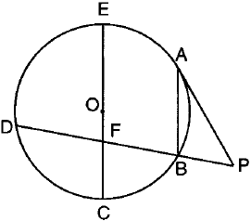

Find: , , , , .

9 In the accompanying diagram of circle O, diameter is extended through C to point P; diameter , tangent , and chords , , are drawn; ; and .

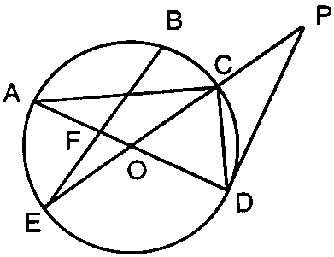

Find: ; ; , , .

10 In the accompanying diagram of circle O, ; diameter and chord are drawn; chord is parallel to chord ; chord is extended through C to D; and tangent is drawn.

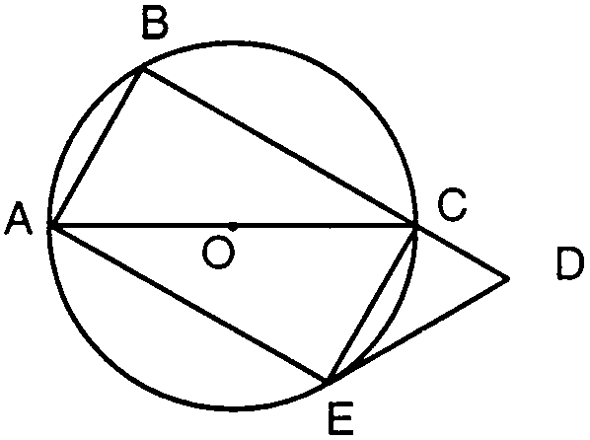

Find: , , , , .

11 In the accompanying diagram of circle O, , , , is a tangent, secant intersects diameter at F, and secant is drawn.

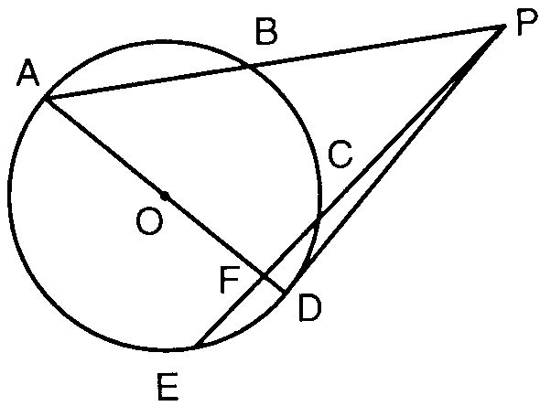

Find , , , ,

12 In the accompanying diagram of circle O, diameter is extended through E to C; tangent , chord , and radius are drawn; and .

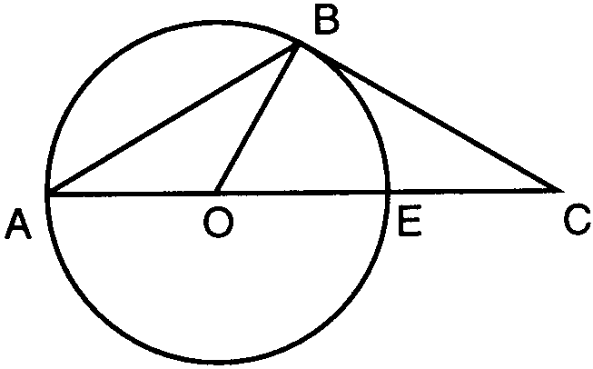

a Find: , , , .
b Is acute, right, obtuse or equiangular? Explain your answer.

13 In the accompanying diagram of circle O, diameter , chord , and secants and are drawn; ; and .

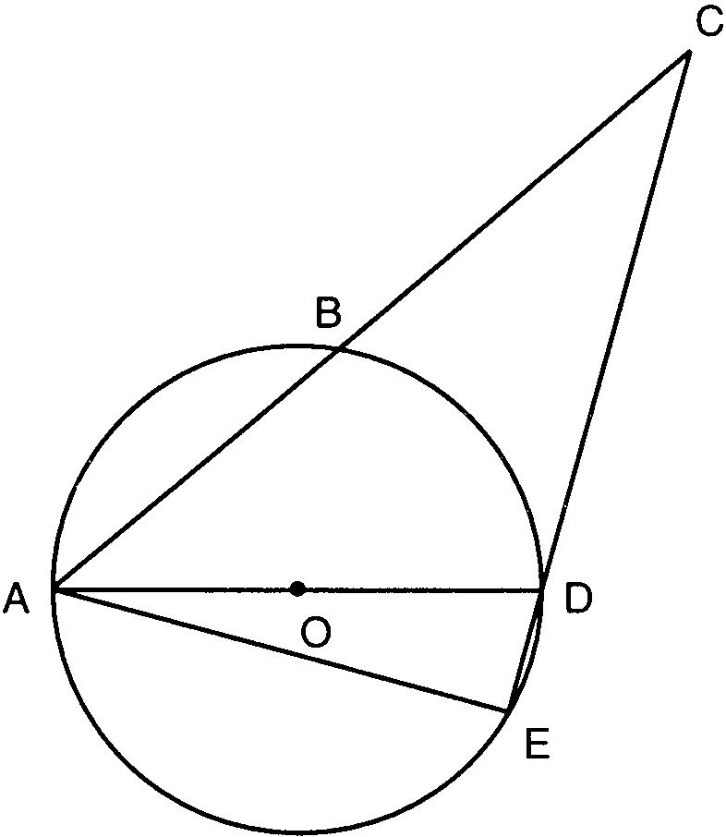

Find: , , , , .

14 In the accompanying diagram of circle O, is a diameter, is a tangent, is a secant, chords and are drawn, , and .

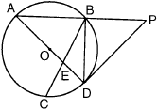

Find: , , , ,

15 In the accompanying diagram of circle O, is a diameter, is a tangent, is a secant, is a chord, , and .

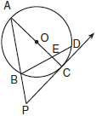

Find: , , , AP to the nearest tenth

16 In the accompanying diagram of circle O, tangent , secant , diameter , and chord are drawn; ; ; and .

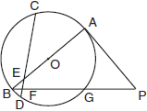

Find: , , , ,

17 In the accompanying diagram of circle O, tangent , secant , and chords , , and are drawn; , ; .

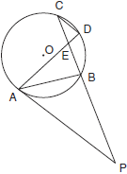

Find: , , , ,

18 In the accompanying diagram of circle O, tangent and chord are drawn, secant intersects diameter at F, , and .

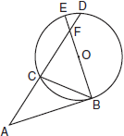

Find: , , , ,

19 In the accompanying diagram of circle O, secant , secant , tangent , and chord are drawn; ; and .

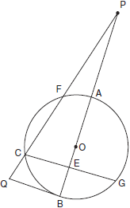

Find: , , , ,

20 In the accompanying diagram of circle O, secant , secant , and chord are drawn; chords and intersect at E, tangent intersects circle O at C, and .

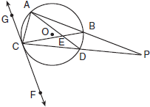

Find: , , , ,

21 In the accompanying diagram of circle O, tangent , secant , chord , and chord are drawn; ; ; ; and .

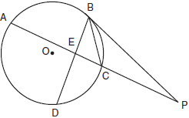

Find: ; ; to the nearest degree.

22 In the accompanying diagram of circle O, chords , , and , tangent , and secant are drawn; , ; and .

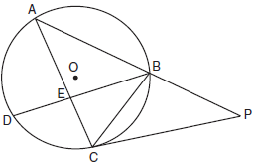

Find: , , , ,

23 In the accompanying diagram of circle O, is tangent to the circle at A; is a secant; diameter intersects chord at E; chords , , and are drawn; ; and is 32 more than .

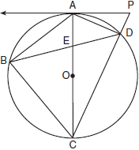

Find: ; ; ; ;
1 ANS:
40, 60, 70, 50, 60

REF: 010436siii

2 ANS:
140, 90, 40, 30, 90

REF: 080036siii

3 ANS:
80, 55, 40, 85, 35

REF: 019639siii

4 ANS:
75, 30, 135, 45, 30

REF: 069636siii

5 ANS:
160, 80, 50, 50, 100

REF: 089636siii

6 ANS:
80, 20, 140, 30, 110

REF: 069737siii

7 ANS:
72, 72, 36

REF: 089738siii

8 ANS:
60, 80, 100, 50, 30

REF: 019839siii

9 ANS:
120, 30, 30, 80, 90

REF: 069837siii

10 ANS:
120, 60, 90, 30, 60

REF: 089842siii

11 ANS:
50, 84, 48, 37, 95

REF: 019937siii

12 ANS:
120, 30, 30, 120, right because

REF: 069939siii

13 ANS:
80, 150, 35, 90, 105

REF: 089937siii

14 ANS:
43, 94, 130, 47, 25

REF: 010036siii

15 ANS:
72, 54, 108, 19.8

REF: 010136siii

16 ANS:
110, 10, 50, 90, 40

REF: 060136siii

17 ANS:
40, 50, 80, 70, 30

REF: 080140siii

18 ANS:
40, 90, 40, 130, 100

REF: 010239siii

19 ANS:
80, 120, 20, 75, 70

REF: 060240siii

20 ANS:
60, 80, 10, 130, 50

REF: 080242siii

21 ANS:
80, 40, 20

REF: 010336siii

22 ANS:
140, 90, 60, 25, 95

REF: 060336siii

23 ANS:
74, 53, 67, 104, 90
REF: 080338siii

