1 Given: circle O, tangent , secant , chords and , .

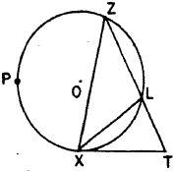

Find: , , , ,

2 In the accompanying figure, is inscribed in circle O, bisects , is tangent to circle O, and .

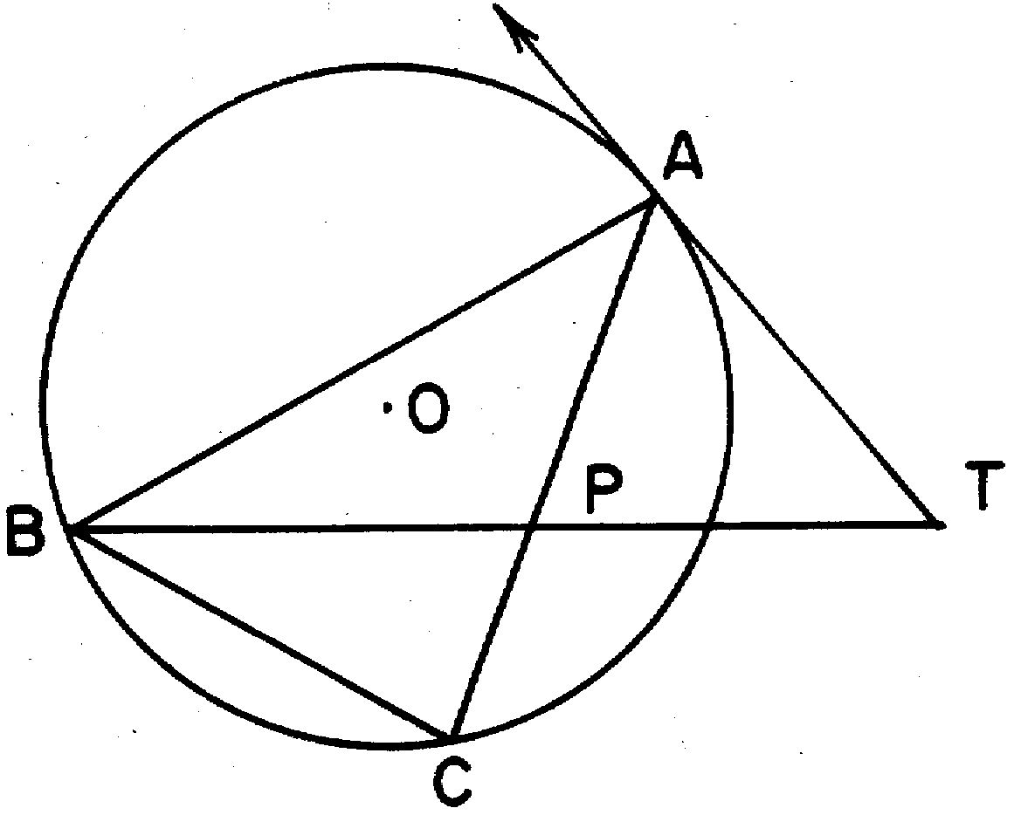

Find: , , , ,

3 In circle O, is a tangent, is a secant, and are chords. , , and .

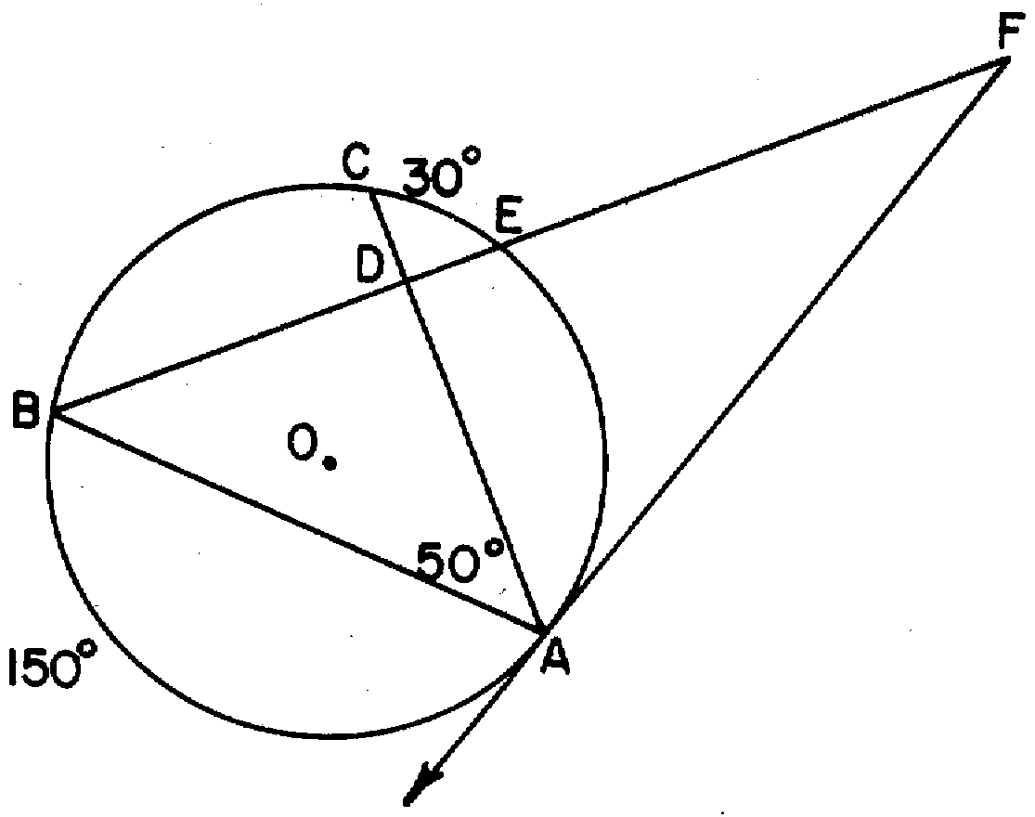

Find: , , , ,

4 In the accompanying figure, is tangent to circle O, is a secant, and , , and are chords.

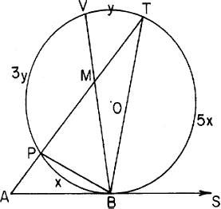

If , , , and are represented by x, 3y, y, and 5x respectively, express each of the following in terms of x and y: , , , . If , find the number of degrees represented by y.

5 In the accompanying diagram, is a tangent to circle O at point A, secant intersects diameter at point E, , and .

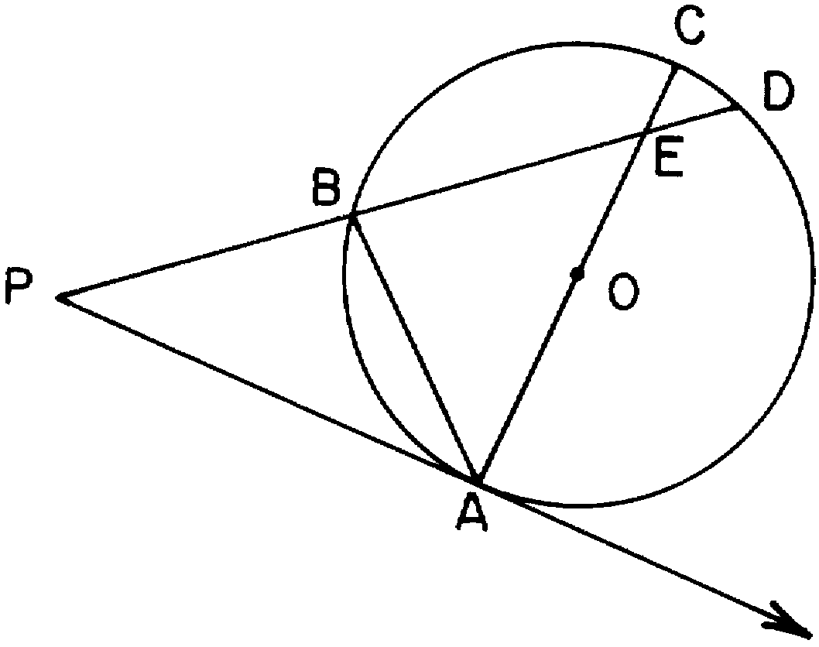

Find , , , , and

6 In the accompanying diagram, B is the midpoint of , triangle ADC is inscribed in circle O, chords and intersect at E, is a tangent to circle O at D, is a secant, and .

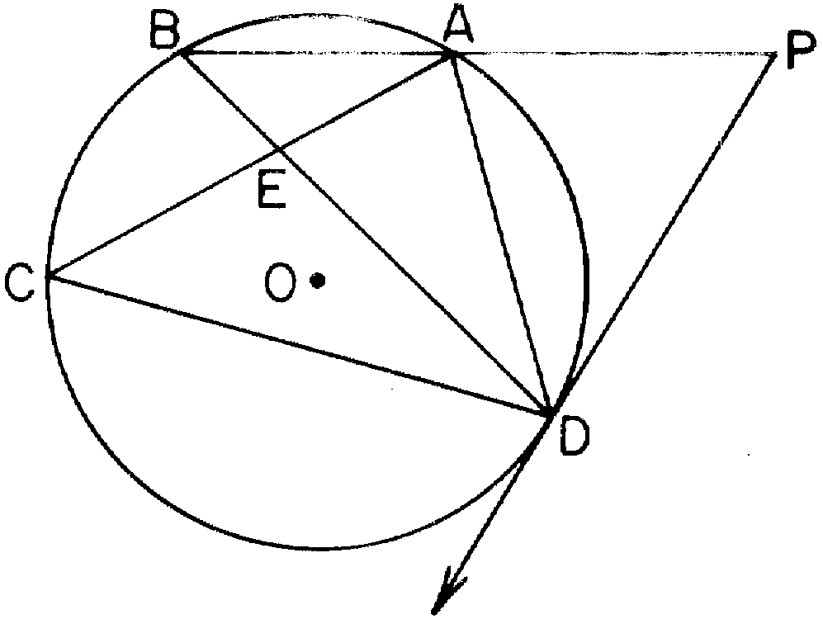

Find: , , , ,

7 In circle O, is a tangent, is a secant, and are chords, , , and .

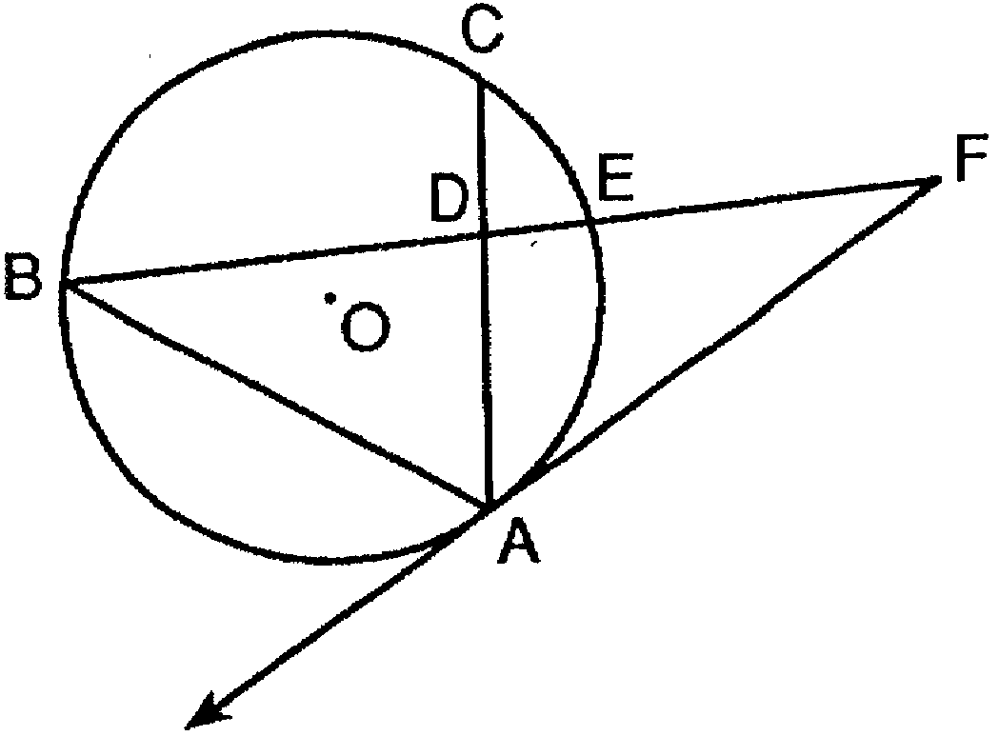

Find: , , , ,

8 In the accompanying diagram, is a diameter of circle O, and are secants, .

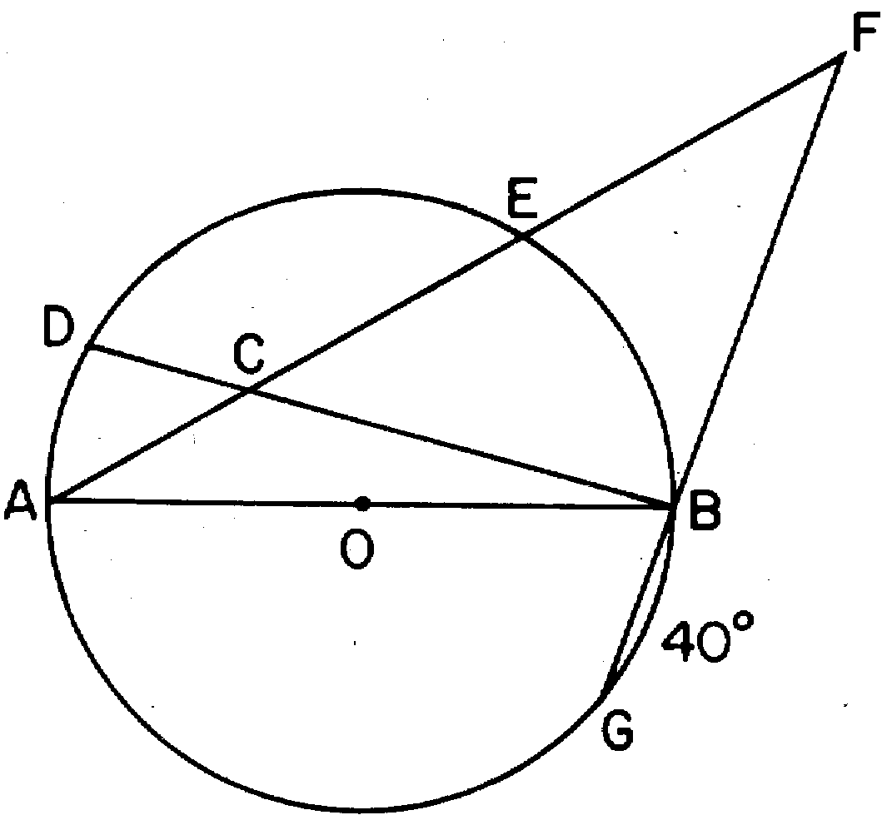

Find , , , , and

9 In circle O, is a tangent, is a diameter, is a secant, is a radius, , and .

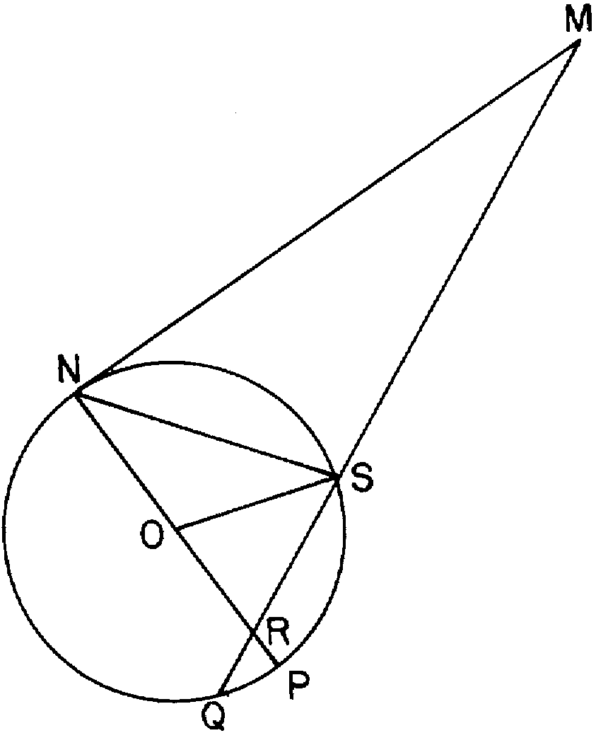

Find , , , , and

10 In the accompanying diagram, is isosceles with , , , is tangent to circle O at D, is a secant, and chords and intersect at E.

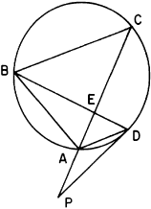

Find: , , , ,

11 In the accompanying diagram, is inscribed in circle O. Secant bisects and intersects diameter at G, is a secant, , and .

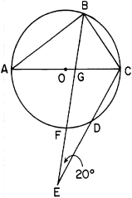

Find: , , , ,

12 In the accompanying diagram of circle O, is a secant, is tangent to circle O at T, , and .

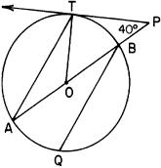

Find: , , , ,

13 Given: circle O with , diameter is extended to C, is tangent to circle O at B, and .

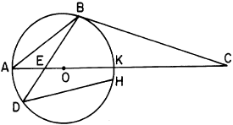

Find: , , , ,

14 In the accompanying diagram of circle O, and are chords, is a diameter and is extended to C, is a secant, , and .

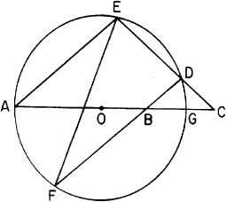

Find , , , , and

15 In the accompanying diagram of circle O, and are secants, chords and intersect at E, , chord is drawn, , and .

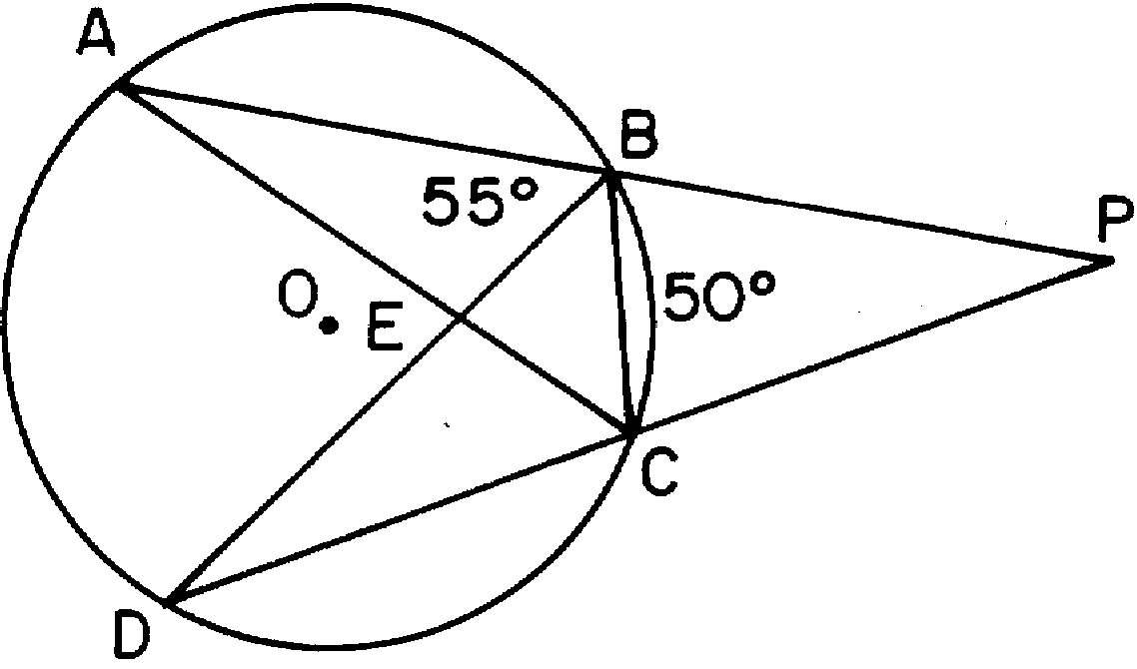

Find: , , , , .

16 In the accompanying diagram, and are secants from external point to circle . Chords , , , and are drawn, , is twice , and is 60 more than .

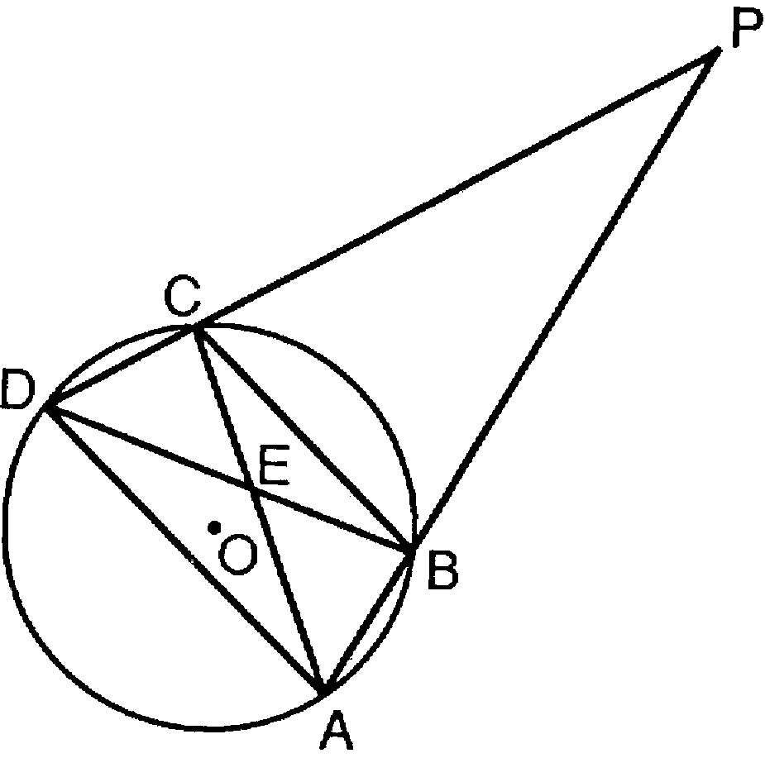

Find: , , , ,

17 In the accompanying diagram, is inscribed in circle . Diameter is extended through to point and intercepts chord at , is tangent to the circle at , chord is drawn, , and .

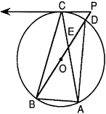
Find: , , , ,

18 In the accompanying diagram, is tangent to circle O at D, is a secant, chords and intersect at E, chord is drawn, , is twice , and .

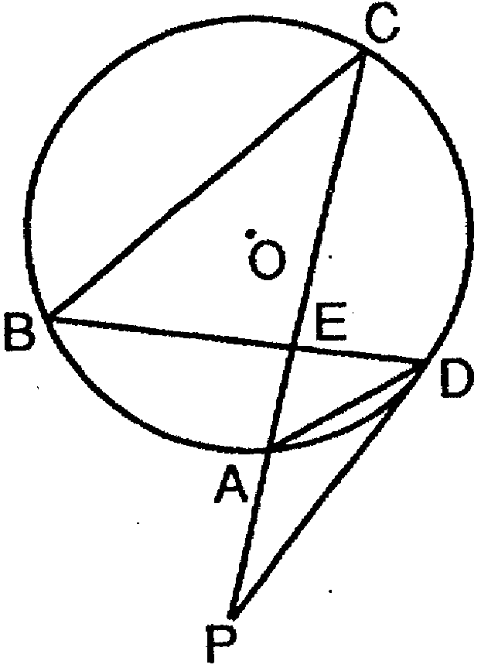

Find , , , and .

19 In the accompanying diagram, , and are tangent to circle O, , and .

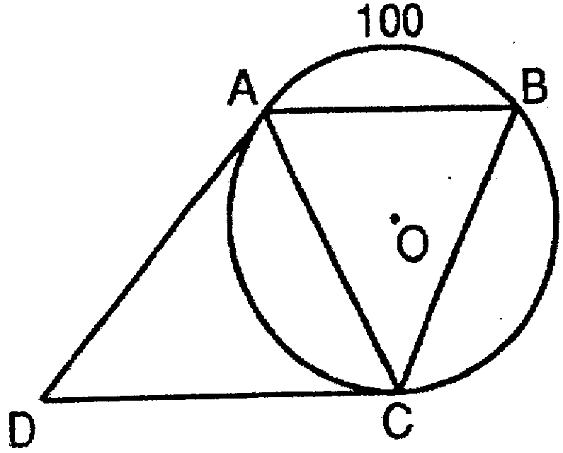

Find , , and
Is ABCD a parallelogram? [Explain your answer.]

20 In the accompanying diagram of circle O, the ratio is . Chord is extended to external point M, chords and intersect at D, and tangent is drawn.

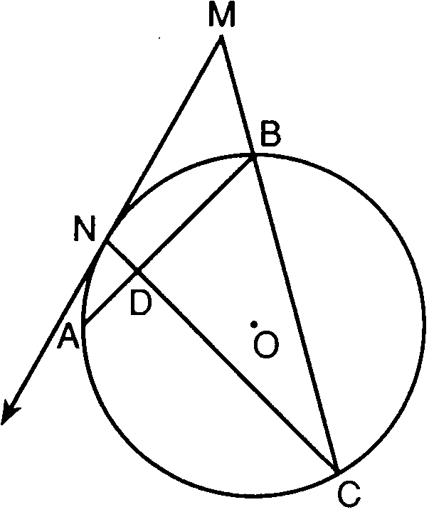

Find: , , , ,

21 In the accompanying diagram, chords and intersect at Q, secants and are drawn, , , , and is tangent to the circle at T.

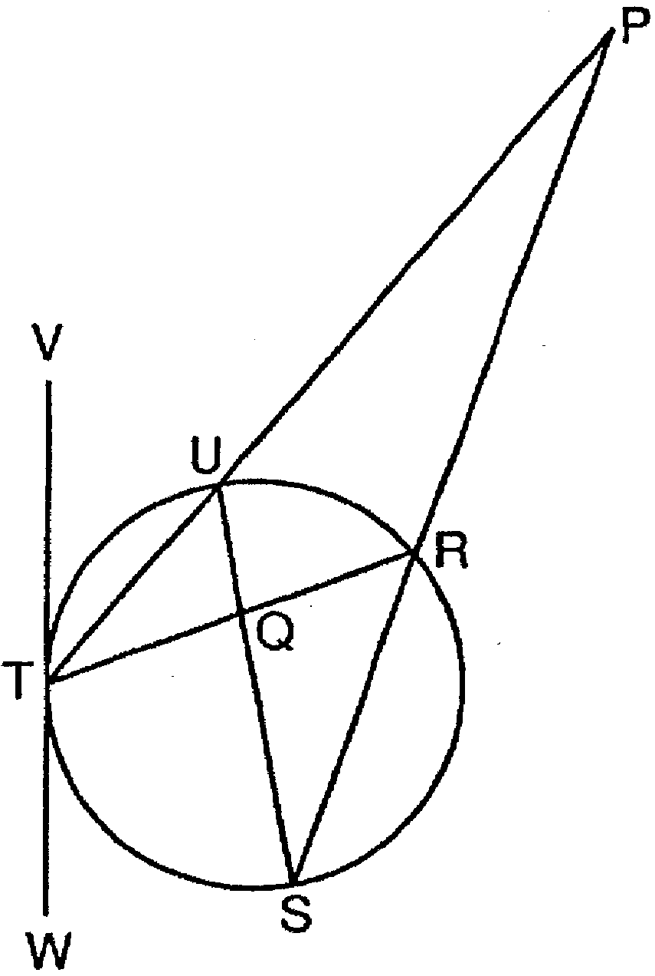

Find , , , and .

22 Quadrilateral ABCD is inscribed in circle O, and are diameters, and are secants, , and .

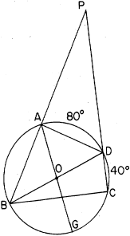

Find , , , , and

23 In the accompanying diagram of circle O, and are secants, chords and intersect at F, tangent intersects circle O at C, , , and .

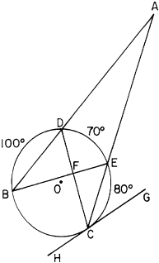

Find: , , , ,
1 ANS:
80, 40, 60, 80, 80

REF: 068138siii

2 ANS:
40, 80, 110, 60, 50

REF: 018437siii

3 ANS:
100, 40, 90, 35, 55

REF: 068438siii

4 ANS:
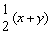; , 2y, 2x, 27

REF: 088439siii

5 ANS:
160, 80, 50, 50, 100

REF: 068640siii

6 ANS:
60, 60, 105, 45, 60

REF: 068542siii

7 ANS:
120, 35, 95, 30, 55

REF: 019537siii

8 ANS:
90, 45, 40, 95, 30

REF: 018539siii

9 ANS:
20, 80, 60, 100, 30

REF: 088641siii

10 ANS:
45, 90, 22º30’, 22º30’, 90

REF: 018736siii

11 ANS:
72, 32, 45, 99, 61

REF: 068741siii

12 ANS:
50, 25, 130, 25, 155

REF: 088742siii

13 ANS:
36, 18, 42, 126, 108

REF: 088940siii

14 ANS:
20, 30, 40, 40, 100

REF: 018937siii

15 ANS:
55, 30, 50, 80, 75

REF: 068939siii

16 ANS:
50, 30, 25, 130, 75

REF: 069037siii

17 ANS:
146, 78, 56, 46, 151

REF: 089039siii

18 ANS:
72, 48, 24, 84, 24

REF: 069437siii

19 ANS:
130, 65, 50, 115, no, because is not congruent to

REF: 089439siii

20 ANS:
150, 60, 45, 90, 105

REF: 069537siii

21 ANS:
60, 50, 20, 100, 40

REF: 089537siii

22 ANS:
100, 90, 80, 30, 40
REF: 088538siii

23 ANS:
20, 55, 90, 40, 125
REF: 068840siii

