1 What is the greatest possible number of points of intersection of a triangle and a circle?
1) | 6
2) | 2
3) | 3
4) | 4

2 Chords and intersect at E in circle O, as shown in the diagram below. Secant and tangent are drawn to circle O from external point F and chord is drawn. The , , and the ratio of .

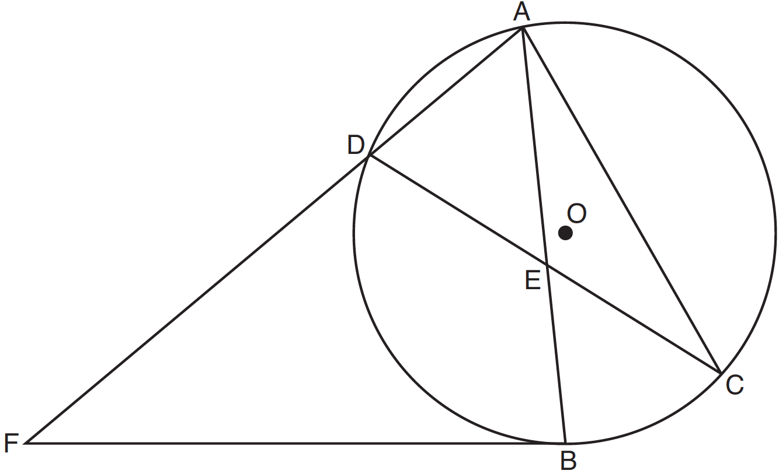

Determine . Determine . Determine .

3 In circle O shown below, diameter is perpendicular to at point C, and chords , , , and are drawn.

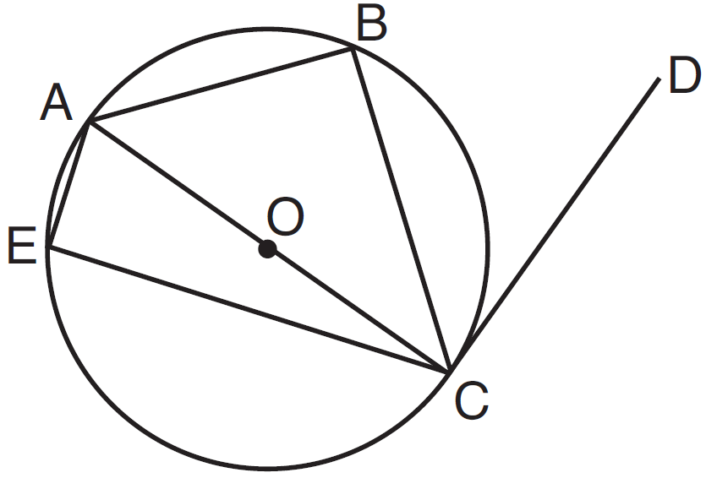

Which statement is not always true?
1)
2)
3)
4)

4 Given circle O with diameter ; secants and intersect at point H; ; and chord . Find the ratio of to .

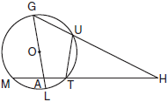

5 In the accompanying diagram, circle O has radius , diameter , secant , and chords and ; is tangent to circle O at D; ; and . Find , , , , , and .

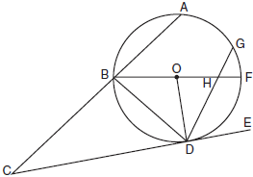

6 In the accompanying diagram, is tangent to circle O at A, chord and secant are drawn, and chords and intersect at E. If and , find , , and .

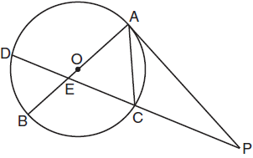
1 ANS: 1
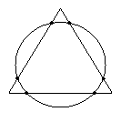
REF: 010208a

2 ANS:
52, 40, 80. 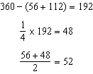. 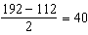. 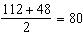
REF: 081238ge

3 ANS: 1 REF: 061520geo

4 ANS:
2:1. and form a semi-circle and measure 126° 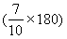 and 54° 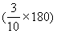, respectively. measures 36°. and form a semi-circle and measure 126°. measures 144° Equal chords intercept equal arcs. Because chord chord and each measures 72° 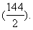 The measure of an inscribed angle is half that of its intercepted arc. So The angle formed by a tangent and a secant is equal to half the difference between the intercepted arcs. 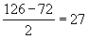. The ratio of to is 54:27, or 2:1. 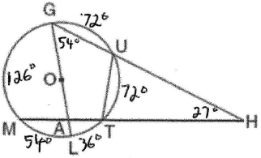
REF: 080333b

5 ANS:
30, 65, 75, 55, 35, 100. and form a semi-circle and measure 90° 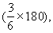 60° 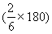 and 30° 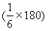, respectively. The measure of an inscribed angle is half that of its intercepted arc. So 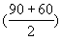 and 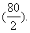 Therefore (180-(75+40)). The angle formed by a tangent and a chord is half the intercepted arc. Since the intercepted arc is 110° (80+30), Given diameter and The angle formed by a tangent and a secant is equal to half the difference between the intercepted arcs, so . 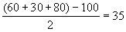. The measure of a central angle is equal to the measure of the arc it intercepts, so 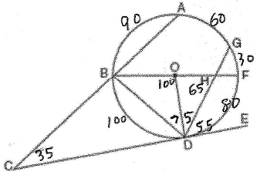
REF: 080633b

6 ANS:
25, 115, 115
REF: 011033b

