1 A small fragment of something brittle, such as pottery, is called a shard. The accompanying diagram represents the outline of a shard from a small round plate that was found at an archaeological dig.

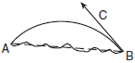

If is a tangent to at B and , what is the measure of , the outside edge of the shard?
1) | 45°
2) | 90°
3) | 135°
4) | 225°

2 In the circle below, , , , and are chords, is tangent at point D, and .

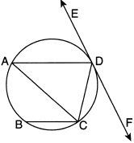

Which statement is always true?
1)
2)
3)
4)

3 In the diagram below, is tangent to circle O, and is a chord. If , find the measure of .

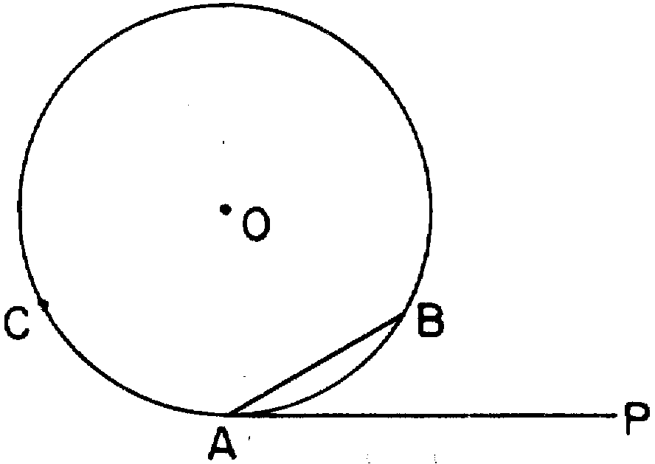

4 In the accompanying diagram, is tangent to circle O at B, is a chord, and is a diameter. If , find .

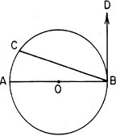

5 In the accompanying diagram, CD is tangent to circle O at B, AO and BO are radii, and chord is drawn. If , find .

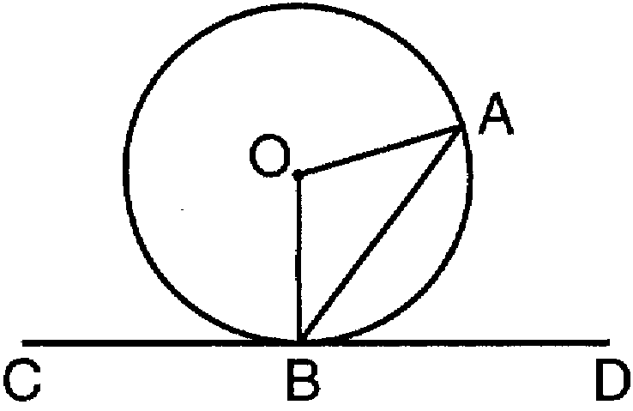
1 ANS: 2
The angle formed by a tangent and a chord is half the intercepted arc. Since the angle is 45°, the intercepted arc is 90°.

REF: 010510b

2 ANS: 2
Since , . 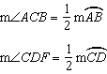

REF: 012323geo

3 ANS:
30

REF: 068502siii

4 ANS:
72

REF: 068810siii

5 ANS:
54

REF: 019704siii

