1 Diameter of circle O is extended through Q to point P, and tangent is drawn. If , what is ?
1) | 10°
2) | 20°
3) | 40°
4) | 50°

2 In the accompanying diagram of circle O, is a tangent, is a secant, , and . Find .

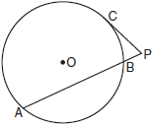

3 In the diagram below of circle K, secant and tangent are drawn from external point P.

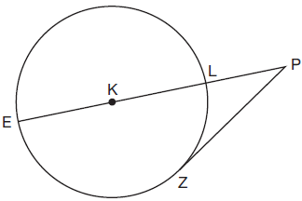

If , determine and state the degree measure of angle P.

4 In the diagram below, tangent and secant are drawn to circle O from external point D, such that .

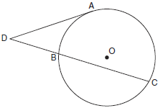

If , determine and state .

5 In the accompanying diagram of circle O, diameter is extended through B to external point P, tangent is drawn to point C on the circle, and . Find .

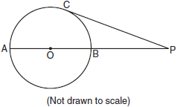

6 In the diagram below, tangent and secant are drawn to circle O. The ratio is . Find .

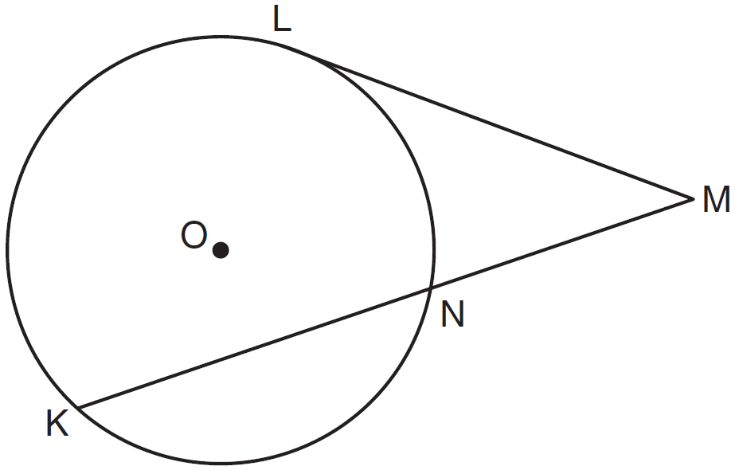

7 In the accompanying diagram, tangent and secant are drawn to circle O. If is twice and is 50, what is ?

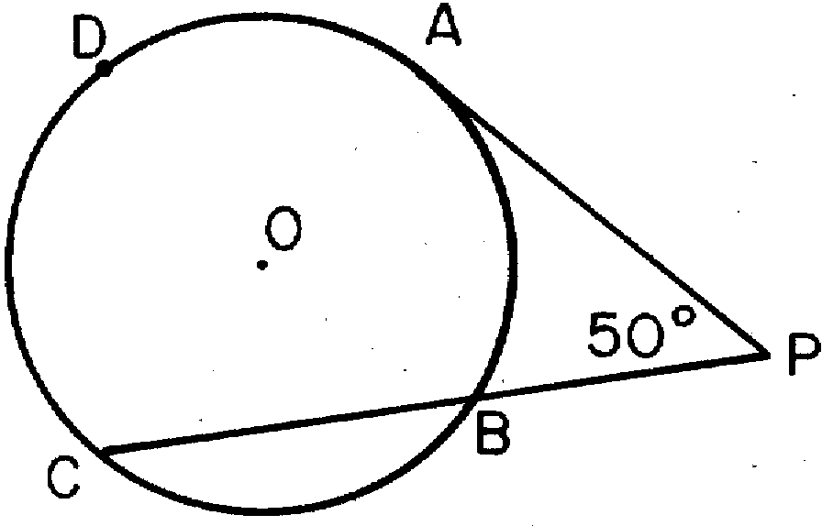
1) | 25
2) | 50
3) | 100
4) | 200

8 In the accompanying diagram, is tangent to circle O at Q and is a secant. If and , find .

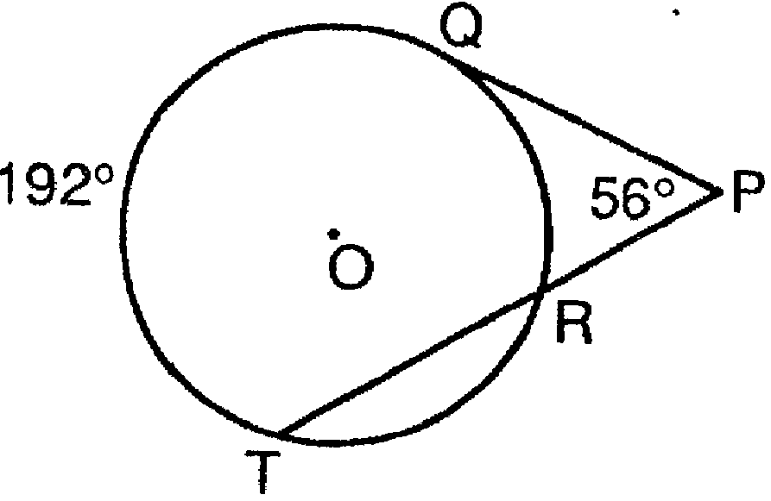

9 Point P lies outside circle O, which has a diameter of . The angle formed by tangent and secant measures 30°. Sketch the conditions given above and find the number of degrees in the measure of minor arc CB.
1 ANS: 1
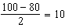

REF: 062219geo

2 ANS:
68. . 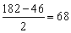

REF: 080925b

3 ANS:
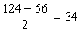

REF: 081930geo

4 ANS:
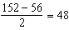

REF: 011728geo

5 ANS:
50. and form a semi-circle and measure 140° 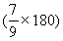 and 40° 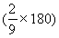, respectively. The angle formed by a tangent and a secant is equal to half the difference between the intercepted arcs. 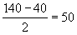. 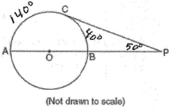

REF: 010721b

6 ANS:
30. 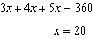. . 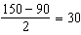

REF: 061136ge

7 ANS: 3 REF: 018531siii

8 ANS:
80

REF: 089510siii

9 ANS:
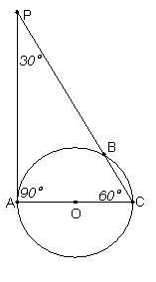 . Because is a tangent, It follows that The measure of an inscribed angle is half that of its intercepted arc. So Since is a diameter,

REF: 060132b

