1 In the diagram below of circle O, and are secants.

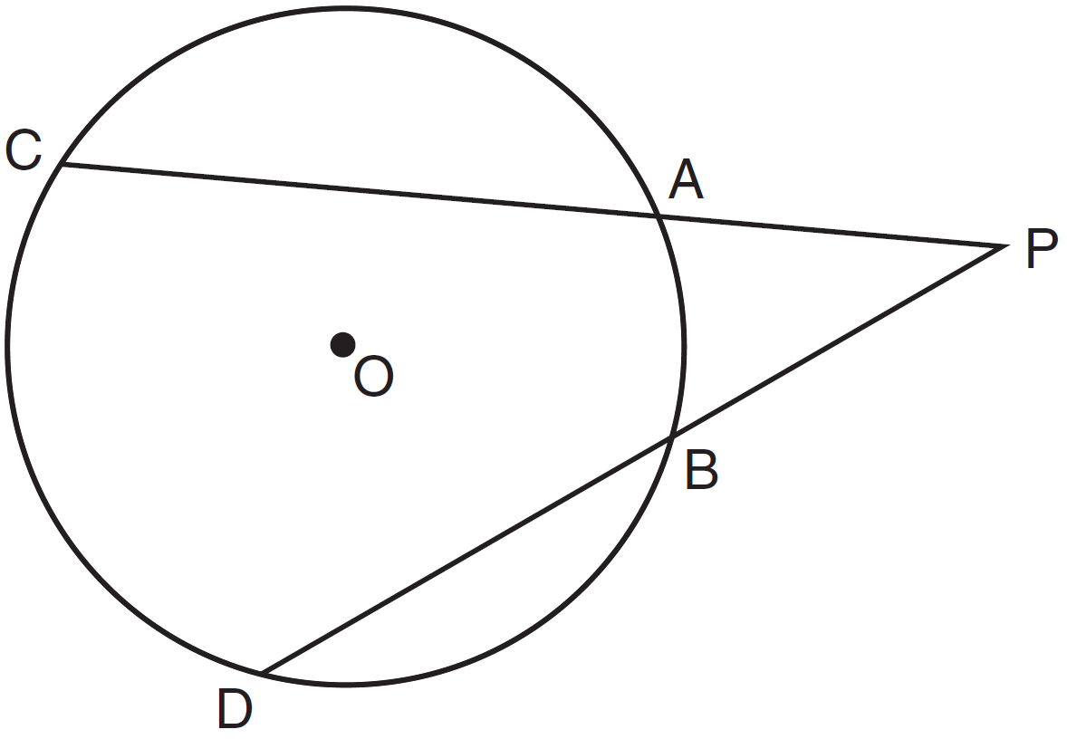

If and , what is the degree measure of ?
1) | 25
2) | 35
3) | 45
4) | 50

2 In the diagram below of circle O, secants and are drawn from external point C.

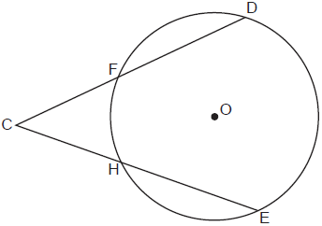

If and , then is
1) | 46°
2) | 48°
3) | 68°
4) | 88°

3 In circle O two secants, and , are drawn to external point P. If , and , what is the measure of ?
1) | 19º
2) | 38º
3) | 53º
4) | 106º

4 In the diagram below of circle C, , and .

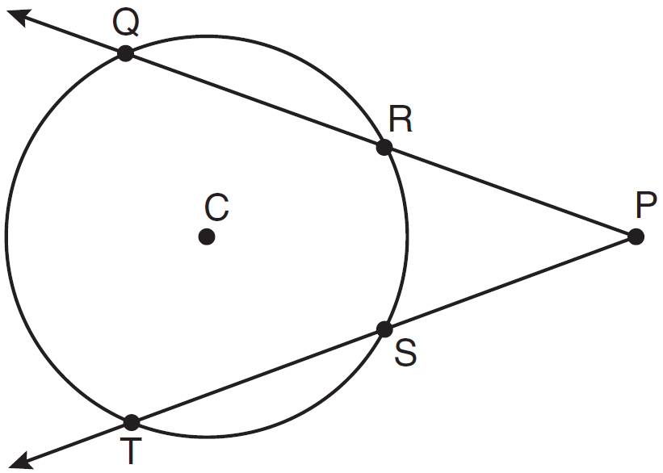
What is ?
1) | 50
2) | 60
3) | 90
4) | 110

5 In the accompanying diagram, and are secants to the circle. If and , find .
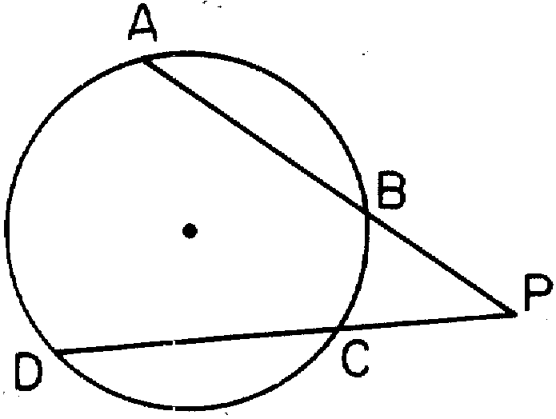

6 As shown in the diagram below, secants and are drawn to circle O from external point P.
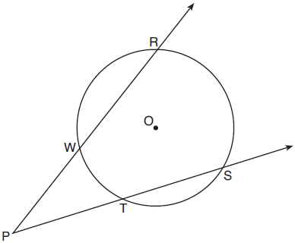

If and , determine and state .
1 ANS: 1
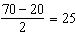

REF: 011325ge

2 ANS: 2
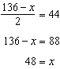

REF: 012414geo

3 ANS: 1
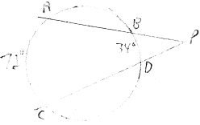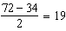

REF: 061918geo

4 ANS: 2
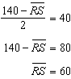

REF: 081025ge

5 ANS:
40

REF: 088910siii

6 ANS:
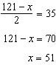

REF: 011927geo

