1 In the accompanying diagram, and are tangents drawn to circle O. If , find .

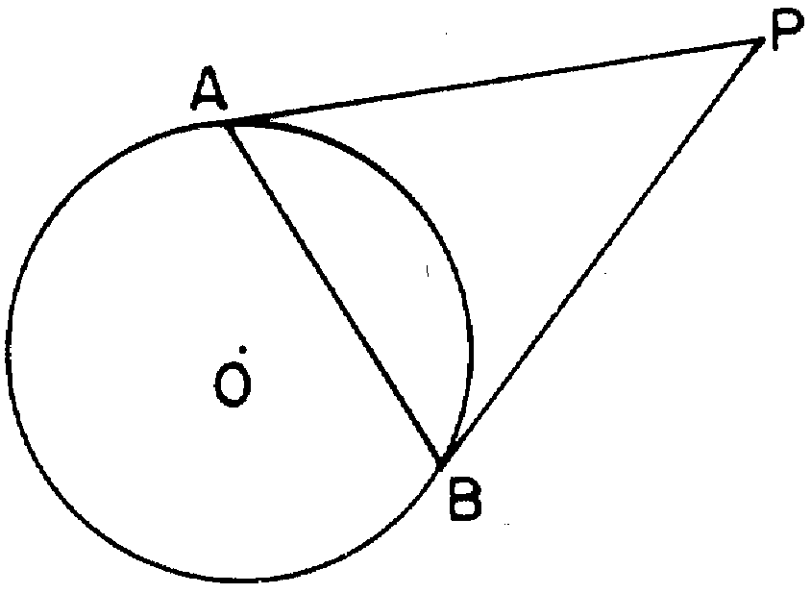

2 In the accompanying diagram, and are tangents to circle O, and chord is drawn. If , what is ?

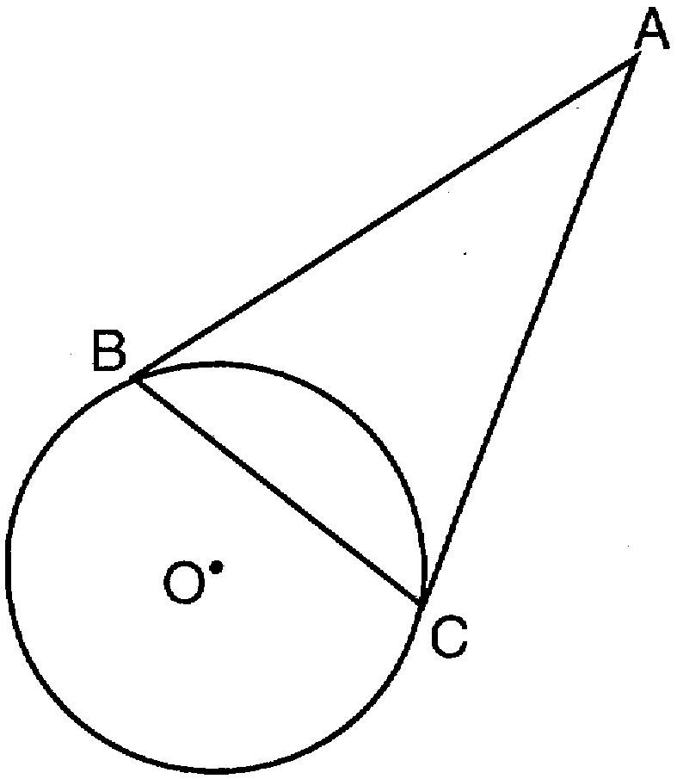

3 In the accompanying diagram of circle O, and are tangents and . Find .

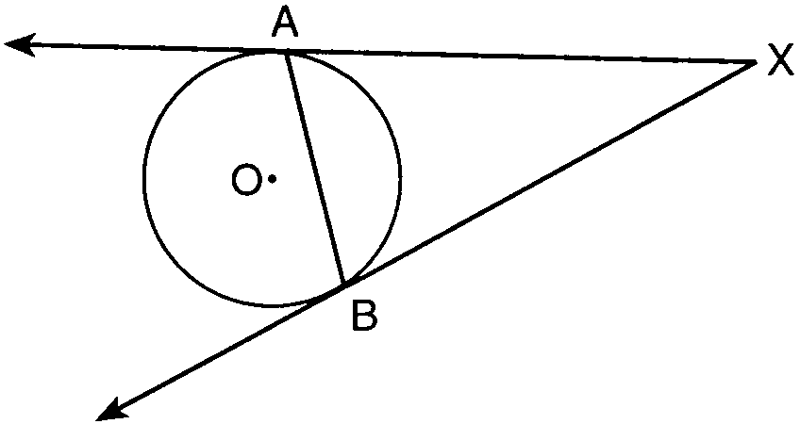

4 From external point A, two tangents to circle O are drawn. The points of tangency are B and C. Chord is drawn to form . If , what is ?
1) | 33
2) | 48
3) | 57
4) | 66

5 The accompanying diagram represents circular pond O with docks located at points A and B. From a cabin located at C, two sightings are taken that determine an angle of 30° for tangents and ..

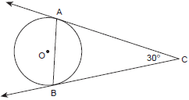

What is ?
1) | 30
2) | 60
3) | 75
4) | 150

6 In the accompanying diagram, and are tangents drawn to circle O, and chord is drawn. If , what is ?

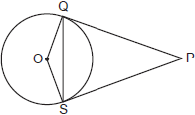

7 In the diagram below, and are tangent to circle O at A and B, respectively, from external point C.

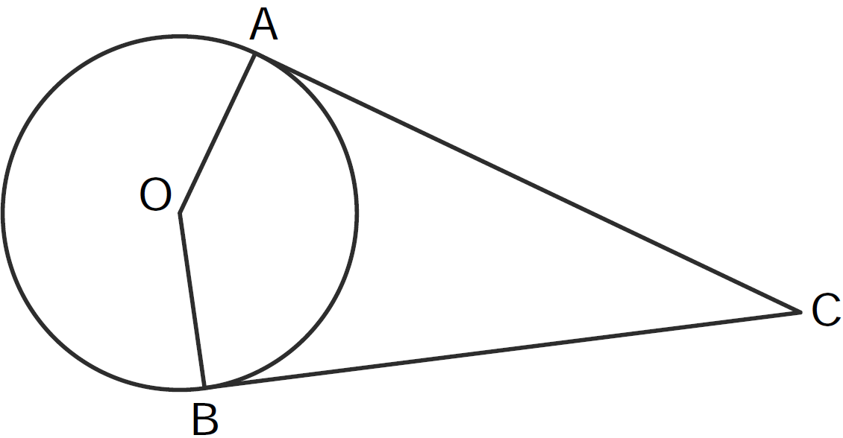

If , what is ?
1) | 71
2) | 104
3) | 142
4) | 161

8 Tangents and are drawn to circle O from an external point, P, and radii and are drawn. If , what is the measure of ?
1) | 140º
2) | 100º
3) | 70º
4) | 50º

1 ANS:
40

REF: 018602siii

2 ANS:
36

REF: 089601siii

3 ANS:
30

REF: 019901siii

4 ANS: 2

REF: 061513ge

5 ANS: 3
Because tangents and meet at a common point, the tangents are of equal length. ΔABC is an isosceles triangle with equal angles of 75° at A and B. 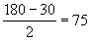

REF: 010213b

6 ANS:
70

REF: 080004siii

7 ANS: 3

REF: 011419ge

8 ANS: 1 REF: 081012ge

