1 In the diagram below, is inscribed in circle O.
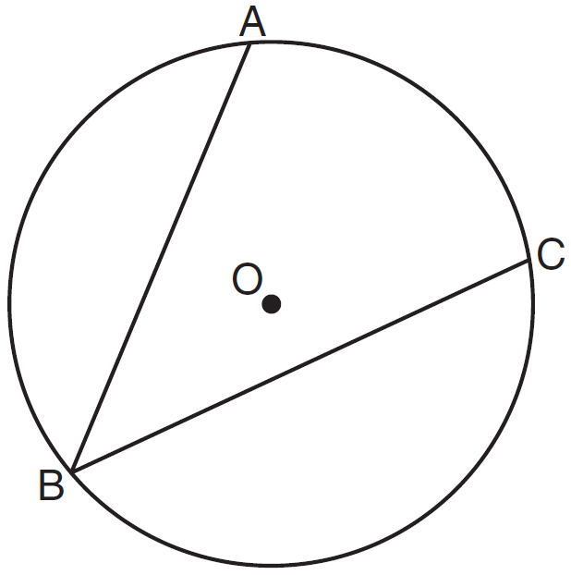
The ratio of the measure of to the measure of is
1)
2)
3)
4)

2 In the diagram below, .
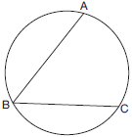
What is the number of degrees in the measure of ?
1) | 134º
2) | 92º
3) | 68º
4) | 46º

3 In the diagram below of Circle O, diameter and chord are drawn, and .
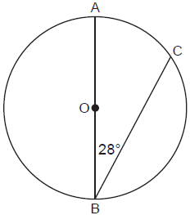
What is ?
1) | 56º
2) | 124º
3) | 152º
4) | 166º

4 As shown in the diagram below, is a diameter of circle O, and chord is drawn.

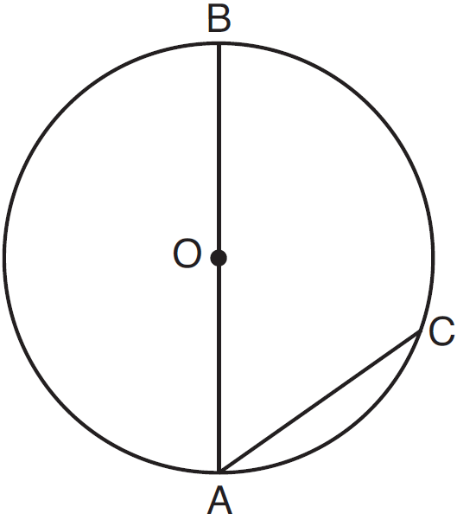

If , then is
1) | 40
2) | 70
3) | 110
4) | 140

5 Circle O with and is shown in the diagram below.

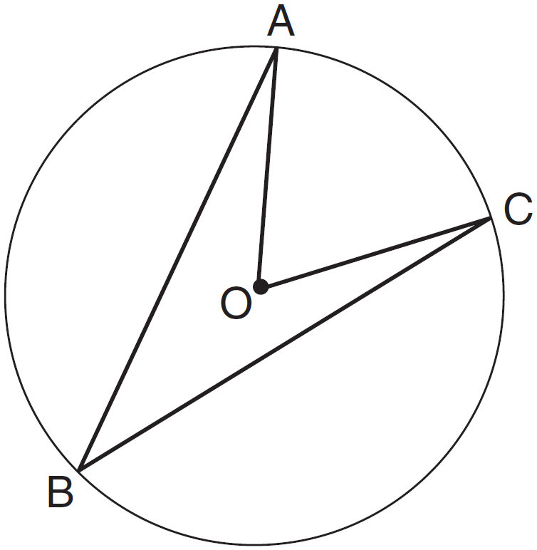

What is the ratio of to ?
1)
2)
3)
4)

6 In the diagram below of circle O, .

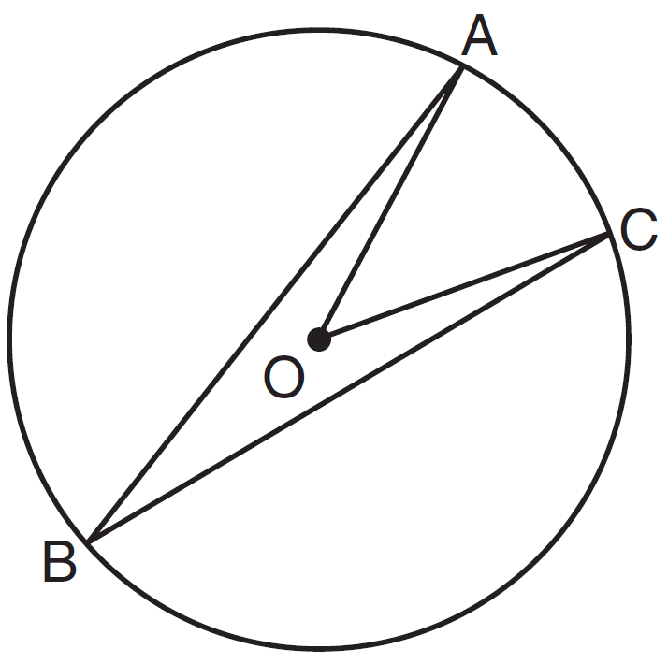

What is the ?
1) | 12
2) | 24
3) | 48
4) | 60

7 In the diagram below of circle O, chords , , , and are drawn such that . Identify one pair of inscribed angles that are congruent to each other and give their measure.

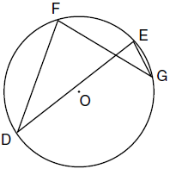

8 In the diagram below, , , , , and are chords of circle O, is tangent at point D, and radius is drawn. Sam decides to apply this theorem to the diagram: “An angle inscribed in a semi-circle is a right angle.”

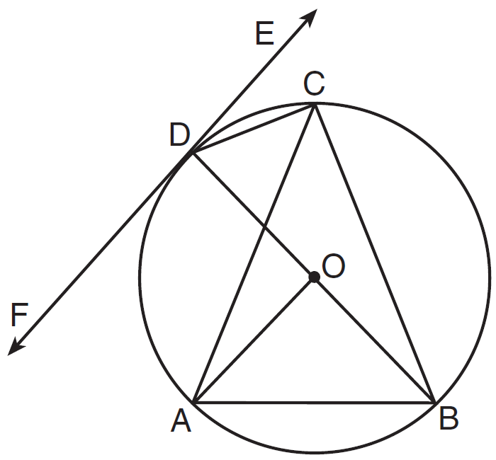

Which angle is Sam referring to?
1)
2)
3)
4)

9 In the diagram below of circle O, chords and intersect at E, and chords and are drawn.

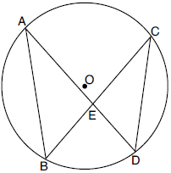

Which statement must always be true?
1)
2)
3)
4)

10 In the diagram below of circle O, chords and intersect at E.

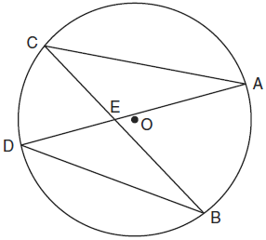

Which relationship must be true?
1)
2)
3)
4)

11 In circle O below, chords and intersect at point A. Chords and are drawn.

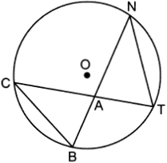

Which statement is always true?
1) | 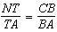
2)
3) | 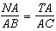
4)

12 In the diagram of circle A shown below, chords and intersect at G, and chords and are drawn.

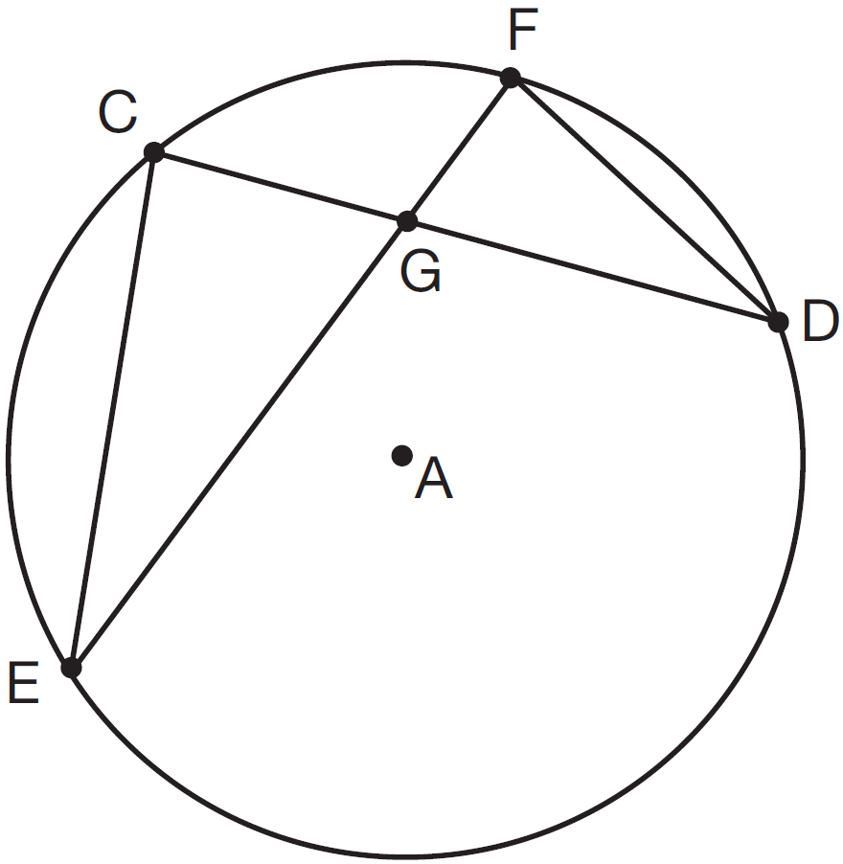

Which statement is not always true?
1)
2)
3) | 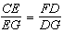
4)

13 In the diagram below of circle O, and are radii, and chords , , and are drawn.

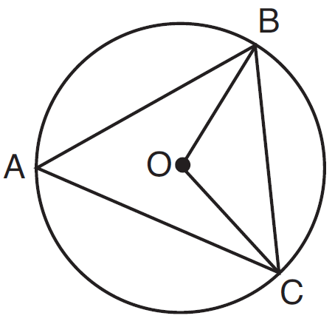

Which statement must always be true?
1)
2) | 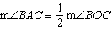
3) | and are isosceles.
4) | The area of is twice the area of .

14 In circle M below, diameter , chords and , and radius are drawn.

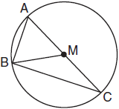

Which statement is not true?
1) | is a right triangle.
2) | is isosceles.
3)
4) | 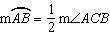

15 In the diagram below, is the diameter of circle A.

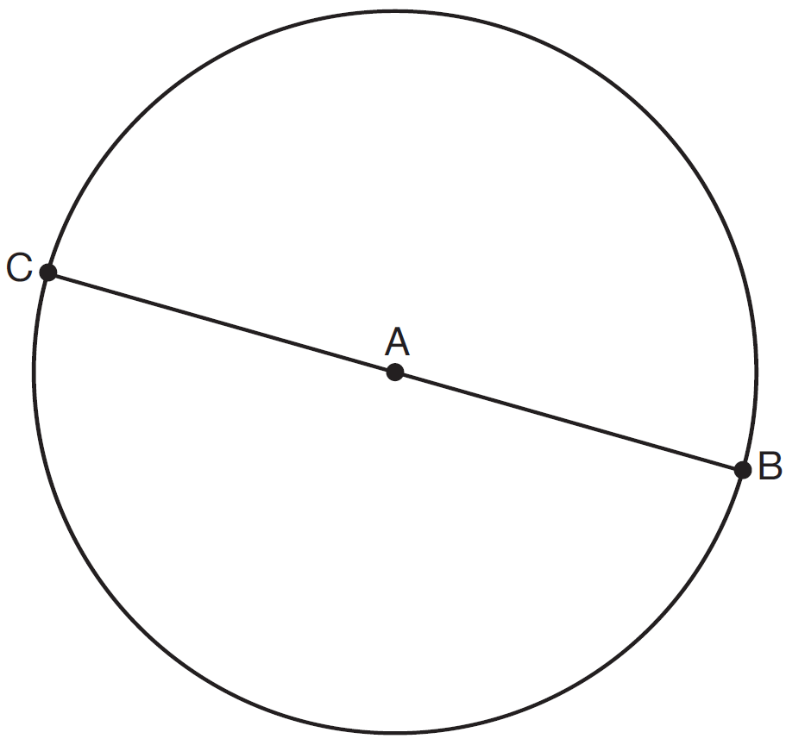

Point D, which is unique from points B and C, is plotted on circle A. Which statement must always be true?
1) | is a right triangle.
2) | is an isosceles triangle.
3) | and are similar triangles.
4) | and are congruent triangles.

16 In the diagram below of circle O, points K, A, T, I, and E are on the circle, and are drawn, , and .

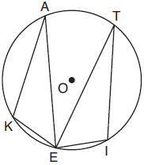

Which statement about and is always true?
1) | They are neither congruent nor similar.
2) | They are similar but not congruent.
3) | They are right triangles.
4) | They are congruent.

1 ANS: 2 REF: 011602ge

2 ANS: 4
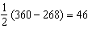

REF: 061704geo

3 ANS: 2
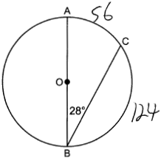

REF: 062305geo

4 ANS: 1 REF: 081518ge

5 ANS: 2 REF: 061322ge

6 ANS: 3 REF: 011523ge

7 ANS:
, and 24° or , and 84°. 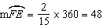. Since the chords forming and are intercepted by , their measure is 24°. 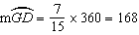. Since the chords forming and are intercepted by , their measure is 84°.

REF: fall0836ge

8 ANS: 3 REF: 011621geo

9 ANS: 4
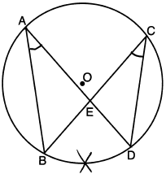

REF: 082218geo

10 ANS: 2
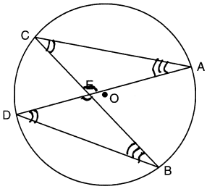

REF: 061026ge

11 ANS: 1 REF: 062409geo

12 ANS: 1 REF: 061508geo

13 ANS: 2 REF: 061610geo

14 ANS: 4 REF: 011816geo

15 ANS: 1
The other statements are true only if .

REF: 081623geo

16 ANS: 4 REF: 011905geo

