1 In the diagram below, chords and of circle O intersect at T.

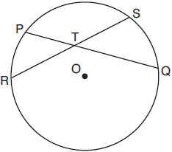

Which relationship must always be true?
1)
2)
3)
4)

2 The accompanying diagram shows two intersecting paths within a circular garden.

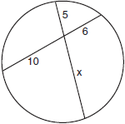

What is the length of the portion of the path marked x?
1)
2) | 11
3) | 3
4) | 12

3 In the diagram below of circle O, chords and intersect at E.

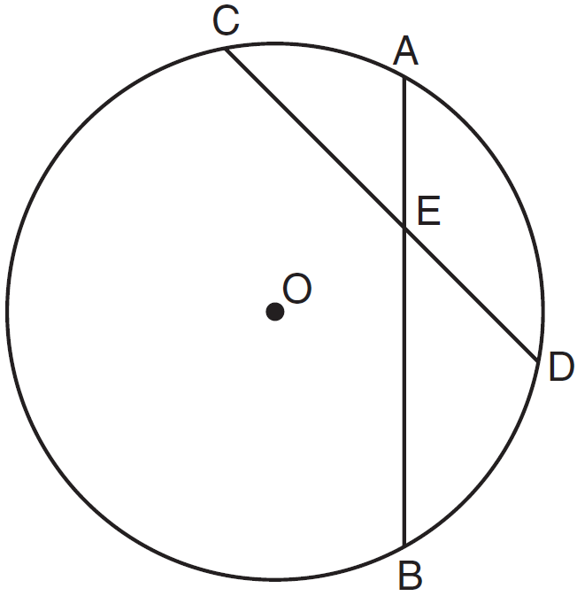

If , , and , what is the length of ?
1) | 15
2) | 12
3) | 6.7
4) | 2.4

4 In the diagram below of circle O, chord bisects chord at E.

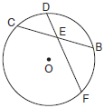

If and FE is 5 more than DE, then FE is
1) | 13
2) | 9
3) | 6
4) | 4

5 In the diagram of circle O below, chord intersects chord at E, , , , and .

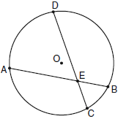

What is the value of x?
1) | 1
2) | 3.6
3) | 5
4) | 10.25

6 In the diagram below of circle O, chords and intersect at M.

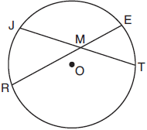

If and , the lengths of and could be
1) | 12 and 9.5
2) | 14 and 8.5
3) | 16 and 7.5
4) | 18 and 6.5

7 Chords and intersect at point E in a circle with center at O. If , , and , what is the length of ?
1) | 6
2) | 9
3) | 10
4) | 12

8 In the diagram below of circle O, chord bisects chord at E. If and , find the length of in simplest radical form.

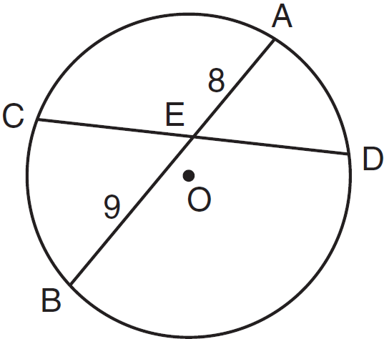

9 In the accompanying diagram of circle O, chords and intersect at E. If , , , and , what is the value of x?

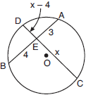

10 A toy truck is located within a circular play area. Alex and Dominic are sitting on opposite endpoints of a chord that contains the truck. Alex is 4 feet from the truck, and Dominic is 3 feet from the truck. Meira and Tamara are sitting on opposite endpoints of another chord containing the truck. Meira is 8 feet from the truck. How many feet, to the nearest tenth of a foot, is Tamara from the truck? Draw a diagram to support your answer.
1 ANS: 4 REF: 081922geo

2 ANS: 4
If two chords intersect, the product of the segments of one chord equals the product of the segments of the other chord. 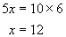.

REF: 010908b

3 ANS: 1
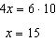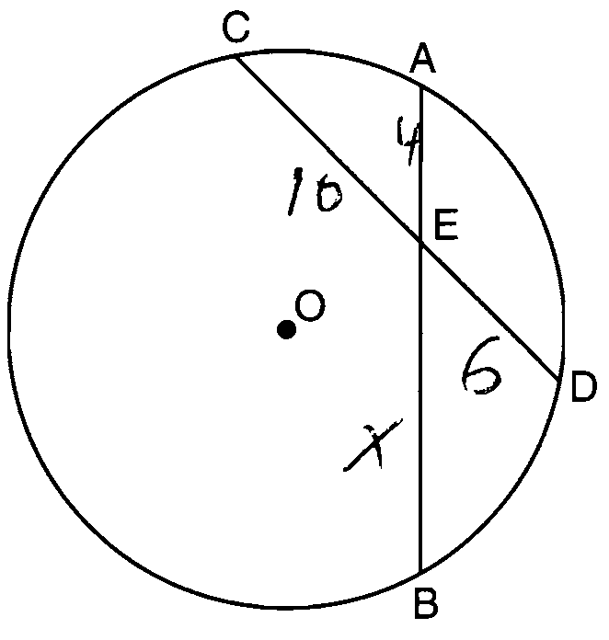

REF: 081017ge

4 ANS: 2
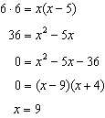

REF: 061708geo

5 ANS: 2
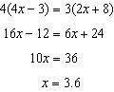

REF: 080923ge

6 ANS: 3

REF: 061913geo

7 ANS: 1
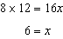

REF: 081328ge

8 ANS:
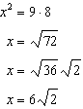

REF: 011132ge

9 ANS:
6. If two chords intersect, the product of the segments of one chord equals the product of the segments of the other chord. 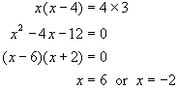. If you substitute -2 for x, distance is negative, which cannot be the case. Therefore x = 6.

REF: 060723b

10 ANS:
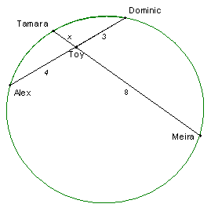 1.5. If two chords intersect, the product of the segments of one chord equals the product of the segments of the other chord. 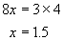.

REF: 080225b

