1 As shown in the diagram below, circle A has a radius of 3 and circle B has a radius of 5.

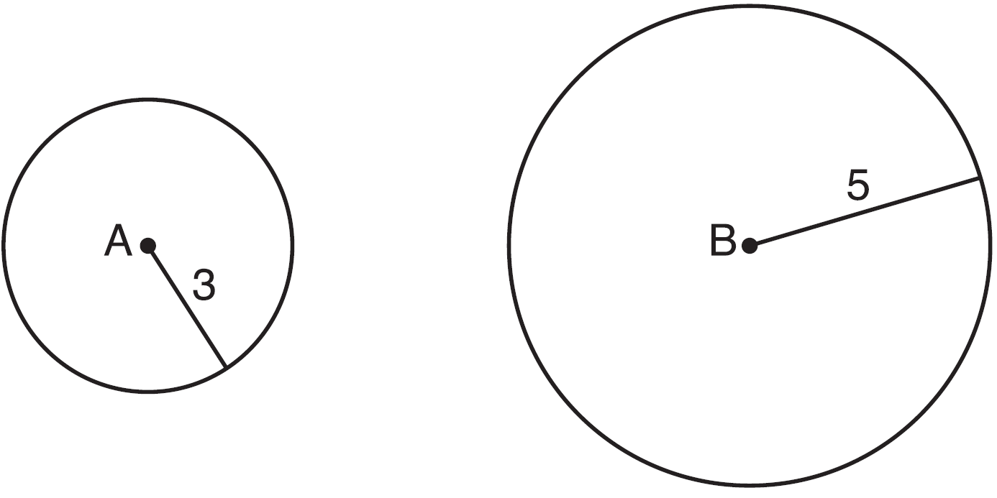

Use transformations to explain why circles A and B are similar.
1 ANS:
Circle A can be mapped onto circle B by first translating circle A along vector such that A maps onto B, and then dilating circle A, centered at A, by a scale factor of . Since there exists a sequence of transformations that maps circle A onto circle B, circle A is similar to circle B.

REF: spr1404geo

