1 If x is a positive acute angle and 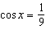, what is the value of 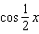?
1)
2)
3) | 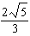
4)

2 If 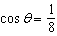, the positive value of 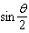 is
1)
2)
3)
4)

3 If 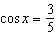, what is the positive value of 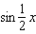?

4 If 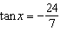, and x is an angle in Quadrant II, find .

5 If 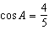, find the positive value of 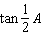.

6 What is a positive value of 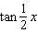, when ?
1) | 0.5
2) | 0.4
3) | 0.33
4) | 0.25

1 ANS: 4 REF: 080135siii

2 ANS: 2 REF: 019426siii

3 ANS:

REF: 068117siii

4 ANS:

REF: 089441siii

5 ANS:

REF: 068409siii

6 ANS: 1
If , then . 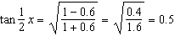.

REF: 061220a2

