1 If 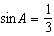, what is the value of ?
1)
2)
3)
4)

2 If 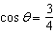, then what is ?
1)
2)
3)
4)

3 If x is an acute angle, and 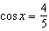, then is equal to
1)
2)
3)
4)

4 If 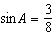, what is the value of ?
1)
2)
3)
4)

5 If x is an acute angle and 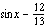, then equals
1)
2)
3) | 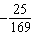
4) | 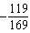

6 If is an acute angle such that 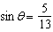, what is the value of ?
1)
2)
3)
4)

7 If x is a positive acute angle and 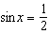, what is ?
1)
2)
3) | 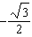
4)

8 If 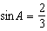 where , what is the value of ?
1) | 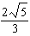
2) | 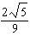
3) | 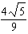
4) | 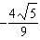

9 If 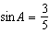, find .

10 If 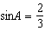, find .

11 If is in Quadrant II and 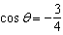, find an exact value for .

12 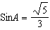 and is in Quadrant I. Find, in simplest form, the value of and .

13 The expression has the same value as
1)
2)
3)
4)

14 The expression has the same value as
1)
2)
3)
4) | 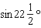

15 The expression has the same value as
1)
2)
3)
4)

16 The expression has the same value as
1)
2)
3)
4)

17 If is an obtuse angle and , then it can be concluded that
1)
2)
3)
4)

1 ANS: 4
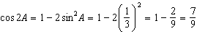

REF: 011311a2

2 ANS: 1
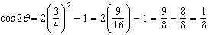

REF: 081522a2

3 ANS: 4
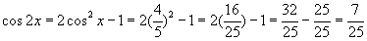

REF: fall9905b

4 ANS: 3
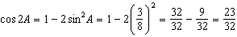

REF: 011510a2

5 ANS: 4
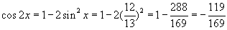

REF: 010418b

6 ANS: 4
If is an acute angle and , 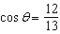. 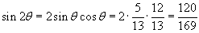.

REF: 060413b

7 ANS: 4
If x is an acute angle and , 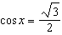. 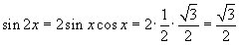.

REF: 060604b

8 ANS: 3
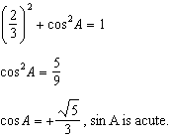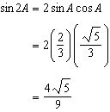

REF: 011107a2

9 ANS:

REF: 068817siii

10 ANS:

REF: 088713siii

11 ANS:
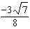

REF: 089940siii

12 ANS:
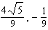

REF: 088938siii

13 ANS: 2 REF: 068523siii

14 ANS: 1 REF: 089521siii

15 ANS: 3 REF: 069727siii

16 ANS: 3 REF: 089821siii

17 ANS: 4
If is an obtuse angle, cos is negative, sin is positive, and b is positive. is negative. . is negative.

REF: 060118b

