1 Is 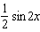 the same expression as ? Justify your answer.

2 For all values of for which the expressions are defined, prove that the following is an identity:
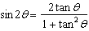

3 For all values of for which the expressions are defined, prove the following is an identity: 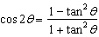

4 For all value of x for which the expressions are defined, prove the following is an identity: 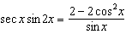

5 For all values of x for which the expressions are defined, show that the following equation is an identity: 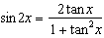

6 For all values of for which the expressions are defined, prove that the following is an identity: 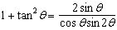

7 Prove the identity:

8 For all values of A for which the expressions are defined, show that the following is an identity: 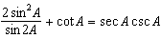

9 For all values of for which the expressions are defined, prove the following is an identity: 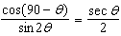

10 For all value of x for which the expressions are defined, prove the following is an identity:

11 For all values of A for which the expressions are defined, prove the following is an identity: 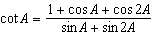

12 For all values of for which the expressions are defined, prove the following is an identity: 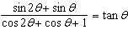

13 For all values of x for which the expressions are defined, prove that the following is an identity:

14 For all value of x for which the expression is defined, prove that the following is an identity: 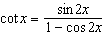

15 For all values of x for which the expressions are defined, prove the following is an identity: 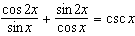

16 Express 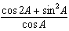 as a single trigonometric function for all values of A for which the fraction is defined.

17 For all value of x for which the expressions are defined, prove the following is an identity: 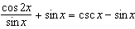

18 Prove the following identity: 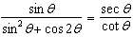

19 Prove the following identity: 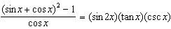

1 ANS:
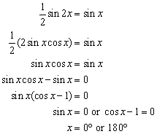Not an identity, so the expressions are not equal.

REF: 060222b

2 ANS:
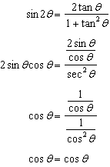

REF: 088442siii

3 ANS:
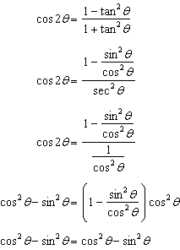

REF: 018542siii

4 ANS:
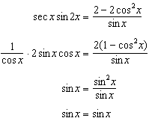

REF: 068541siii

5 ANS:
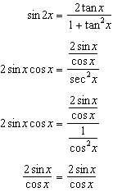

REF: 068738siii

6 ANS:
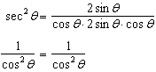

REF: 088737siii

7 ANS:
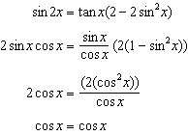
REF: 018941siii

8 ANS:
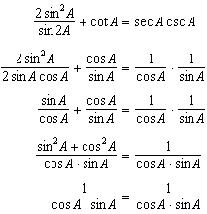
REF: 068942siii

9 ANS:
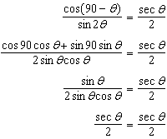
REF: 069040siii

10 ANS:
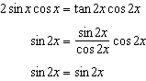
REF: 069442siii

11 ANS:
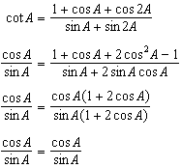
REF: 089442siii

12 ANS:
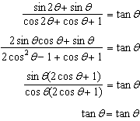
REF: 019637siii

13 ANS:
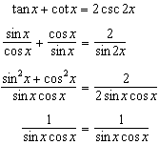
REF: 069640siii

14 ANS:
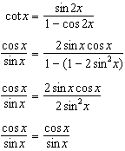
REF: 089638siii

15 ANS:
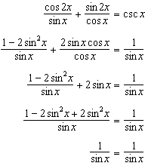
REF: 019740siii

16 ANS:
REF: 010014siii

17 ANS:
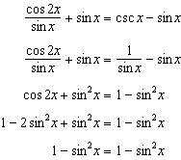
REF: 060141siii

18 ANS:
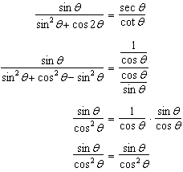
REF: 010242siii

19 ANS:
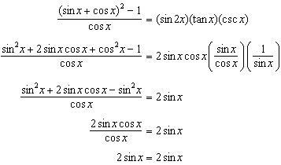
REF: 080239siii

