1 The expression is equivalent to
1)
2)
3)
4)

2 The expression is equivalent to
1)
2)
3)
4)

3 The expression is equivalent to
1)
2)
3)
4)

4 The expression is equivalent to
1)
2)
3)
4)

5 The expression is equivalent to
1) | 1
2) | 2
3)
4)

6 The expression 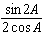 is equivalent to
1)
2)
3)
4) | 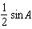

7 The expression 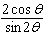 is equivalent to
1)
2)
3)
4)

8 Which trigonometric function is equivalent to the expression 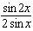?
1)
2)
3)
4)

9 The expression 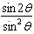 is equivalent to
1) | 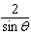
2)
3)
4)

10 The expression 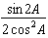 is equivalent to
1)
2)
3)
4)

11 The expression 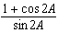 is equivalent to
1)
2)
3)
4)

12 For all values of A for which the expressions are defined, 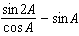 is equivalent to
1) | 1
2)
3)
4)

13 If is a positive acute angle and 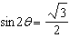, then equals
1) | 1
2) | 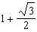
3) | 30°
4) | 60°

14 The expression is equivalent to
1)
2) | 2
3)
4)

15 The expression is equivalent to
1)
2) | 2
3)
4)

16 The expression 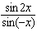 is equivalent to
1)
2)
3)
4)

17 The expression is equivalent to
1) | 1
2)
3)
4)

1 ANS: 1

REF: 061024a2

2 ANS: 4 REF: 080225siii

3 ANS: 1 REF: 018927siii

4 ANS: 3 REF: 089534siii

5 ANS: 1 REF: 018429siii

6 ANS: 3
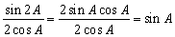

REF: 060914b

7 ANS: 1
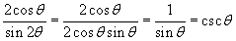

REF: 080315b

8 ANS: 4 REF: 089720siii

9 ANS: 3
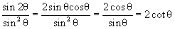

REF: 080617b

10 ANS: 2 REF: 069523siii

11 ANS: 1
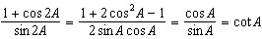

REF: 061522a2

12 ANS: 3 REF: 069024siii

13 ANS: 2
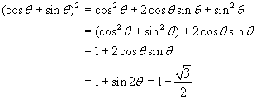

REF: 010609b

14 ANS: 4 REF: 019924siii

15 ANS: 3 REF: 060229siii

16 ANS: 3 REF: 089825siii

17 ANS: 3 REF: 068126siii

