1 If A and B are positive acute angles, 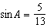, and 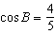, what is the value of ?
1)
2)
3)
4)

2 If 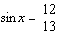, 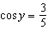, and x and y are acute angles, the value of is
1)
2)
3)
4)

3 If 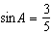, 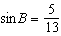, and angles A and B are acute angles, what is the value of ?
1)
2)
3)
4)

4 If A and B are both acute angles, and 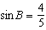, then is
1)
2)
3)
4)

5 If 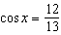 and 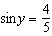, then equals
1)
2)
3)
4)

6 Given angle A in Quadrant I with 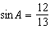 and angle B in Quadrant II with 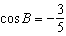, what is the value of ?
1)
2)
3)
4)

7 If 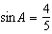, 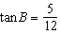, and angles A and B are in Quadrant I, what is the value of ?
1)
2)
3)
4)

8 If and 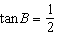, what is the value of ?
1)
2)
3)
4)

9 If 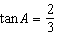 and , what is the value of ?
1)
2)
3)
4)

10 If and 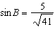 and angles A and B are in Quadrant I, find the value of .

11 If and , express as a fraction in simplest form.

12 When 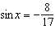 and x lies in Quadrant III and 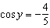 and y lies in Quadrant II, what is ?

13 Using the formula for , find the exact value of in radical form if and .

14 Express as a single fraction the exact value of .

15 If 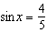, where , find the value of .

1 ANS: 1
If and A is a positive acute angle, 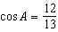. If and B is a positive acute angle, 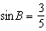. 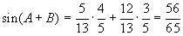

REF: 060312b

2 ANS: 2
If and x is an acute angle, 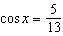. If and y is an acute angle, . 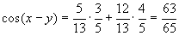.

REF: 080316b

3 ANS: 4 REF: 018620siii

4 ANS: 1 REF: 069020siii

5 ANS: 4 REF: 089432siii

6 ANS: 1
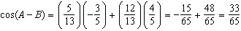

REF: 011214a2

7 ANS: 1
If and angle A is in Quadrant I, 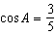. If , and angle B is in Quadrant I, then 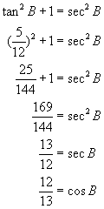 and 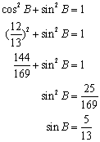. Then 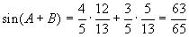.

REF: 080409b

8 ANS: 4 REF: 069525siii

9 ANS: 4 REF: 010018siii

10 ANS:
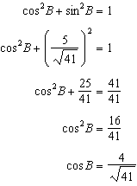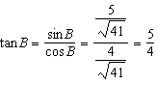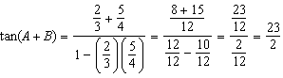

REF: 081037a2

11 ANS:

REF: 088405siii

12 ANS:

REF: 060141siii

13 ANS:
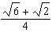

REF: 089041siii

14 ANS:
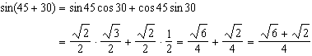

REF: 061136a2

15 ANS:
. If and , then 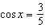. 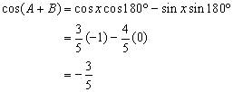

REF: 080126b

