1 The expression is equivalent to
1)
2)
3)
4)

2 The expression is equivalent to
1)
2)
3)
4)

3 is equivalent to
1)
2)
3)
4)

4 Which expression is equivalent to ?
1)
2)
3)
4)

5 Which expression is equivalent to ?
1)
2)
3)
4)

6 The expression is equivalent to
1)
2)
3)
4)

7 is equivalent to
1)
2)
3)
4)

8 The expression is equivalent to
1)
2)
3)
4)

9 The expression is equivalent to
1)
2)
3)
4)

10 The expression is equivalent to
1)
2)
3)
4)

11 If and , then is
1)
2)
3)
4)

12 Express as a single trigonometric function of a positive acute angle.

13 Which expression is equivalent to ?
1) | 1
2) | 0
3)
4)

14 Which expression is equivalent to ?
1) | 1
2) | 0
3)
4)

15 The value of is
1) | 1
2)
3)
4) | 0

16 What is the value of ?
1) | 1
2)
3) | 0
4) | 180

17 The value of is
1)
2)
3) | 0
4)

18 The value of is
1)
2)
3)
4) | 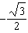

19 Evaluate:

20 Evaluate in radical form:

21 The expression is equal to
1)
2)
3)
4)

22 For all values of A and B for which the expressions are defined, prove that the following is an identity: 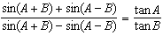

1 ANS: 3 REF: fall0910a2

2 ANS: 1
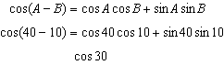
REF: 010401b

3 ANS: 3 REF: 068835siii

4 ANS: 3 REF: 081604a2

5 ANS: 3 REF: 019629siii

6 ANS: 2 REF: 019721siii

7 ANS: 4 REF: 019819siii

8 ANS: 1 REF: 019917siii

9 ANS: 1 REF: 080111siii

10 ANS: 3 REF: 010317siii

11 ANS: 2
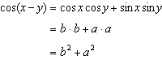
REF: 061421a2

12 ANS:
REF: 089708siii

13 ANS: 3 REF: 019521siii

14 ANS: 1 REF: 018621siii

15 ANS: 4 REF: 089330siii

16 ANS: 3 REF: 089019siii

17 ANS: 1 REF: 069816siii

18 ANS: 1 REF: 010216siii

19 ANS:
REF: 019410siii

20 ANS:
REF: 088906siii

21 ANS: 4 REF: 088631siii

22 ANS:
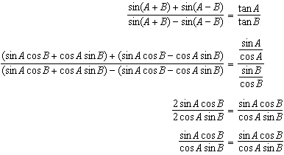
REF: 089742siii

