1 The expression 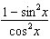 is equivalent to
1) | 1
2)
3)
4)

2 The expression 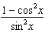 is equivalent to
1) | 1
2)
3)
4)

3 If , then the value of the expression is equivalent to
1) | 1
2)
3) | k
4)

4 The expression 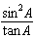is equivalent to
1) | 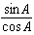
2)
3) | 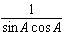
4) | 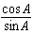

5 The expression 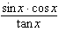 is equivalent to
1) | 1
2)
3)
4)

6 A crate weighing w pounds sits on a ramp positioned at an angle of with the horizontal. The forces acting on this crate are modeled by the equation , where M is the coefficient of friction. What is an expression for M in terms of ?
1)
2)
3)
4)

7 Show that is an identity.

8 For all values of for which the expressions are defined, prove the identity:

9 Prove that the equation shown below is an identity for all values for which the functions are defined:

10 For all values of for which the expressions are defined, prove that the following is an identity.

11 For all values of x for which the expressions are defined, prove the following is an identity:

12 For all values of for which the expressions are defined, prove the following is an identity:

13 Express in simplest terms: 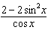

14 For all values of x for which the expressions are defined, prove that the following is an identity: 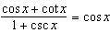

15 For all values of for which the expressions are defined, prove the identity:
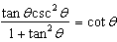

16 For all values of x for which the expressions are defined, prove the following equation is an identity: 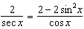

17 Prove the following is an identity for all values of for which the expressions are defined: 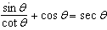

18 Prove the following identity: 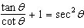

19 For all values of x for which the expressions are defined, prove that the following is an identity: 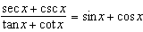

20 For all values of for which the expressions are defined, prove the following is an identity: 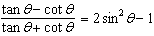

21 For all values of for which the expressions are defined, prove the following is an identity: 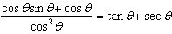

22 Prove the following identity: 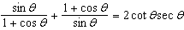

23 For all values of for which the expressions are defined, prove that the following is an identity: 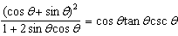

24 For all values of for which the expressions are defined, prove that the following is an identity: 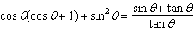

1 ANS: 1
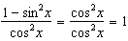

REF: 081616a2

2 ANS: 1
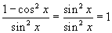

REF: 060610b

3 ANS: 4 REF: 019026siii

4 ANS: 2 REF: 089023siii

5 ANS: 4 REF: 080032siii

6 ANS: 1
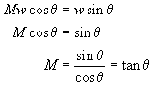

REF: 060515b

7 ANS:
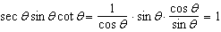

REF: 011428a2

8 ANS:
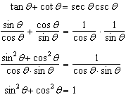

REF: 068036siii

9 ANS:
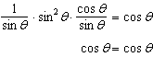

REF: 011634a2

10 ANS:
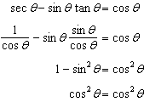

REF: 088937siii

11 ANS:
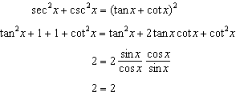

REF: 019542siii

12 ANS:
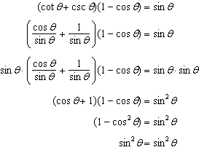

REF: 060041siii

13 ANS:
. 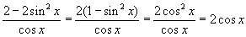.

REF: 080526b

14 ANS:
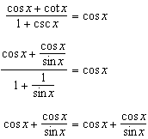

REF: 019439siii

15 ANS:
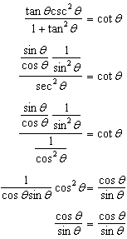

REF: 068140siii

16 ANS:
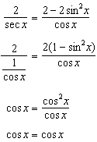

REF: 089341siii

17 ANS:
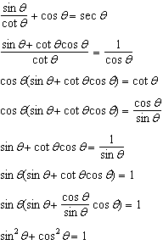

REF: 089940siii

18 ANS:
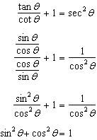

REF: 080040siii

19 ANS:
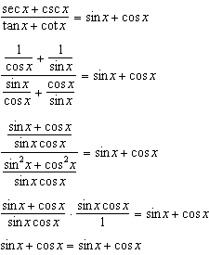

REF: 069541siii

20 ANS:
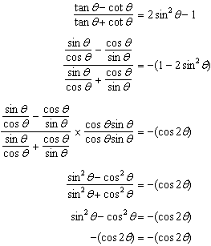

REF: 010042siii

21 ANS:
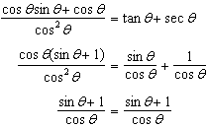

REF: 068639siii

22 ANS:
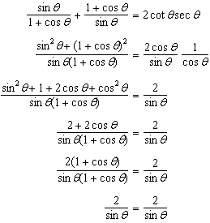

REF: 019938siii

23 ANS:
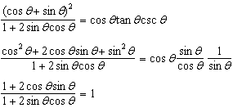

REF: 068440siii

24 ANS:
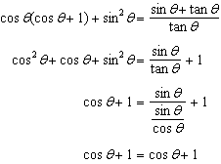

REF: 088636siii

