1 Which expression always equals 1?
1) |  | 3)
2) |  | 4)

2 If , then M equals
1) | 32° | 3) | 68°
2) | 58° | 4) | 72°

3 The expression is equivalent to
1) | 1 | 3)
2) | 2 | 4)

4 The expression is equivalent to
1) | 1 | 3)
2) |  | 4)

5 If is a positive acute angle and , which expression represents in terms of a?
1) |  | 3)
2) |  | 4) | 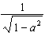

6 Starting with , derive the formula .

1 ANS: 2 REF: 011208a2

2 ANS: 1 REF: 011704aii

3 ANS: 1

REF: 060812b

4 ANS: 3 REF: 060121siii

5 ANS: 2
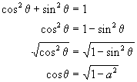

REF: 060418b

6 ANS:
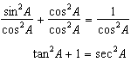

REF: 011135a2

