1 In which quadrant does lie if and ?

2 If and , in which quadrant does the terminal side of lie?

3 In which quadrant are both tangent and cosecant negative?

4 If 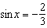 and , in which quadrant does terminate?

5 Natalia's teacher has given her the following information about angle .
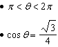
Explain how Natalia can determine if the value of is positive or negative.

1 ANS:
II

REF: 089409siii

2 ANS:
III

REF: 060006siii

3 ANS:
IV

REF: 010107siii

4 ANS:
IV

REF: 018705siii

5 ANS:
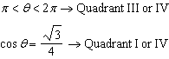 must be in Quadrant IV, where is negative.

REF: 012332aii

