1 If 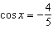 and , the value of is?
1) 2) 3) 4)

2 If 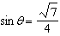 and 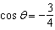, what is ?
1) 2) 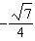 3) 4) 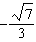

3 If 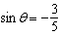 and , what is the value of ?
1) 2) 3) 4)

4 If 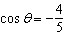 and lies in Quadrant II, what is the value of ?
1) 2) 3) 4)

5 If 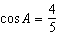 and A is in Quadrant I, what is the value of ?
1) 2) 3) 4)

6 If 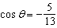 and , then is
1) 2) 3) 4)

7 If 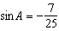 and terminates in Quadrant IV, equals
1) 2) 3) 4)

8 If x is a positive acute angle and 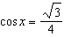, what is the exact value of ?
1) 2) 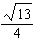 3) 4)

9 If 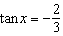 and angle x lies in the second quadrant, what is the value of ?
1) 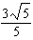 2) 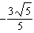 3) 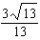 4) 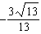

10 If and is negative, the value of is
1) 2) 3) 4)

11 If 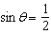 and terminates in Quadrant II, what is the value of ?
1) 2) 3) 4) 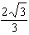

12 If x is a positive acute angle and 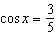, find the value of .

13 If the sine of an angle is and the angle is not in Quadrant I, what is the value of the cosine of the angle?

14 If 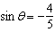 and is in Quadrant IV, find .

15 If terminates in Quadrant II and 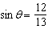, find .

16 If 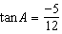 and , find .

17 Given 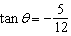 and 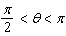, determine the exact value of the expression .

18 If 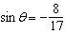 and is positive, what is the value of ?

1 ANS: 4 REF: 018628siii

2 ANS: 4 REF: 010321siii

3 ANS: 2 REF: 010021siii

4 ANS: 3
If and lies in Quadrant II, then 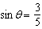. 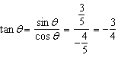

REF: 061004b

5 ANS: 1 REF: 069421siii

6 ANS: 4 REF: 068417siii

7 ANS: 2
If , 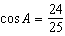, and 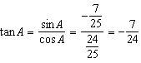

REF: 011413a2

8 ANS: 2
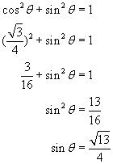

REF: 080604b

9 ANS: 4 REF: 068632siii

10 ANS: 4 REF: 019431siii

11 ANS: 1
If and terminates in Quadrant II, 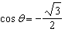. 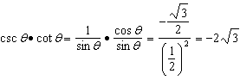

REF: 011721a2

12 ANS:

REF: 019003siii

13 ANS:
. 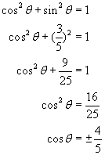. Since the angle is not in Quadrant I, 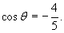

REF: 080121b

14 ANS:

REF: 089007siii

15 ANS:

REF: 019611siii

16 ANS:

REF: 068013siii

17 ANS:
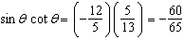

REF: 061635a2

18 ANS:

REF: 089712siii

