1 The value of is
1) | 1
2)
3) | 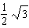
4) | 0

2 What is the exact value of 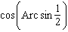?
1)
2)
3)
4)

3 If 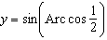, the value of y is
1)
2)
3)
4)

4 The value of 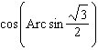 is
1) | 1
2)
3)
4)

5 What is the value of 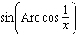?
1) | 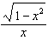
2) | 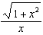
3) | 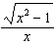
4) | 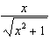

6 The value of is
1) | 1
2)
3) | 90
4) | undefined

7 If 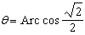, what is the value of ?
1) | 1
2)
3)
4)

8 What is the value of 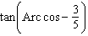?
1)
2)
3)
4)

9 What is the value of 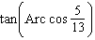?
1)
2)
3)
4)

10 What is the value of 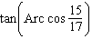?
1)
2)
3)
4)

11 If 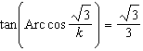, then k is
1) | 1
2) | 2
3)
4)

12 If , the value of is
1)
2)
3)
4)

13 The value of 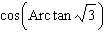 is
1) | 1
2)
3)
4) | 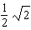

14 What is the value of y if 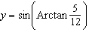?
1)
2)
3)
4)

15 What is a value of 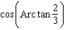?
1) | 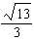
2) | 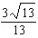
3) | 5
4) | 13

16 What is the value of 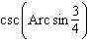?
1)
2)
3)
4)

17 Evaluate:

18 Find the value of 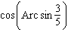.

19 Find the value of 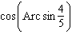.

20 Find the value of 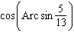.

21 What is the value of 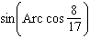?

22 Find 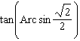.

23 Find 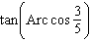.

24 Find the value of 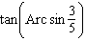.

25 Find 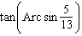.

26 Find the value of 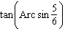.

27 Find the value of 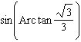.

28 What is the value of 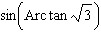?

29 Evaluate: 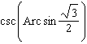

30 What is the value of 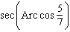?

1 ANS: 4 REF: 019921siii

2 ANS: 3 REF: 061008b

3 ANS: 2 REF: 088618siii

4 ANS: 2 REF: 069916siii

5 ANS: 3 REF: 010029siii

6 ANS: 4 REF: 010221siii

7 ANS: 1 REF: 068427siii

8 ANS: 4 REF: 080123siii

9 ANS: 3 REF: 060322siii

10 ANS: 1
If 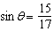, then 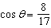. 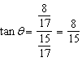
REF: 081508a2

11 ANS: 2
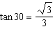. 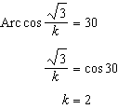
REF: 061323a2

12 ANS: 2 REF: 060023siii

13 ANS: 2 REF: 089320siii

14 ANS: 1 REF: 089817siii

15 ANS: 2 REF: 060225siii

16 ANS: 2
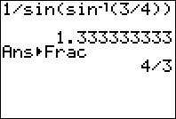
REF: 080817b

17 ANS:
REF: 089404siii

18 ANS:
REF: 018504siii

19 ANS:
REF: 018908siii

20 ANS:
REF: 068808siii

21 ANS:
REF: 010114siii

22 ANS:
1
REF: 068105siii

23 ANS:
REF: 018417siii

24 ANS:
REF: 068516siii

25 ANS:
REF: 068711siii

26 ANS:
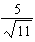
REF: 069808siii

27 ANS:
REF: 019511siii

28 ANS:
REF: 080003siii

29 ANS:
REF: 069410siii

30 ANS:
REF: 010315siii

