1 Solve algebraically for all values of in the interval that satisfy the equation 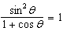.

2 Find all values of x in the interval that satisfy the equation . Express your answer to the nearest ten minutes or nearest tenth of a degree.

3 Find, to the nearest ten minutes or nearest tenth of a degree, all values of x in the interval that satisfy the equation .

4 Find, to the nearest ten minutes or nearest tenth of a degree, all values of in the interval that satisfy the equation .

5 Find, to the nearest ten minutes or nearest tenth of a degree, all values of in the interval that satisfy the equation .

6 Find, to the nearest degree, all values of in the interval that satisfy the equation .

7 Find, to the nearest tenth of a degree, all values of in the interval that satisfy the equation .

8 Solve algebraically for all values of in the interval .
Express your answers to the nearest degree.

9 In the interval , when x equals
1) | 45º, only
2) | 45º and 225º
3) | 135º and 315º
4) | 225º, only

10 What is one solution of the equation ?
1)
2)
3)
4) | 0

1 ANS:
90, 270. 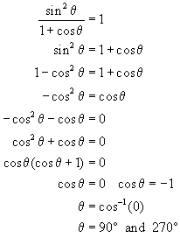. The solution cos θ = -1 is extraneous.
REF: 080432b

2 ANS:
194.5º, 270º, 345.5º or 194º30', 270º, 345º30'
REF: 060039siii

3 ANS:
9º40’, 170º20’, 270º or 9.6º, 170.4º, 270º
REF: 060239siii

4 ANS:
14º30’, 165º30’, 270º or 14.5º, 165.5º, 270º
REF: 080241siii

5 ANS:
53.1º, 306.9º or 53º10', 306º50'
REF: 069840siii

6 ANS:
111, 249
REF: 019942siii

7 ANS:
78.5 and 281.5
REF: 010337siii

8 ANS:
19, 90, 161. 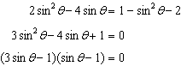. 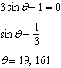. 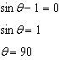.
REF: 061034b

9 ANS: 2 REF: 068627siii

10 ANS: 1 REF: 010025siii

