1 In the interval , what is the solution of the equation ?
1) | 120º
2) | 150º
3) | 210º
4) | 240º

2 What is the solution set of the equation when ?
1)
2)
3)
4)

3 Solve algebraically for all values of x in .

4 Find, algebraically, the measure of the obtuse angle, to the nearest degree, that satisfies the equation .

5 What is one possible value of in the equation ?
1)
2)
3)
4)

6 Find all values of in the interval which satisfy the equation .

7 In the interval , find all values of that satisfy the equation .

8 Find all values of in the interval which satisfy the equation .

9 Find a positive acute angle such that .

10 Find, to the nearest degree, all values of in the interval which satisfy the equation .

11 Find, to the nearest ten minutes or nearest tenth of a degree, all values of x in the interval that satisfy the equation .

12 Find, to the nearest degree, all values of in the interval which satisfy the equation .

13 In the interval , solve the equation algebraically for all values of , to the nearest tenth of a degree.

14 Find, to the nearest degree, all values of in the interval that satisfy the equation 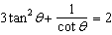.
1 ANS: 3 REF: 080130siii

2 ANS: 3
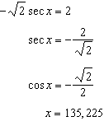

REF: 011322a2

3 ANS:
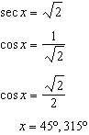

REF: 061434a2

4 ANS:
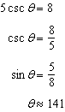

REF: 061332a2

5 ANS: 3 REF: 010229siii

6 ANS:
90º, 210º, 330º

REF: 068639siii

7 ANS:
30º, 150º, 270º

REF: 080040siii

8 ANS:
60º, 180º, 300º

REF: 018442siii

9 ANS:
60º or

REF: 060311siii

10 ANS:
30, 150

REF: 018542siii

11 ANS:
22º20’, 157º40’, 241º30' and 298º30' or 22.3º, 157.7º, 241.5º and 298.5º

REF: 010236siii

12 ANS:
31, 180, 329

REF: 068036siii

13 ANS:
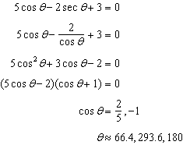

REF: 061539a2

14 ANS:
34º, 135º

REF: 068737siii

