1 Solve algebraically for all exact values of x in the interval :

2 Solve for all values of in the interval .

3 Find, to the nearest degree, all values of θ in the interval that satisfy the equation .

4 Find the value of x in the interval which satisfies the equation .

5 Solve for a value of in the interval .

6 Find, to the nearest degree, all values of in the interval which satisfy the equation .

7 Find the positive acute angle which satisfies the equation .

8 Find the value of x in the interval which satisfies the equation .

9 Find the measure of the smallest positive angle which satisfies the equation .

10 Find, to the nearest degree, all values of in the interval which satisfy the equation .

11 In the interval , what is the total number of values of x that satisfy the equation ?

12 Find all values of in the interval that satisfy the equation .

13 Find, to the nearest degree, all values of in the interval that satisfy the equation .

14 Find the value of x between 0º and 360º which satisfies the equation .

15 Find, to the nearest degree, all values of in the interval that satisfy the equation .

16 Find, to the nearest degree, all values of in the interval that satisfy the equation .

17 To the nearest degree, find all values of x in the interval that satisfy the equation .

18 Find all values of x in the interval that satisfy the equation .

19 Find, to the nearest degree, all values of x in the interval that satisfy the equation .

20 Find, to the nearest degree, all values of x in the interval that satisfy the equation .

21 Find, to the nearest degree, all values of x in the interval that satisfy the equation .

22 Find, to the nearest degree, all values of in the interval that satisfy the equation .

23 Find, to the nearest degree, all values of in the interval that satisfy the equation .

24 Find, to the nearest degree, all values of x in the interval that satisfy the equation .

25 Find, to the nearest ten minutes or nearest tenth of a degree, all values of A in the interval that satisfy the equation .

26 Find, to the nearest degree, all positive values of less than 360º that satisfy the equation .

27 Find, to the nearest ten minutes or nearest tenth of a degree, all values of x in the interval that satisfy the equation .

28 Find all values of x in the interval that satisfy the equation .

29 On a monitor, the graphs of two impulses are recorded on the same screen, where . The impulses are given by the following equations:
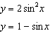
Find all values of x, in degrees, for which the two impulses meet in the interval . [Only an algebraic solution will be accepted.]

30 Find the value of in the interval that satisfies the equation .
1 ANS:
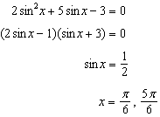

REF: 011436a2

2 ANS:
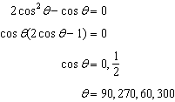

REF: 061638a2

3 ANS:
60, 104. Substitute x for cos θ. 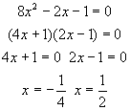. Substitute back cos θ for x. 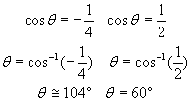. 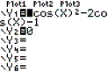. 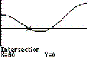. 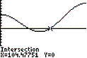.

REF: 010727b

4 ANS:
150º

REF: 068116siii

5 ANS:
60º

REF: 068411siii

6 ANS:
19º, 161º, 270º

REF: 068440siii

7 ANS:
45

REF: 018515siii

8 ANS:
90º

REF: 068513siii

9 ANS:
60º

REF: 088513siii

10 ANS:
19, 161, 210, 330

REF: 088542siii

11 ANS:
3

REF: 018605siii

12 ANS:
0º, 180º, 210º, 330º, 360º

REF: 018637siii

13 ANS:
27º, 135º, 207º, 315º

REF: 088636siii

14 ANS:
270º

REF: 018718siii

15 ANS:
14º, 166º, 210º, 330º

REF: 068837siii

16 ANS:
19, 161

REF: 018942siii

17 ANS:
14, 90, 166

REF: 069041siii

18 ANS:
90º, 210º, 330º

REF: 089038siii

19 ANS:
42, 138, 210, 330

REF: 069442siii

20 ANS:
35º, 77º, 215, 257º

REF: 019540siii

21 ANS:
48, 60, 300, 312

REF: 069538siii

22 ANS:
0, 104, 256

REF: 019638siii

23 ANS:
90, 222, 318

REF: 019737siii

24 ANS:
90, 199, 341

REF: 089739siii

25 ANS:
35.3º, 144.7º, 215.3º, 324.7º or 35º20', 144º40', 215º20', 324º40'

REF: 069937siii

26 ANS:
61, 141, 241, 321

REF: 010040siii

27 ANS:
228º40' and 311º20' or 228.6º and 311.4º

REF: 010140siii

28 ANS:
90º, 135º, 270º, 315º

REF: 080139siii

29 ANS:
30, 150, 270. 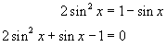 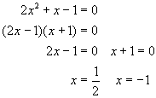 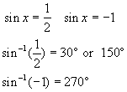 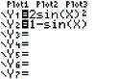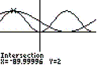

REF: 060233b

30 ANS:
90º

REF: 088512siii

