1 Which value of x does not satisfy the equation ?
1) 2) 3) 4)

2 Which is a solution for the equation ?
1) 2) 3) 4)

3 Which value of satisfies the equation ?
1) 2) 3) 4) 0

4 Which value of satisfies the equation ?
1) 2) 3) 4)

5 What is a positive value of x for which 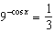?
1) 30° 2) 45° 3) 60° 4) 90°

6 In the interval , how many values of satisfy the equation 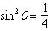?
1) 1 2) 2 3) 3 4) 4

7 If is an angle in Quadrant I and , what is the value of to the nearest degree?
1) 1 2) 2 3) 63 4) 75

8 In the interval , the solutions of the equation are
1) 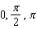 2) 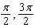 3) 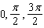 4) 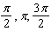

9 In the interval , how many values of satisfy the equation ?
1) 1 2) 2 3) 3 4) 4

10 Which values of x in the interval satisfy the equation ?
1) 2) 3) 4)

11 In the interval , how many values of satisfy the equation ?
1) 1 2) 2 3) 3 4) 4

12 What is the total number of solutions for the equation in the interval ?
1) 1 2) 2 3) 3 4) 4

13 If , the solutions of the equation are 30º and
1) 2) 3) 4)
1 ANS: 1 REF: 088929siii

2 ANS: 3 REF: 088425siii

3 ANS: 1 REF: 080023siii

4 ANS: 2 REF: 069930siii

5 ANS: 3
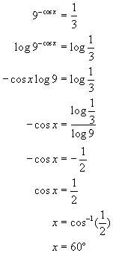. 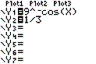. 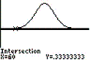

REF: 010404b

6 ANS: 4 REF: 088732siii

7 ANS: 3 REF: 019919siii

8 ANS: 1 REF: 019528siii

9 ANS: 3 REF: 068033siii

10 ANS: 2
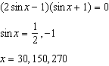

REF: 081514a2

11 ANS: 4 REF: 018434siii

12 ANS: 2 REF: 069027siii

13 ANS: 1 REF: 010325siii

