1 A solution set of the equation contains all multiples of
1) | 45°
2) | 90°
3) | 135°
4) | 180°

2 If , a value of is
1) | 45º
2) | 90º
3) | 180º
4) | 270º

3 What is the solution set for in the interval ?
1)
2)
3)
4)

4 A solution of the equation is
1)
2)
3)
4)

5 Which two values of x satisfy the equation ?
1) | 150º and 210º
2) | 120º and 240º
3) | 60º and 300º
4) | 30º and 330º

6 If and , find .

7 Solve the following equation algebraically for all values of in the interval .

8 Find a value for in the interval that satisfies the equation .

9 Find the value of x in the domain that satisfies the equation .

10 Find the number of degrees in the measure of the smallest positive angle that satisfies the equation .

11 Find in the interval that satisfies the equation .

12 If is a positive acute angle and , find the number of degrees in .

13 What is the number of degrees in the value of that satisfies the equation in the interval ?

14 Solve for the smallest non-negative value of : .

15 Solve the equation below algebraically for all values of in the interval .

16 What are the values of in the interval that satisfy the equation ?
1) | 60º, 240º
2) | 72º, 252º
3) | 72º, 108º, 252º, 288º
4) | 60º, 120º, 240º, 300º

17 What value of x in the interval satisfies the equation ?
1) | –30°
2) | 30°
3) | 60°
4) | 150°

18 Solve the equation algebraically for all values of C in the interval .

19 Navigators aboard ships and airplanes use nautical miles to measure distance. The length of a nautical mile varies with latitude. The length of a nautical mile, L, in feet, on the latitude line is given by the formula . Find, to the nearest degree, the angle , , at which the length of a nautical mile is approximately 6,076 feet.

20 The horizontal distance, in feet, that a golf ball travels when hit can be determined by the formula 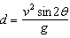, where v equals initial velocity, in feet per second; g equals acceleration due to gravity; equals the initial angle, in degrees, that the path of the ball makes with the ground; and d equals the horizontal distance, in feet, that the ball will travel. A golfer hits the ball with an initial velocity of 180 feet per second and it travels a distance of 840 feet. If feet per second per second, what is the smallest initial angle the path of the ball makes with the ground, to the nearest degree?

21 An architect is using a computer program to design the entrance of a railroad tunnel. The outline of the opening is modeled by the function , in the interval , where x is expressed in radians. Solve algebraically for all values of x in the interval , where the height of the opening, , is 6. Express your answer in terms of . If the x-axis represents the base of the tunnel, what is the maximum height of the entrance of the tunnel?
1 ANS: 4
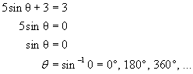. 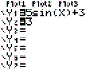. 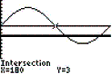.

REF: 080610b

2 ANS: 3
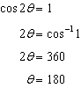

REF: 011007b

3 ANS: 4
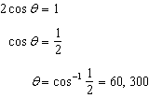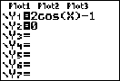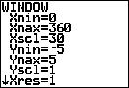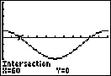

REF: 061203a2

4 ANS: 3 REF: 068828siii

5 ANS: 2 REF: 080230siii

6 ANS:
270

REF: 089803siii

7 ANS:
30, 150. 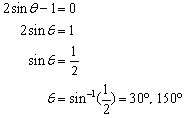. 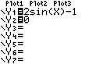. 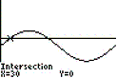. 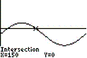

REF: 010523b

8 ANS:
210

REF: 010412siii

9 ANS:
45

REF: 019614siii

10 ANS:
120

REF: 069613siii

11 ANS:
240

REF: 019813siii

12 ANS:
60

REF: 010104siii

13 ANS:
300

REF: 089914siii

14 ANS:
0

REF: 080013siii

15 ANS:
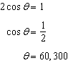

REF: 081631a2

16 ANS: 1
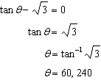. 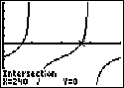.

REF: fall0903a2

17 ANS: 4
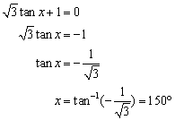. 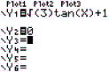. 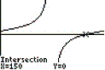.

REF: 060319b

18 ANS:
45, 225 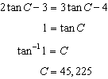

REF: 081032a2

19 ANS:
44. 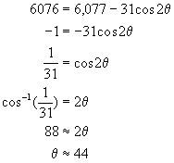. 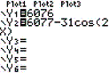. 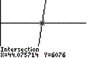

REF: 060427b

20 ANS:
28. 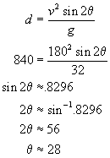. 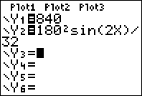. 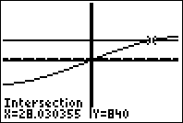.

REF: 010832b

21 ANS:
and , 10. 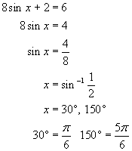. The sine function has a maximum height of 1. . 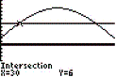. 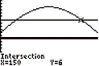.

REF: 010630b

