1 Which graph shows ?
1) | 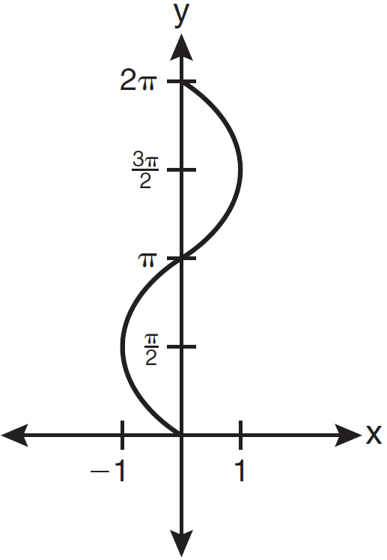
2) | 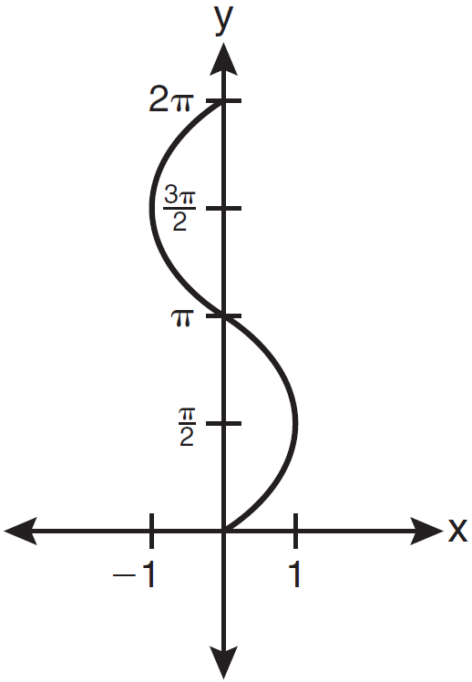
3) | 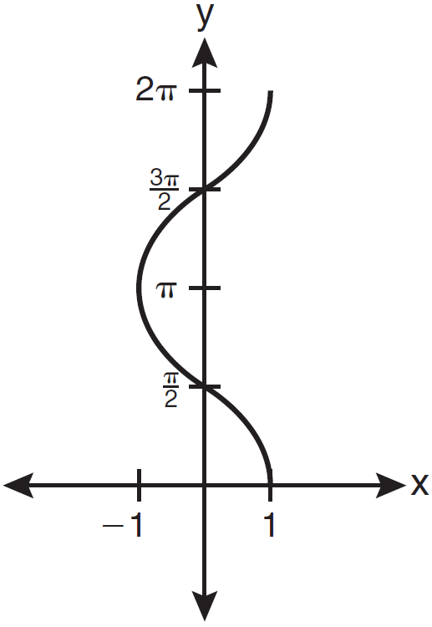
4) | 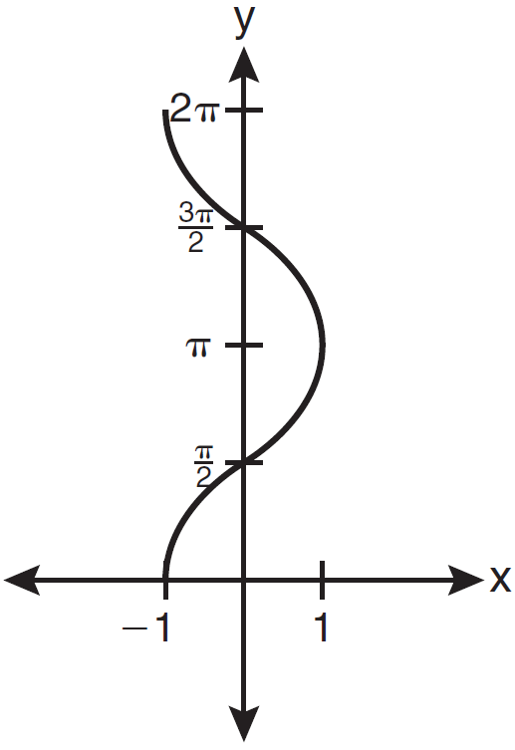

2 Which graph represents the equation ?
1) | 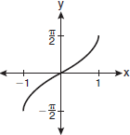
2) | 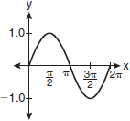
3) | 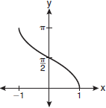
4) | 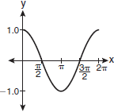

3 Which is an equation of the graph shown below?

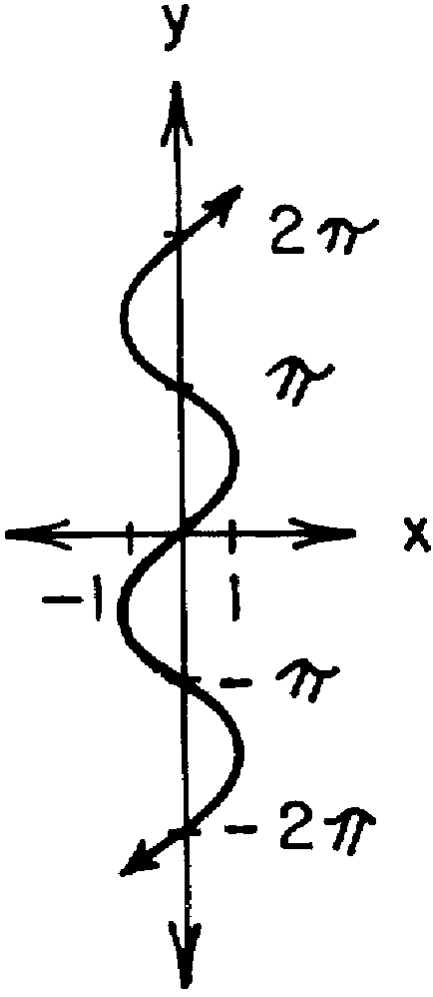
1)
2)
3)
4)

4 (1) Graph the equation in the domain 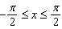.
(2) On the same set of axes, reflect the graph drawn in part (1) in the line , and label the graph b.
(3) Is the relation graphed in part (2) a function? State a mathematical justification for your answer.
(4) Write an equation the represents the graph drawn in part (2).

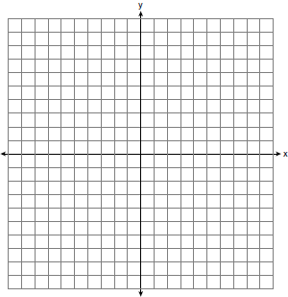

1 ANS: 3 REF: 061119a2

2 ANS: 3 REF: fall0913a2

3 ANS: 1 REF: 068631siii

4 ANS:
yes,

REF: 019436siii

