1 Which value of x is not in the domain of the function defined by ?
1)
2)
3)
4)

2 In which interval of is the inverse also a function?
1) | 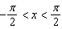
2) | 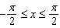
3)
4) | 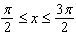

3 Which statement regarding the inverse function is true?
1) | A domain of is .
2) | The range of is .
3) | A domain of is .
4) | The range of is .

4 The function is defined in such a way that is a function. What can be the domain of ?
1)
2)
3) | 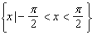
4) | 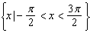

5 When the inverse of is sketched, its domain is
1)
2) | 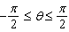
3)
4)

1 ANS: 2 REF: 018635siii

2 ANS: 3 REF: 061224a2

3 ANS: 4 REF: 061427a2

4 ANS: 3 REF: 061022a2

5 ANS: 4 REF: 011622a2

