1 The graph of which equation has amplitude 2 and period ?
1)
2) | 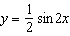
3)
4) | 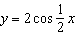

2 The graph of which function has an amplitude of 2 and a period of ?
1) | 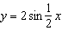
2)
3) | 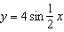
4)

3 Which equation is represented by the accompanying graph?

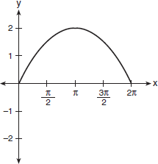

4 Which is an equation of the graph shown below?

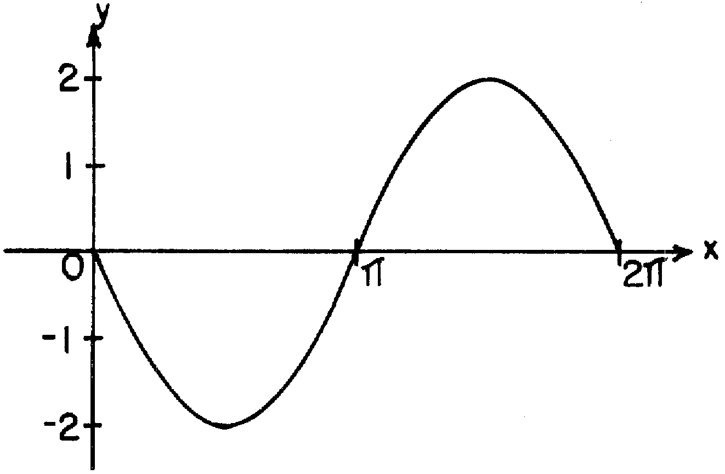

5 Which is an equation of the graph shown below?

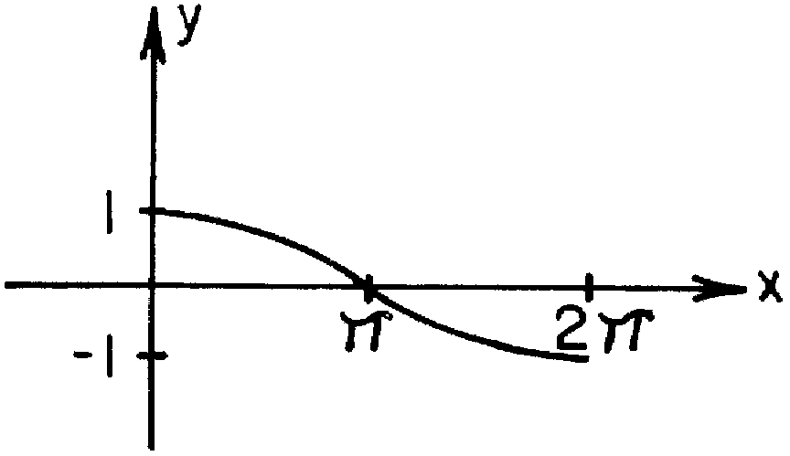

6 Which equation is represented by the graph in the diagram below?

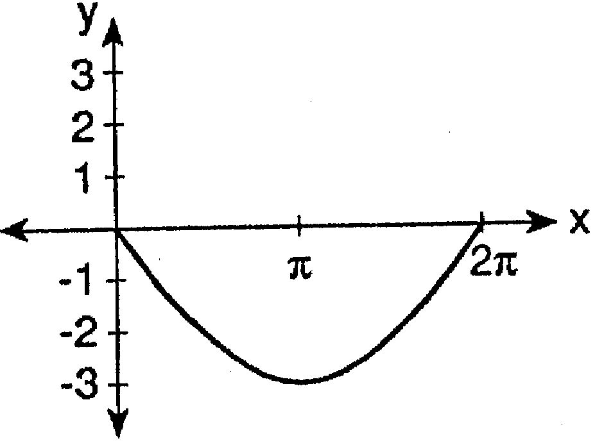

7 Which equation is represented by the graph below?

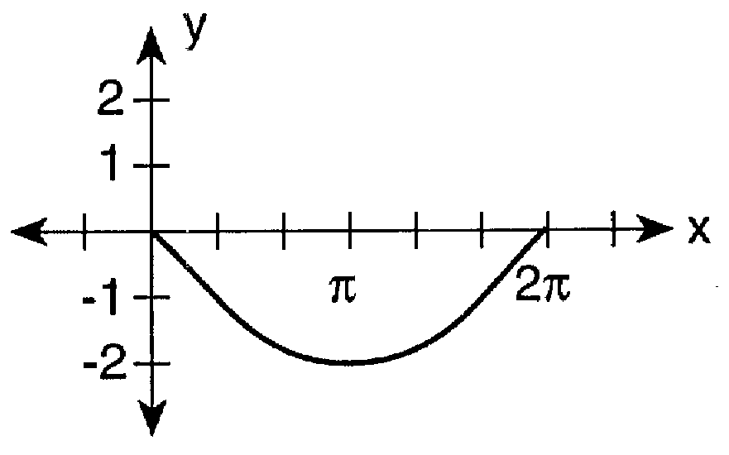

8 Which equation is represented in the graph below?

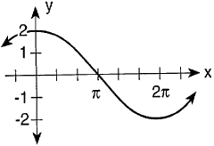

9 Which equation is represented in the accompanying graph?

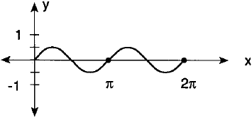

10 Which equation is represented by the graph in the accompanying diagram?

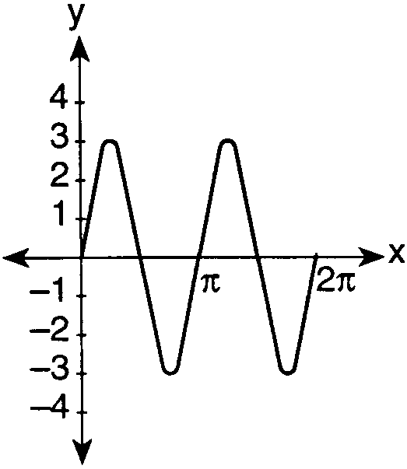

11 Which trigonometric function is shown in the graph below?

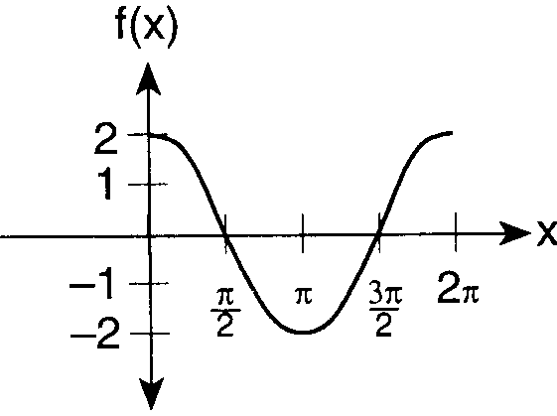

12 Which equation is represented by the graph in the accompanying diagram?

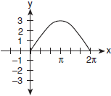

13 Which equation is represented on the graph shown below?

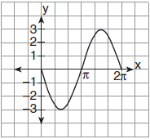

1 ANS: 1 REF: 068425siii

2 ANS: 1 REF: 069634siii

3 ANS:

REF: 010419siii

4 ANS:

REF: 068633siii

5 ANS:
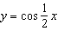

REF: 018917siii

6 ANS:
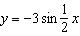

REF: 089522siii

7 ANS:
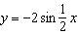

REF: 069721siii

8 ANS:
REF: 089725siii

9 ANS:
REF: 019822siii

10 ANS:
REF: 089820siii

11 ANS:
REF: 010019siii

12 ANS:
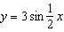
REF: 010119siii

13 ANS:
REF: 080121siii

